ANNUAL PLAN OF OPERATIONS

GLADES SOIL AND WATER CONSERVATION DISTRICT

FY2015

Glades Soil and Water Conservation District

The Glades Soil and Water Conservation District is a dependent, non-taxing, political subdivision of the State of Florida, organized by the landowners of Glades County. The District was established in January of 1947.

The affairs of the District are managed by a Board of Supervisors, composed of five elected individuals. The Glades Soil and Water Conservation Board meets the 2nd Thursday of the month.

The District’s accomplishments are made possible by working in conjunction with the USDA/Natural Resource Conservation Service and the continued support from the Glades County Board of County Commissioners.

A Unique Conservation Partnership

The Glades Soil and Water Conservation District was established to provide assistance in identifying and solving natural resource problems.

The uniqueness of this conservation effort is that a partnership was established in 1948 between the federal government and our district.

The USDA/Natural Resources Conservation Service and the Glades Soil and Water Conservation District work together to conserve, sustain, and improve the natural resources of Glades County.

OUR MISSION: The mission of the Glades Soil and Water Conservation District working in conjunction with the USDA/Natural Resource Conservation Service is to provide leadership in planning and administering programs to help conserve and improve our natural resources while protecting the environment.

OUR VISION: The Glades Soil and Water Conservation District working in conjunction with the USDA/NRCS will provide information and service in an effort to solve natural resource problems.

OUR POLICY: The Glades Soil and Water Conservation District working in conjunction with the USDA/Natural Resources Conservation service is committed to identifying and solving natural resource problems.

The Glades Soil and Water Conservation District Board

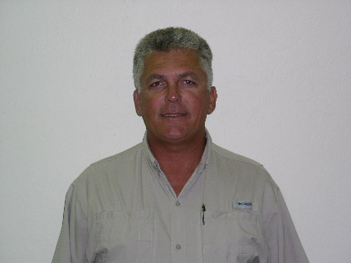

Randy Waguespack, Chairman

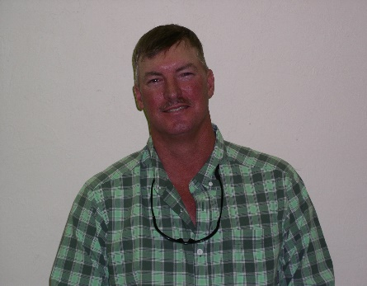

Carl Perry

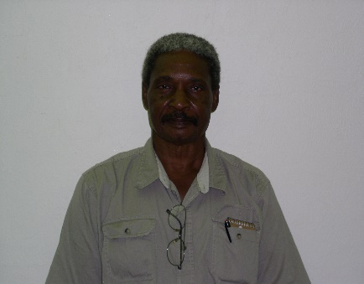
Tom Nichols

The Glades Soil and Water Conservation District Board

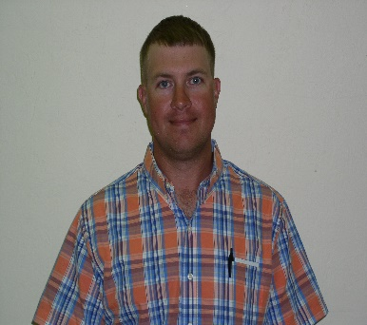

USDA/Natural Resources Conservation Service Staff

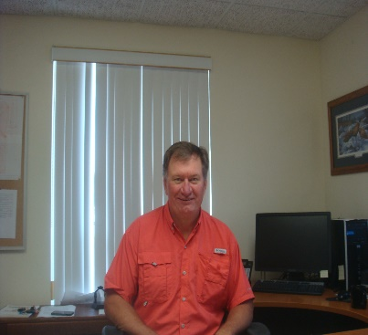
Jim Sutter began duties as the new District Conservationist with the USDA Natural Resources Conservation Service in the LaBelle field office on November 17 filling the position vacated by Dan Rutledge’s retirement. Jim and his wife Vicki arrive here after spending the past 4 years on the big island of Hawaii where Jim worked for NRCS in the Kealakekua (Kona) field office and Vicki was an elementary school teacher. Prior to that, Jim spent 19 years of his career working for NRCS in southern Iowa and operated a cow/calf operation on his farm. During that time Jim worked as NRCS district conservationist in Lee and Davis county Iowa for over 9 years and other positions including civil engineering technician, soil conservationist, conservation technician and grassland specialist. He started his career as a conservation technician for the Iowa Department of Agriculture in his home county of Appanoose in 1988 and later transferred to the NRCS as a civil engineering technician in 1992. Jim is a 1984 graduate of Truman State University (formerly Northeast Missouri State University) in Kirksville Missouri and holds a degree in agriculture business.

Jim Sutter

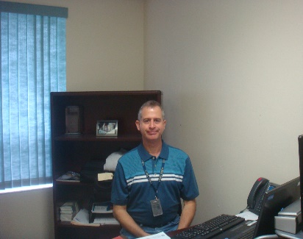
Jorge Ruiz has been a Soil Conservationist with USDA/NRCS since 1991 working in Puerto Rico for 23 years. He joined the LaBelle FO when he and his wife Ivette moved to Florida in December of 2014. Jorge is a graduate of the University of PR, Facility of Agriculture with a BSA is agronomy and soils.

Jorge Ruiz

USDA/Natural Resources Conservation Service Staff

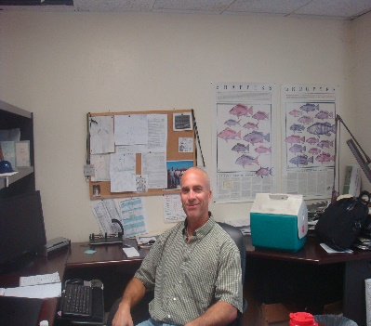
George Poole is the LaBelle FO Grazing Resources Specialist. He has been with the LaBelle office for 10 years. George has a bachelors degree in Wildlife Management. He and his wife Ivette have five children and they reside in Fort Myers.

George Poole

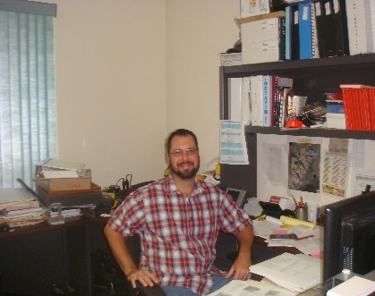
Chris Zimmerly graduated from LaBelle High School in 2002 and joined the LaBelle Field Office that November. Chris is now a full time Soil Conservation Technician with the agency. He and his wife Jessica live in LaBelle and have one child.

Chris Zimmerly

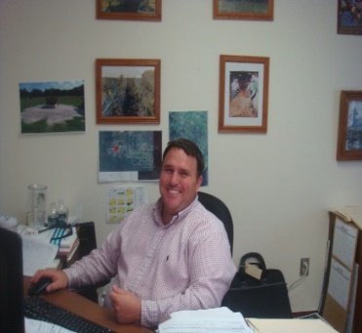
Cliff is a graduate of the University of Florida Agronomy department where he obtained his degree in plant science in 2002. He also was raised on a family row crop and cattle farm in North Florida. He started as a Conservation District Technician in Suwannee County in 2008 and later became a USDA/NRCS employee in 2010. He began his NRCS career in the panhandle of Florida and was transferred to Okeechobee service center in mid-2011. He then was promoted to Florida’s Tribal Liaison/Resource Conservationist and station in LaBelle to serve the field office and the local tribes. Cliff currently resides in Okeechobee where his wife works at the local hospital and his daughter and son attend elementary school.

Glades Board of County Commissioners
The Honorable Weston Pryor District 1
The Honorable Donna Storter Long District 2
The Honorable Paul Beck District 3
The Honorable John Ahern District 4
The Honorable Tim Stanley District 5

Map of Florida Counties
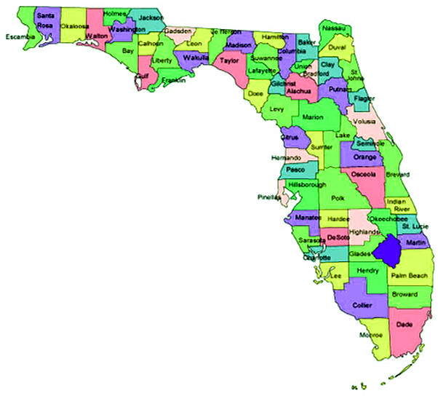
Map of Glades Couty
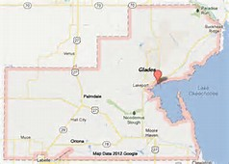

Description

Glades County is in the South-central part of the Florida Peninsula. It is bordered
on the Northeast by Okeechobee County , East by Lake Okeechobee, on the
Northwest by Desoto and Highlands Counties, on the South by Hendry County,
on the Southwest by Lee County, and on the West by Charlotte County.
The average population is 13,300 with the following breakdown: Rural 71%,
Cities 29%.

Glades County was founded in 1921 and named after the Florida Everglades. It
covers 986 square miles, 774 in land and 213 in water.
The primary industry is agriculture with its top commodities being cattle, citrus
and sugarcane.

There are approximately 403,000 acres of farmland in Glades County. Glades
County ranks in the top eight for cattle production in the state and the top three in
sugarcane for sugar. Glades County produces 73,000 acres of vegetables, melons,
citrus and sugarcane.

GLADES SWCD OBJECTIVES

- Work in conjunction with the USDA/Natural Resources Conservation Service to assist landowners in managing Glades County’s natural resources, i.e.: wildlife habitat, threatened and endangered species, water quality and quantity, wetlands, and soil sustainability by supporting the implementation of recognized and approved Best Management Practices.
- Promote the proper use and grazing of pasture and range lands in Glades County through Best Management Practices.
- Promote soil and water conservation through educational and outreach programs through schools, FFA, 4-H and in the public sector.
- Assist landowners in utilizing existing conservation programs through other county, state, and federal agencies in order to protect land in both agricultural and developing areas.
- Promote special assistance to minority groups through special emphasis using newspapers, brochures, newsletters and website.

ACCOMPLISHMENTS

- Promotes and administers BMP (Best Management Practices) grant programs through the Florida Department of Agriculture and Consumer Services.
- Co-operates with the USDANRCS with administering EQIP (Environmental Quality Incentive Program).
- Assists with requests for technical assistance. Distributes Hendry/Glades Soil Survey and Plat Books. Promotes Stewardship Week and provides pamphlets and materials to schools and public sector on request.
- Holds contests based on conservation themes chosen yearly by NACD in order to help educate the youth of Glades County.

EARTH TEAM VOLUNTEERS

The EARTH TEAM is sponsored by the USDA/Natural Resources Conservation Service and consists of individuals who care about our soil and water resources. They volunteer their time and services to be part of the greater conservation effort.
Volunteers must be at least 14 years of age, they may work full or part time, outdoors or indoors helping the USDA/NRCS and the Glades Soil and Water Conservation District serve the public needs.
Our EARTH TEAM volunteers have assisted us with assignments ranging from field surveying and office work to barbecuing at sponsored events.
We are proud of our volunteers and would like to acknowledge and commend them for their dedicated service.

