# Beginner Exercise 1. The Grip and Ready Position. (10 Minutes)

1. Have kids line up against the side wall facing you.
2. Ask them to put their hurls on the ground in front of them.
3. Ask them which hand they use to colour with/write with – This is their hurley hand.
4. Ask them to pick up the hurley with the hurley hand. Hand right up at the top of the hurl. (Fig. 1)
5. Tell them their other hand is the catching Hand – Ask them why they think this is the catching hand? (To catch the ball!!)
6. Ask them to put their catching hand on the hurley down near the bás. Fingers to the front “like a guitar”. Nose of the bás pointing towards the sky. This is the ‘Ready’ Position. (Fig 2).
7. Ask them to slide their catching hand all the way up the hurl till it meets the Hurley Hand. Make sure their hands are firmly touching. This is the ‘Lock’ position. (Fig 3)
8. Ask them to raise both arms in the air, directly over their head, in the ‘Lock’ position.
9. Ask the kids to GENTLY move the hurley from side to side over their heads using the Lock position. (Like a sword). (Fig 4)

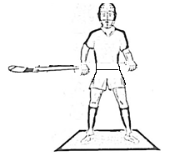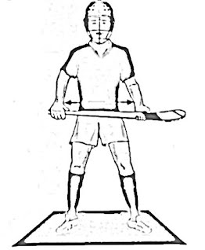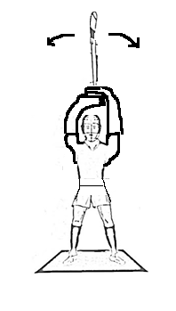

Fig 1 Fig 2 Fig 3 Fig 4