# Beginner Exercise 2 – Hitting Tyres (10 minutes)

1. In two groups have kids form a ‘líne’ (bus queue) at each end of the row of tyres (Fig. 1)
2. Have first child from each group WALK to first tyre in ready position and strike the tyre. Make sure children are at opposite sides of the tyre (Fig 2)
3. Make sure child moves to Lock Position before striking, and make sure they are bending their arms. (Fig 3)
4. When child reaches the end of the tyres, they join the other group at the end of the line, and second child from each group begins.
5. As the drill progresses you can have the second and subsequent children begin while the child ahead of them is only partially complete (at second or third tyre for example).
6. As children get comfortable you can ask them to jog (in the Ready position) between Tyres.

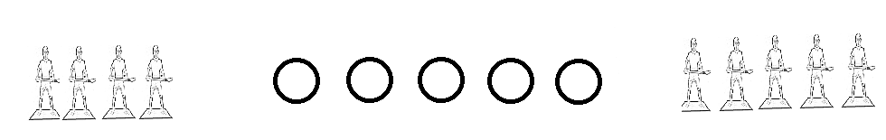Fig 1.

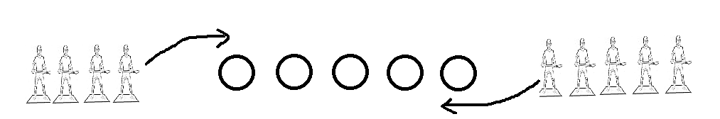

Fig 2.



Fig 3.