ANNUAL PLAN OF OPERATIONS

HENDRY SOIL AND WATER CONSERVATION DISTRICT

FY2015

Hendry Soil and Water Conservation District

The Hendry Soil and Water Conservation District is a dependent, non-taxing, political subdivision of the State of Florida, organized by the landowners of Hendry County. The first election ballots were cast on July 22, 1944.

The affairs of the District are managed by a Board of Supervisors, composed of five elected individuals. The Hendry Soil and Water Conservation Board meets the 4th Thursday of the month.

The District’s accomplishments are made possible by working in conjunction with the USDA/Natural Resource Conservation Service and the continued support from the Hendry County Board of County Commissioners.

A Unique Conservation Partnership

The Hendry Soil and Water Conservation District was established to provide assistance in identifying and solving natural resource problems.

The uniqueness of this conservation effort is that a partnership was established in 1948 between the federal government and our district.

The USDA/Natural Resources Conservation Service and the Hendry Soil and Water Conservation District work together to conserve, sustain, and improve the natural resources of Hendry County.
The District and the USDA/Natural Resources Conservation Service have a common goal of helping to bring about the conservation, development and wise use of land, water and related natural resources.

OUR MISSION: The mission of the Hendry Soil and Water Conservation District working in conjunction with the USDA/Natural Resource Conservation Service is to provide leadership in planning and administering programs to help conserve and improve our natural resources while protecting the environment.

OUR VISION: The Hendry Soil and Water Conservation District working in conjunction with the USDA/NRCS will provide information and service in an effort to solve natural resource problems.

OUR POLICY: The Hendry Soil and Water Conservation District working in conjunction with the USDA/Natural Resources Conservation service is committed to identifying and solving natural resource problems.

The Hendry Soil and Water Conservation District Board

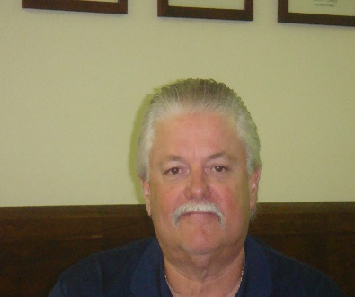
Chairman Bruce Hendry was appointed to the board in 1999. Mr. Hendry is a lifetime resident of Florida and a direct descendant of Captain F.A. Hendry, founder of Hendry County. He owns Bruce Hendry Insurance Co. and is a managing partner of BR Bar Ranch where he and his wife Karen reside. They have one daughter and two grandchildren.
Bruce Hendry, Chairman

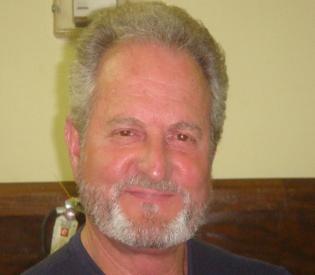
Robert “Bobby” McDaniel Jr. has lived in Hendry County all his life. Bobby was a Hendry County Commissioner from 1984 to 1996 and has also served on the Hendry Regional Hospital Board. He lives on, and helps operate the McDaniel Ranch. This family ranch consists of cattle, citrus and leasing of land to vegetable farmers. He and his wife have five children.
Robert “Bobby” McDaniel Jr.

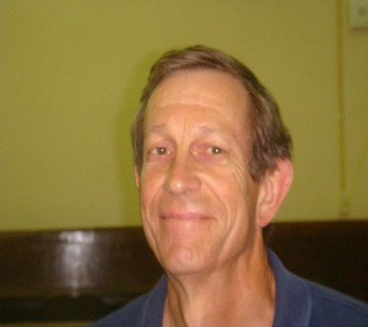
Supervisor Mabry McCray served as Supervisor from 1991 to 2000, he was re-elected in 2004. Mabry grew up on a farm near Mayo Florida but has lived in Hendry County since 1989. He worked for US Sugar Corporation for 13 years and the last 11 years has been employed by the University of Florida at the Everglades Research and Education Center. Mabry and his wife Chrystal have three children.
Mabry McCray

The Hendry Soil and Water Conservation District Board

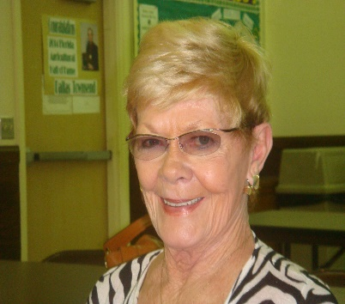
Supervisor Marilyn Sears was appointed to the board in 2013. She is the owner of Riverside Realty in LaBelle.
Marilyn Sears

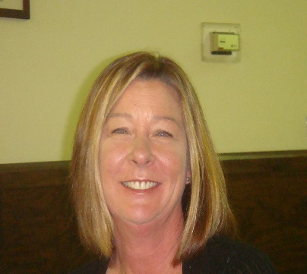
Supervisor Lisa Cleghorn was appointed to the board in 2014. Lisa grew up on a ranch in Northern Florida where her family raised cattle, corn, soy beans, tobacco and peanuts, she has lived in Hendry County for 25+ years. She is married to Travis Cleghorn a retired dairy farmer. Lisa and Travis own and run a ranch in Hendry and Glades County growing citrus, sugar cane and hay. Lisa is also an active real estate associate with Southern Heritage Real Estate specializing in Agricultural real estate.
Lisa H. Cleghorn

Hendry Soil and Water Conservation District Employee

Noreen Berden (Secretary/Office Manager) joined the F.O. staff in 2014 transferring from Hendry County Clerk of Courts office. Noreen was raised in LaBelle. She has a BS degree in business. She and her husband Dale have five children.
Noreen Berden

Jorge graduated from the University of Puerto Rico in 1977 with a BS degree in Agronomy. He retired in 2005 after 29 years with the USDA/NRCS. Jorge is a full time pastor and is presently working part time for the HSWCD. Jorge and his wife Asidalia have four children.
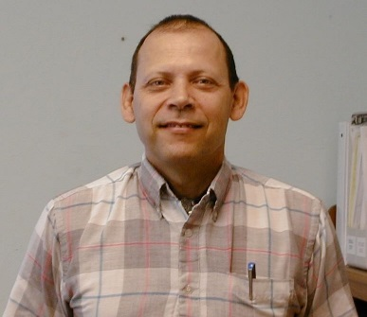
Jorge Rodriguez

USDA/Natural Resources Conservation Service Staff

Jim Sutter began duties as the new District Conservationist with the USDA Natural Resources Conservation Service in the LaBelle field office on November 17 filling the position vacated by Dan Rutledge’s retirement. Jim and his wife Vicki arrive here after spending the past 4 years on the big island of Hawaii where Jim worked for NRCS in the Kealakekua (Kona) field office and Vicki was an elementary school teacher. Prior to that, Jim spent 19 years of his career working for NRCS in southern Iowa and operated a cow/calf operation on his farm. During that time Jim worked as NRCS district conservationist in Lee and Davis county Iowa for over 9 years and other positions including civil engineering technician, soil conservationist, conservation technician and grassland specialist. He started his career as a conservation technician for the Iowa Department of Agriculture in his home county of Appanoose in 1988 and later transferred to the NRCS as a civil engineering technician in 1992. Jim is a 1984 graduate of Truman State University (formerly Northeast Missouri State University) in Kirksville Missouri and holds a degree in agriculture business.
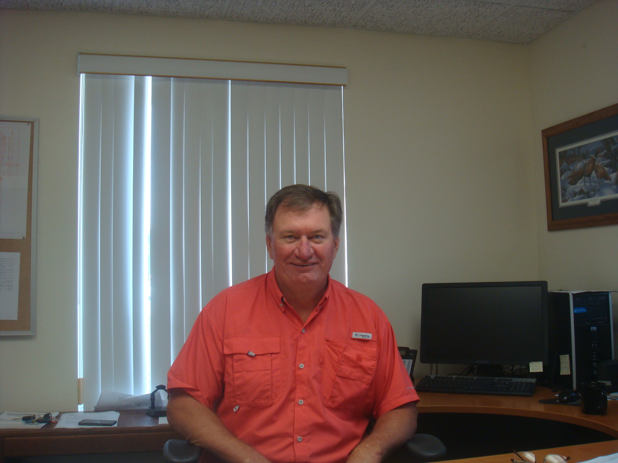
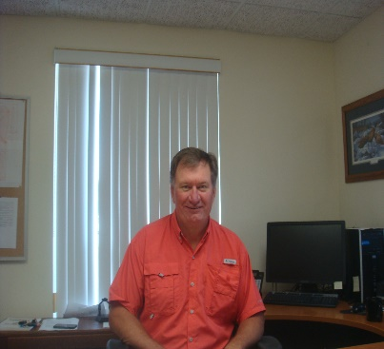
Jim Sutter

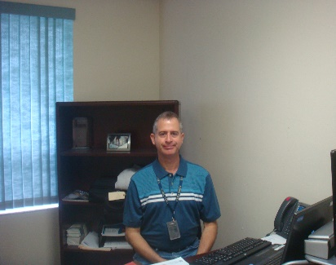
Jorge Ruiz has been a Soil Conservationist with USDA/NRCS since 1991 working in Puerto Rico for 23 years. He joined the LaBelle FO when he and his wife Ivette moved to Florida in December of 2014. Jorge is a graduate of the University of PR, Facility of Agriculture with a BSA is agronomy and soils.
Jorge Ruiz

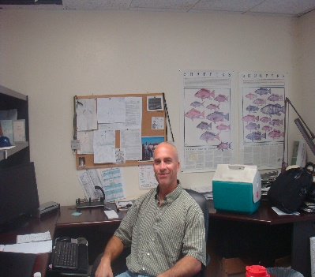
George Poole is the LaBelle FO Grazing Resources Specialist. He has been with the LaBelle office for 10 years. George has a bachelors degree in Wildlife Management. He and his wife Ivette have five children and they reside in Fort Myers.
George Poole

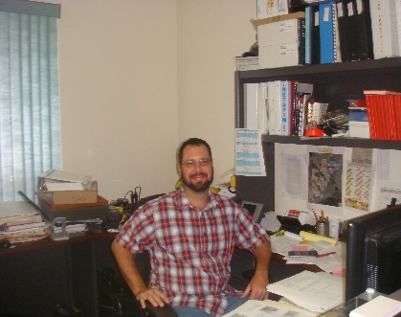
Chris Zimmerly graduated from LaBelle High School in 2002 and joined the LaBelle Field Office that November. Chris is now a full time Soil Conservation Technician with the agency. He and his wife Jessica live in LaBelle and have one child.
Chris Zimmerly

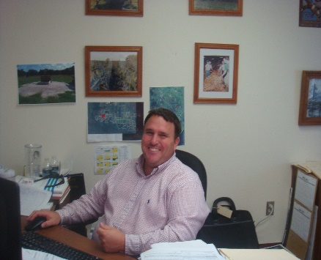
Cliff is a graduate of the University of Florida Agronomy department where he obtained his degree in plant science in 2002. He also was raised on a family row crop and cattle farm in North Florida. He started as a Conservation District Technician in Suwannee County in 2008 and later became a USDA/NRCS employee in 2010. He began his NRCS career in the panhandle of Florida and was transferred to Okeechobee service center in mid-2011. He then was promoted to Florida’s Tribal Liaison/Resource Conservationist and station in LaBelle to serve the field office and the local tribes. Cliff currently resides in Okeechobee where his wife works at the local hospital and his daughter and son attend elementary school.

Cliff Starling

Hendry Board of County Commissioners
The Honorable Janet B. Taylor District 1
The Honorable Darrell R. Harris District 2
The Honorable Don Davis District 3
The Honorable Michael Swindle District 4
The Honorable Karson Turner District 5

Map of Florida Counties
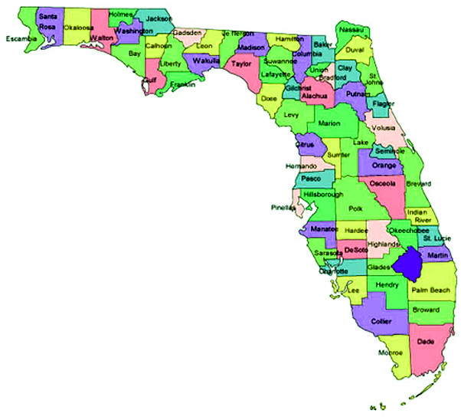
Map of Hendry County

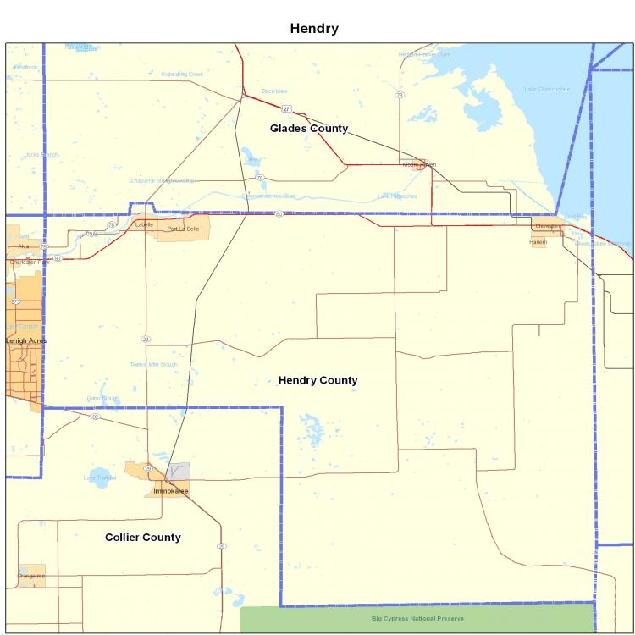

Description

Hendry County is in the South-central part of the Florida Peninsula. It is bordered
on the North by Glades County and Lake Okeechobee, on the Southeast by
Broward and Palm Beach Counties, on the Southwest by Collier County, and on
the West by Lee County.
The average population is 37,000 with the following breakdown: LaBelle 4,200,
Clewiston 7,100 and unincorporated 25,700.

Hendry County is Florida’s 63rd county and covers 774,013 acres, or about 1,210
square miles. The primary agricultural industries are citrus, sugar cane, vegetables
and cattle.

Hendry County has approximately 109,000 acres of citrus and 61,000 acres in
sugarcane. There are approximately 271,000 acres of pastureland with Hendry
County ranking in the top five in cattle production in the state. Hendry County also
produces cucumbers, squash, tomatoes, peppers, green beans and
watermelons.

Hendry County has an abundance of land zoned for industry and housing.

HENDRY SWCD OBJECTIVES

- Work in conjunction with the USDA/Natural Resources Conservation Service to assist landowners in managing Hendry County’s natural resources, i.e.: wildlife habitat, threatened and endangered species, water quality and quantity, wetlands, and soil sustainability by supporting the implementation of recognized and approved Best Management Practices.
- Promote the proper use and grazing of pasture and range lands in Hendry County through Best Management Practices.
- Promote soil and water conservation through educational and outreach programs through schools, FFA, 4-H and in the public sector.
- Assist landowners in utilizing existing conservation programs through other county, state, and federal agencies in order to protect land in both agricultural and developing areas.
- Promote special assistance to minority groups through special emphasis using newspapers, brochures, newsletters and website.

ACCOMPLISHMENTS

- Promotes and administers BMP (Best Management Practices) grant programs through the Florida Department of Agriculture and Consumer Services.
- Co-operates with the USDANRCS with administering EQIP (Environmental Quality Incentive Program).
- Assists with requests for technical assistance. Distributes Hendry/Glades Soil Survey and Plat Books. Promotes Stewardship Week and provides pamphlets and materials to schools and public sector on request.

EARTH TEAM VOLUNTEERS

The EARTH TEAM is sponsored by the USDA/Natural Resources Conservation Service and consists of individuals who care about our soil and water resources. They volunteer their time and services to be part of the greater conservation effort.
Volunteers must be at least 14 years of age, they may work full or part time, outdoors or indoors helping the USDA/NRCS and the Hendry Soil and Water Conservation District serve the public needs.
Our EARTH TEAM volunteers have assisted us with assignments ranging from field surveying and office work to barbecuing at sponsored events.
We are proud of our volunteers and would like to acknowledge and commend them for their dedicated service.

