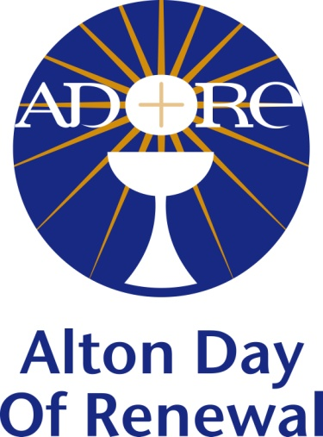

CONSOLIDATED ACCOUNTS 2018

Balance brought forward from 2017 | £ 122.39
Income from donations | £ 3,494.12
Gifts to speakers and priests | £ 1,855.00
Room hire, equipment, copyright licence | £ 707.10
Publicity (brochures, posters, website, advertising) | £ 550.36
Stationery & Postage | £ 287.03
Charitable donations to other causes | £ 130.00
Total expenditure | £ 3,529.49
Balance carried forward to 2019 | £ 87.02

