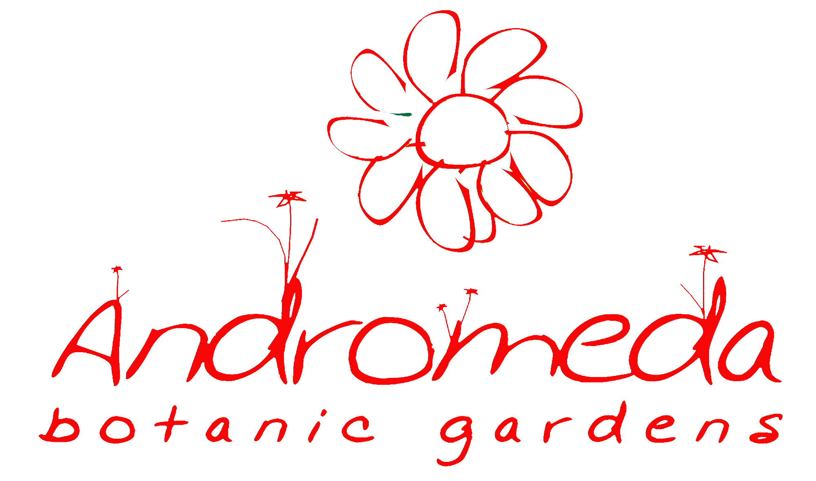

Passiflora Ltd, Andromeda Botanic Gardens, Bathsheba, St Joseph 246-433-9384
www.andromdabarbados.com

ABG Membership Form -
Thank you for choosing to become a member of Andromeda Botanic Gardens. Please print, complete and return the registration form and remittance by post or in person:
Andromeda Botanic Gardens, Bathsheba, St Joseph. Please make the cheque payable to Passiflora Ltd.
or email to sharon@andromedabarbados.com and phone with card details
or phone with information below and card details: 433 9384
Annual Membership – BD$55. For the inaugural 2018 membership, cardholders get Sept-Dec 2017 free.

Name |  | Age
Address
Telephone numbers
Email Address
(Optional) Nationality
(for statistical purposes only)
Which aspects of membership are you particularly interested in?  Tick all that apply | Unlimited Entrance into Andromeda
 | Free entrance into selected UK Gardens
 | Workshops/Lectures
 | Plants
 | Supporting development of Andromeda
 | Other – Please specify

Membership cards will be posted to you or can be collected from Andromeda Botanic Gardens.
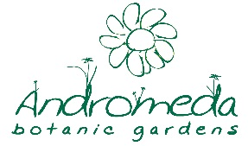

Passiflora Ltd Registered Address Newcastle New Road, Newcastle, St John

