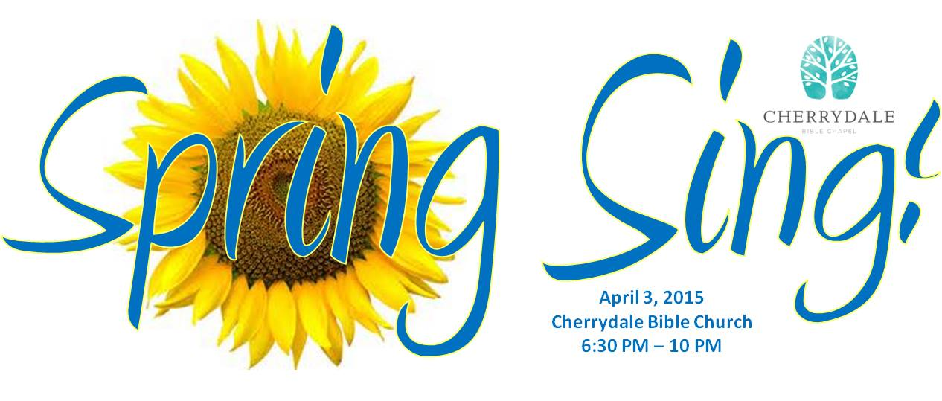

Come out for a music night at Cherrydale Bible Church!
All are welcome for a night of singing, praise, food, and fellowship on Friday, April 3rd. This is Good Friday, so come ready to sing songs about the Cross and Resurrection! Bring your friends and family along for an evening you won't want to miss! Light food will be served at 6:30 p.m., with singing to follow.
Cherrydale Bible Church is located just off of Lee Highway near I-66 in Arlington, Virginia.

Cherrydale Bible Church
1905 N. Monroe St.
Arlington, VA 22207

