Feed My Lambs
How to Communicate God’s Word Effectively
April 25th – 26th, 2014

Schedule
Friday: 7:00 p.m. Potluck Fellowship Supper
9:00 p.m. Session End
Saturday: 9:00 a.m. Sessions Begin
5:00 p.m. Sessions End
Topics
- How to Build Up the Saints Through the Teaching of the Word
- How to Formulate a Sermon Thesis
- How to Prepare a Sermon Efficiently
- How to Deliver a Sermon Effectively
- How to Raise Up the Next Generation of Bible Teachers
- How to Use God’s Word in Evangelistic and Pastoral Ministry

All invited. All sessions at CBC. Lunch details to follow.

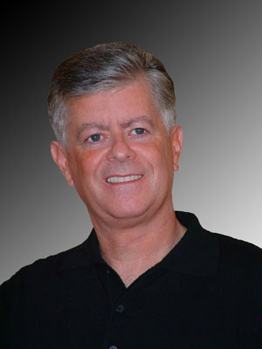
Jim McCarthy is a Bible teacher, conference speaker, and author from San Jose, California. He and his wife, Jean, came to Christ in their mid-twenties through a home Bible study. In 1981, Jim graduated from the Discipleship Intern Training Program (DITP), a nine-month program of Bible instruction and practical training in San Leandro, California. In 1983, Hillview Bible Chapel in Cupertino, California, commended Jim and Jean to fulltime Christian ministry. In 1984, the McCarthy’s moved to Ireland to assist two Irish churches, returning to California again in 1986 when Jim was asked to join the faculty of the DITP. In 1999 Jim helped start Grace Bible Chapel in San Jose, where he presently serves as an elder. He continues to teach in the DITP, now hosted by Grace Bible Chapel and Hillview Bible Chapel. He also is the founder and instructor of the Galilee Program, a summer discipleship program held in Lafayette, Louisiana.

