Upcoming Social Activities for May-June-July

- Sat. June 2 – 9 AM - Pancake Breakfast – $3
– 10 AM - Board Meeting (open to all residents)
Saturday June 9 – 5:30PM – Belmont Stakes Party
(BYOB & hors d'oeuvres)
- Sat. June 23 - Pizza Night - 5:30 - $5
- Sat. July 7 – 9 AM - Board Meeting (current Board)
- 10 AM - ANNUAL MEETING for all residents
- Sat. July 7 – 3 PM - Annual Picnic Potluck @ Legend Park
(burgers & dogs provided, bring a dish to pass)
- Sat. July 21 – Pizza Night - 5:30 - $5

There are three 3-year Board positions to fill this election year. The terms of service for Polly Buchanan, Laura-Hart-Smith and Tom Jeffery will expire on June 31, 2018. Are you the candidate EFPOA is looking for? If so, draft your resume of no more than 200 words, in one or two paragraphs, describing your background and the expertise you can bring to the Board. Send it to the Elections Committee, PO Box 40, Waters, MI, 49797. It must be postmarked by May 25, 2018.

Ballots will be mailed June 1, 2018. Only property owners in “good standing” (paid dues) are entitled to cast a vote. Ballots are numbered for security and verification purposes only and do not represent lot numbers, addresses nor are they used to track votes. One ballot per each lot you own will be issued. You can vote for up to 3 candidates per ballot. Any ballot with more than 3 votes or writing of any kind, other than the check-box, will invalidate the ballot.

The official announcement of the 3 new Board members will take place at the Annual Board Meeting, Saturday, July 7, 2018 at 10:00am. Please consider running for a Board position; we need resident input to make current and future plans for Guthrie Lakes. Also, make sure you vote and by all means, come to the Annual meeting. This is your Association and we need you!

Enchanted Forest Property Owners Association (EFPOA) – Website: www.efpoa.com
Mailing Address: PO Box 40, Waters, MI 49797 - Club House Phone: 989.732.1942 - Email: efpoa@efpoa.com

EFPOA Board Elections Coming Soon!!
May 2018
Guthrie Lakes
LYRIC

President: Tony Esson
E: tony@anthonyessonarchitect.com
Ph: 989.350.1827

Vice Pres: Ron LeBourdais
E: rlebourd@live.com
Ph: 989.732.0730

Treasurer: Nancy Gregg
E: njgregg65@gmail.com
Ph: 989.732.4579

Secretary:
Brooke Joyner
E:brookejoyner34@gmail.com
Ph: 989.619.3267

Directors:
Fred Novack
E: novackbf@att.net
Ph: 989.732.7215

Laura Hart-Smith
E:lahartsmith24@yahoo.com
Ph: 989.619.1274

Tom Jeffery
E:txj48335@sbcglobal.net
Ph: 989.732.8292

Chad Canda
E:ccanda@valspar.com
Ph:989.889.5062

Polly Buchanan
E: pbuchanan@emich.edu
Ph: 734.358.5282

Management Staff:
Sherice Esson - Business
Thomas Hall - Facilities
E: efpoa@efpoa.com
Ph: 989.732.1942
Board of Directors

From the President
By Tony Esson

We are just a few days away from our annual Memorial Day weekend kick-off to the 2018 summer season. The docks are in, the pool is filled and ready, and Sherice has been busy planning social events for the coming months.

Planning for renovations to the pool and locker rooms is on-going and progressing nicely; we will have a detailed presentation on this project for the membership at the Annual Meeting on July 7, 2018 at 10 AM at the Clubhouse.

Our Memorial Day weekend festivities will again include Dumpster Day starting on Saturday morning followed by a Grilled Chicken Potluck Saturday evening at 5:30 at the Clubhouse. We will have a large dumpster at the Clubhouse to help with your spring clean-up projects. Plan to get here early Saturday, as the Dumpster will fill up fast. Our Memorial Day celebration will also include a ceremony at 3 PM on Monday, Memorial Day; light refreshments will be served.

Please join us at the Clubhouse for one of these special events or activities, or simply stop by and have a warm cup of coffee with friends and neighbors.

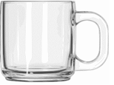
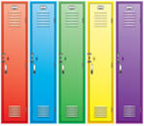

In Memoria to the Following Guthrie Lakes Residents
Mary Ellen Gleeson (Lot # 459 at 11407 Enchanted)
Pat Guthrie (Lot #436, 2582 Hidden Isle)
Delphine Snyder

Higher Water Levels this Year by Fred Novack

Have you noticed over the past few years that the water level in Guthrie Lake, Section One Lake and other Michigan lakes is on the rise? Our two lake levels are now above their normal established shorelines. This means that anything touched by the water could end up as debris in our lakes including such things as soil, sand from our beaches, grasses along the edges, tree branches and even whole trees may end up in the lake. Natural wave action can eat away at the shore lines, and over time permanently change it.

Just imagine the effect of boating wakes on lake edges; they can be very devastating to our lakes. So please use extra caution this year as you enjoy our beautiful lakes. And remember, if you use fertilizer of any kind, keep it at least 25 feet away from the lake edge. Fertilizers are known to cause algae growth in lakes. Excessive algae growth can cause a release of toxins, odor, even taste in the water, and unbalance our ecosystem in the lakes… and we DON’T want that in our beautiful lakes!

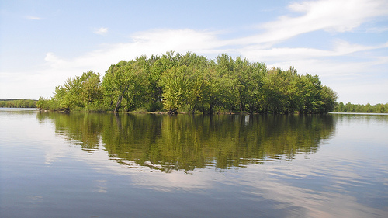

SUMMER CLUBHOUSE HOURS starting Memorial Day Weekend

Monday through Thurs. 9 AM to 9 PM
Friday and Saturday 9 AM to 10 PM
Sunday 9 AM to 8 PM

Pool & Boathouse Friday-Sat-Sun – Noon to 6 PM
For other hours, see Clubhouse Manager

Let’s Review EFPOA Rules and Regulations

The last 11 pages of the Guthrie Lakes Property Owners Directory always includes the entire Rules & Regulations document. With summer approaching and more outdoor activities occurring, let’s review some of the basic rules that some residents have forgotten.

- Who has been shooting in the neighborhood?? Under General Regulations #2 it clearly states that “hunting, trapping, and the discharge of firearms or any other weapon” are prohibited. Archery ranges on your own property are allowed if the range has been approved by the EFPOA Manager.
  - FYI: Michigan Hunting rules state on pg. 16 that “no hunting with a firearm is allowed within 450 ft. of an occupied building.”

- What are the rules for garbage/trash pick-up? Under General Regulations #4, garbage and rubbish are collected every Wednesday must be in animal-proof sealed containers, and only put out the night before; if not home to do this, ask a neighbor to help you out. Containers must be taken in the next day… not left out for days and days. Only one large item (i.e., a couch or bed) can be left for pick-up each month.

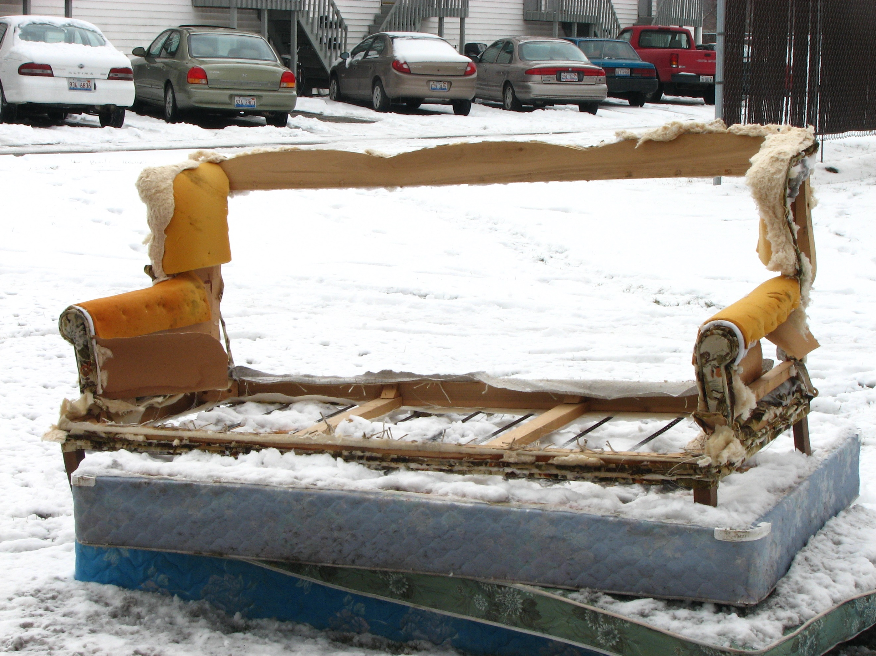

- How messy is your yard?? Under General Regulations #11 it states that owners are required to maintain their lots in a “clean and attractive state” as interpreted by the Manager. If violated, warned and not corrected, an owner will lose their good standing with EFPOA (not be able to use ANY amenities, i.e., swimming pool or clubhouse) and will be reported to Otsego County. After an official county warning, a ticket will be issued if clean up is not accomplished.

- How fast are you driving around our neighborhood? For the safety and well-being of bikers, walkers and children, a speed limit of no more than 25 miles an hour is advised.

SUPPORT OTSEGO COUNTY RECYCLING DROP-OFF PROGRAM

It’s really easy to recyle in our county; items only have to be separated two ways… in to “Mixed Containers” and “Paper, Boxes & Bags”. Below is a review of what items belong in each category.

MIXED CONTAINERS (Rinse and flatten everything possible… so more fits in!)
- All plastics #1, 2, 3, 4, 5, 6, 7 (NO juice pouches or straws). Labels are ok.
- NO styrofoam, motor oil jugs, toys, durable dishes
- No cornbased plastics (PLA) or “biodegradable” plastics
- No plastic shopping bags… they belong in with Paper, Boxes Bags
- Metal cans, foil and trays; aluminum, steel and tin ok, NO aerosol cans or propane tanks
- Glass bottles & jars; clear, green brown and blue; labels are ok, No light bults, window glass or dishes
PAPER, BOXES & BAGS
- No packing materials, syrofoams, or pet food bags; NO loose plastic bags (stuff all bags into one bag and tie it shut; grocery bags must be clean and dry.
- Shrink wrap is OK like around rolls of paper towels or cases of water bottles.
- No cling wrap, no cereal box liners but boxboard from cereal boxes is OK, & paper towel tubes
- No “crunchy” plastics like potato chip bags
- Newspapers are ok but must be DRY
- Hardcover, paperback and phone books are OK
- Office paper, junk mail, file folders, shredded paper in transparent bags tied shut, NO construction paper or dark or bright copy paper; NO padded or plastic envelopes
NO NEED to remove: rubber bands, paper clips, sticky notes, staples, tape.

The closest location to us is: 247 Old State Road across from the Otsego Lake Township Cemetery north of Waters, MI Half-mile east of the intersection of Old 27 South and Old State Road. For more information, please visit www.otsegorecycling.org.

