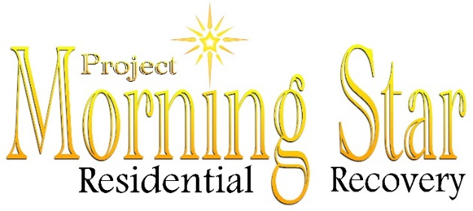
VOLUNTEER APPLICATION
Project Morning Star provides a safe, structured and sober living environment to those in long-term recovery. We are a nonprofit organization that relies heavily on volunteers that have a heart for those we serve. Our goal is to foster the necessary spiritual growth, emotional stability and personal integrity to allow our residents to pursue rewarding lives.

Name:_______________________________________________________________________________
Address:_____________________________________________________________________________
City:_________________________ State:__________________________ Zip:_____________________
Phone:____________________________________ Email:_____________________________________

Personal References:
Name:_______________________________________________________________________________
Address:_____________________________________________________________________________
Phone:_______________________________ Email:__________________________________________

Name:_______________________________________________________________________________
Address:_____________________________________________________________________________
Phone:_______________________________ Email:__________________________________________

Areas of Interest

Special talents or skills you have that you feel would benefit our organization:____________________
____________________________________________________________________________________
_____________________________________________________________________________________
Areas of Need: Please check those areas that you are interested in:
Provide transportation to and from work, meetings, treatment, appointments, and church
Grant writing
Website and Facebook assistance
Office work
Basic maintenance and property repairs
Outside maintenance
Gardening/landscaping
Resident mentorship
Childcare

Availability:
Mon Tues Wed Thurs Fri Sat Sun

Times Available: From:_____________ To:__________________
Do you have any physical limitations we need to be aware of?_________________________________
If the position you are interested in are you willing to submit to a background check?______________
Emergency Contact Information: Name:___________________________________________________
Phone:______________________________________________________________________________

As a volunteer at Project Morning Star, I agree to abide by the policies and procedures. I understand that I will be volunteering at my own risk and the Project Morning Star, it’s employees and affiliates, cannot assume any responsibility for any liability for any accident, injury or health problem which may arise from any volunteer work I preform for the organization. I agree that all work I do is on a volunteer basis and I am not eligible to receive any monetary payment or reward.
Signature:_____________________________________________Date:___________________________

