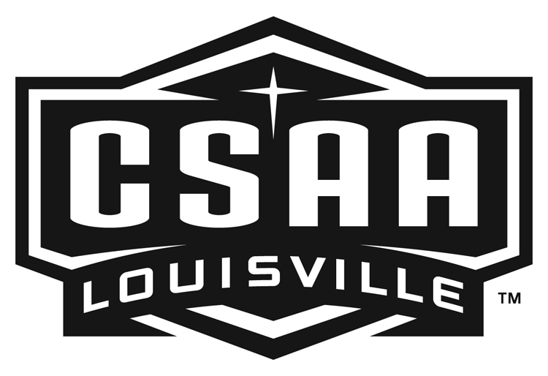
Catholic School Athletic Association
1949 Goldsmith Lane, #101, Louisville, KY 40218
(502) 456-2722 e-mail: info@loucsaa.org

2014 CSAA Tennis Championship

To all AD’s and Tennis Coordinators, April 27, 2014

The CSAA tennis tournament will take place June 9TH - June 12TH at Mercy Academy and Sacred Heart Academy.

The CSAA Tennis tournament is open to boys and girls in grade school who are eligible members of your parish. The divisions are divided into a Senior Division (7th /8th) and Junior Division (5th / 6th) and a 10 and under CO-ED division supported by the USTA. An advanced bracket for the Sr. Division may be added pending the number of advanced players.

Please list the LIRC/USTA rating of the player or N/A if they do not have a rating. You do not need a rating to participant in the CSAA Tennis Tournament. Please take notice of the new 10 and under division, sponsored by the USTA.

The championship bracket will be for 1st through 4th place. The consolation bracket will play for 5th and 6th place.

AWARDS: Team trophies will be awarded to the winner and runner-up teams in the Jr. and Sr. Division for Boys and Girls teams. Individual awards will be given for 1st through 6th place in the Jr. and Sr. Division for the Boys and Girls divisions.

FORMAT:
Front Draw - 8 Game Pro-set (no AD scoring). Semi-Finals and Finals 2 out of 3, 3rd set 10 point tie break.
Consolation Bracket will remain an 8 game pro set format.

FEE: $11.00 per entry. Each school will be sent an invoice from the CSAA office. No payments will be accepted on site.

Each entrant is required to supply a tennis racket and tennis shoes and must know how to keep score. Tennis balls will be furnished by the CSAA. Please complete the enclosed entry form with all applicable information. This information must be in the CSAA Office by May 15th, No entries will be accepted after this time, no exceptions.

Tournament play will begin on the morning of Monday, June 9th. If we get rained out on Monday June 9th it may be necessary to cancel the consolation bracket. All participants must be eligible to play the entire week. Weather delays may occur and changes to the schedule may be necessary. If a participant can not complete the entire tournament due to other social engagements, vacation, or other commitments, please do not sign up for the CSAA tournament.

The tournament draw will be e-mailed to the coaches and posted on the CSAA web site at www.loucsaa.org. It will be the coach’s responsibility to inform each player of their match times.

10 AND UNDER CO-ED MATCHES (USTA SPONSORED):

FORMAT: 10 AND UNDER – UP TO 25 INCH RACKETS, 60 FOOT COURT, ORANGE BALL, WITH SHORTENED SCORING.

WHEN: JUNE 9TH - 12TH

LOCATION: SACRED HEART OR MERCY

START: 9:00 AM

FEE: $11.00

Please fill out and return the attached sign up form(s) to the CSAA office by May15th so the tournament brackets can be completed and sent to all CSAA coaches.

