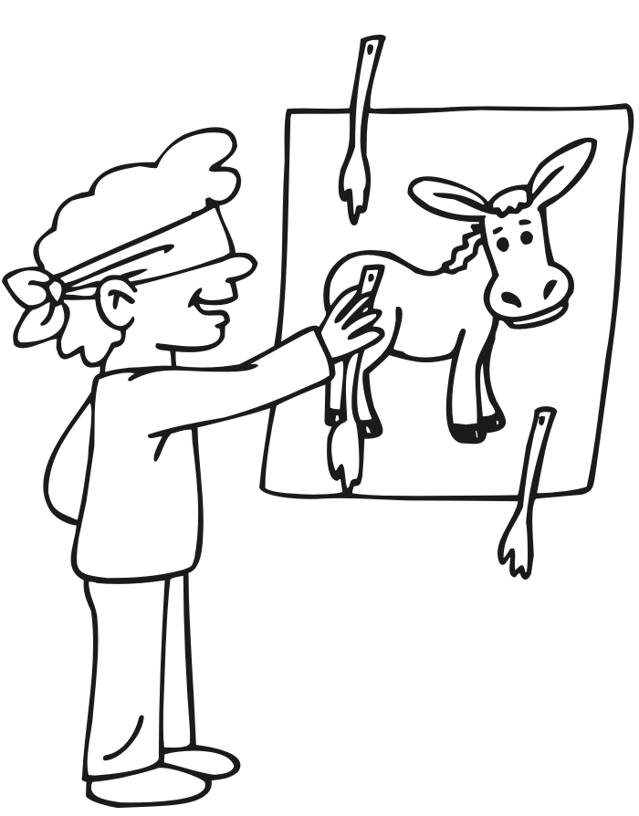 by Bob O’Baldwin™
Assessment Challenges: Pin Your Taxes on Your Donkey Neighbor
If everyone challenged their assessments and everyone won a 50% reduction, no one’s taxes would go down. Because the school districts always get their POUND OF FLESH. If you win an assessment challenge, your neighbor’s taxes go up. And visa versa. The school district has to collect the money from someone.
Your vote for “ the budget” is a disguised vote for higher taxes. For 50+ years, the Baldwin School District has raised taxes every year. This year they want $ 2 million more, a 2% tax hike.
The current local total tax assessment (which the voters raise every year is $ 95 million. The $ 1500/ home STAR subsidy by NY State reduces this to $ 80 milion.
The proposed SCHOOL BUDGET 2019 is $ 130 million. Additional NY State Aid is $ 32 million. Of the $ 130 million, NY State pays $ 47 million from your NYS income tax & your sales tax.
In 2008, our Baldwin School budget was $ 100 million and there were 5300 students. Next year, the budget is $ 130 million for 4500 students.
More for less. But more for the salaries & benefits of our Educators. Who is the real donkey?

