SECOND SUNDAY AFTER EPIPHANY

Bethlehem/Zion Lutheran Parish January 20, 2019 Rev. James Norton Ludington & Fall Creek, Wisconsin Linda Wiese, Organist 715-514-5478

● ● ● ● ● ● ● ● ● ● ● ● ● ● ● ● ● ● ● ● ● ● ● ● ● ● ● ● ● ● ● ● ● ● ● ● ● ● ● ●

LSB P. 235; Morning Prayer LSB Hymns: 802, 770, 803

Old Testament Reading: Isaiah 62:1-5
Epistle: 1 Corinthians 12:1-11
Holy Gospel: John 2:1-11

The Message: "Only the best from God"
Text: John 2:1-11

● ● ● ● ● ● ● ● ● ● ● ● ● ● ● ● ● ● ● ● ● ● ● ● ● ● ● ● ● ● ● ● ● ● ● ● ● ● ●
This Week’s Schedule

Sunday, January 20, 2019 9:00am Zion Worship Service
9:00am Bethlehem Sunday School &
Adult Bible Study
10:00am Zion Sunday School
10:30am Bethlehem Worship Service--
Followed by Potluck and Annual Meeting
7:30 pm Dartball makeup game-Beth.

Monday, January 21 9:00am Quilting @ Bethlehem
Tuesday, January 22 7:30pm Dartball @ Bethlehem
Wednesday, January 23 5:00pm Confirmation
Thursday, January 24 7:00pm Bethlehem Sunday School Teachers Mtg

Please note time change:
Sunday, January 27, 2019 * 9:00am Bethlehem Worship Service and
Sunday School; No Adult Bible Study
9:15am Zion Sunday School
10:30am Zion Worship Service followed by
Potluck and Annual Meeting
● ● ● ● ● ● ● ● ● ● ● ● ● ● ● ● ● ● ● ● ● ● ● ● ● ● ● ● ● ● ● ● ● ● ● ● ● ● ●
*** Be sure to sign the Red Fellowship Folder on the aisle side of your pew.
Happy Birthday this week to: Kathy Berlin, Sharon Tumm, Karon Davidson, Christina Hausmann, Genevieve McCann, and Beverly Curler.

Please remember in your prayers: Pat Biegel after knee replacement last Wednesday
at Oakleaf, Dorothy (Noel) Smith, Don Lane, Bev Curler, Paul Leverty, Penny & Olivia Schmidt, Martha Jaenke, Pastor Jones at Zion-Chippewa, Diane Goss, the grandson of Eugene and Dotty Neumann, Drake, who was hurt snowboarding; shut-ins and members living in Care Facilities.
OUR NURSING HOME RESIDENTS HOMEBOUND
Augusta--Diane Goss--Zion Brian Markham--Beth
Geneva Smith--Beth. Carol Huff--Zion
Eileen Hagedorn--Zion Don Berlin--Beth.
Amy Bergman--Zion Ellie Grunewald-Beth
Naomi Sudbrink--Beth. Delores Starck-Beth.
Winifred Boyea-Wicksey-Zion
Marlene & Bo Tessmer-Beth.
Also in nursing homes, or assisted living: Phyllis Peterson-Zion
Bev Curler...Oak Gardens Place, Altoona
The Manor, Chippewa Falls--Delores Staats, (Marilyn Norton’s mother)
Grace-Woodlands, Eau Claire--Florence Korn-Beth. Neillsville--Dorothy Solberg-Beth.
Stanley--Robert Reppe-Zion River Pines, Altoona--Julia Phillips-Beth
Prayer Chains: Zion, Betty Woodford 715 877 3225; Bethlehem, Sharon Tumm 715 877 2402

Save the date: The Mission Board is having their annual Soup dinners at Bethlehem on February 10th, and at Zion on February 17th. Please plan to attend this fund raiser. Congregations are asked to bring desserts.

Today is the Annual Voters meeting at Bethlehem. There will be a potluck following the church service, and then the meeting. All adult members of the congregation should plan on attending if possible. Please let Marvin or an elder know if you are willing to serve on a Council position. We are in need of a church treasurer. Prayerfully consider helping in this position or ask the Lord to guide someone to help out. ALSO, THE SUNDAY SERVICE & SUNDAY SCHOOL ON JANUARY 27TH, WILL BE AT 9:00 AT BETHLEHEM, so that Zion can have their annual meeting and Pastor can attend.
Today in Sunday School, the lesson was “The Boy Jesus in the Temple.” As a boy, Jesus was found in His Father’s house. In God’s house I hear His Word, see that Jesus is my Savior, and receive His gifts of forgiveness and salvation. Because of sin, we are like Jesus’ parents and do not understand what God says to us. We don’t recognize who Jesus truly is—our Savior. Ask your children, “How does the Holy Spirit help identify who Jesus is?”
Lunch at Zion, today, is hosted by the Mission board, with funds going to send kids to camp. Be sure to join us for food and fellowship and to support these ministries.
Zion is seeking someone to take over the treasurer position, as Chris would like to resign from this position. Please, prayerfully consider if you would be able to fill this need.
Elaine Frank is resigning as Board of Education chair. If you would be interested in serving on the board of education please talk with her as to what it entails.
Zion congregation and choir is also, still seeking someone to take the position of church organist. If you know of someone who would do this, please talk to Dave Kiesow.
Zion’s Annual Meeting will be held on January 27, 2019. The Worship service will be held at 10:30, followed by a potluck and then the annual meeting. Sunday School will be at 9:15. All adult members of the congregation need to plan on attending the meeting. Please prayfully consider helping in the positions that are needed or ask the Lord to guide someone to help out.
A Valentine's dinner is planned for February 10th at Zion....with a movie to follow the meal. Please join us for a fun afternoon of good food and fellowship.

Our Worship Response 01/13/2019

Bethlehem Zion
Attendance 88
Offerings $1401.00 unavailable
Building Fund 25.00
Weekly Budget Needs: $1185.24 $1138.00

SECOND SUNDAY AFTER EPIPHANY, JANUARY 20, 2019
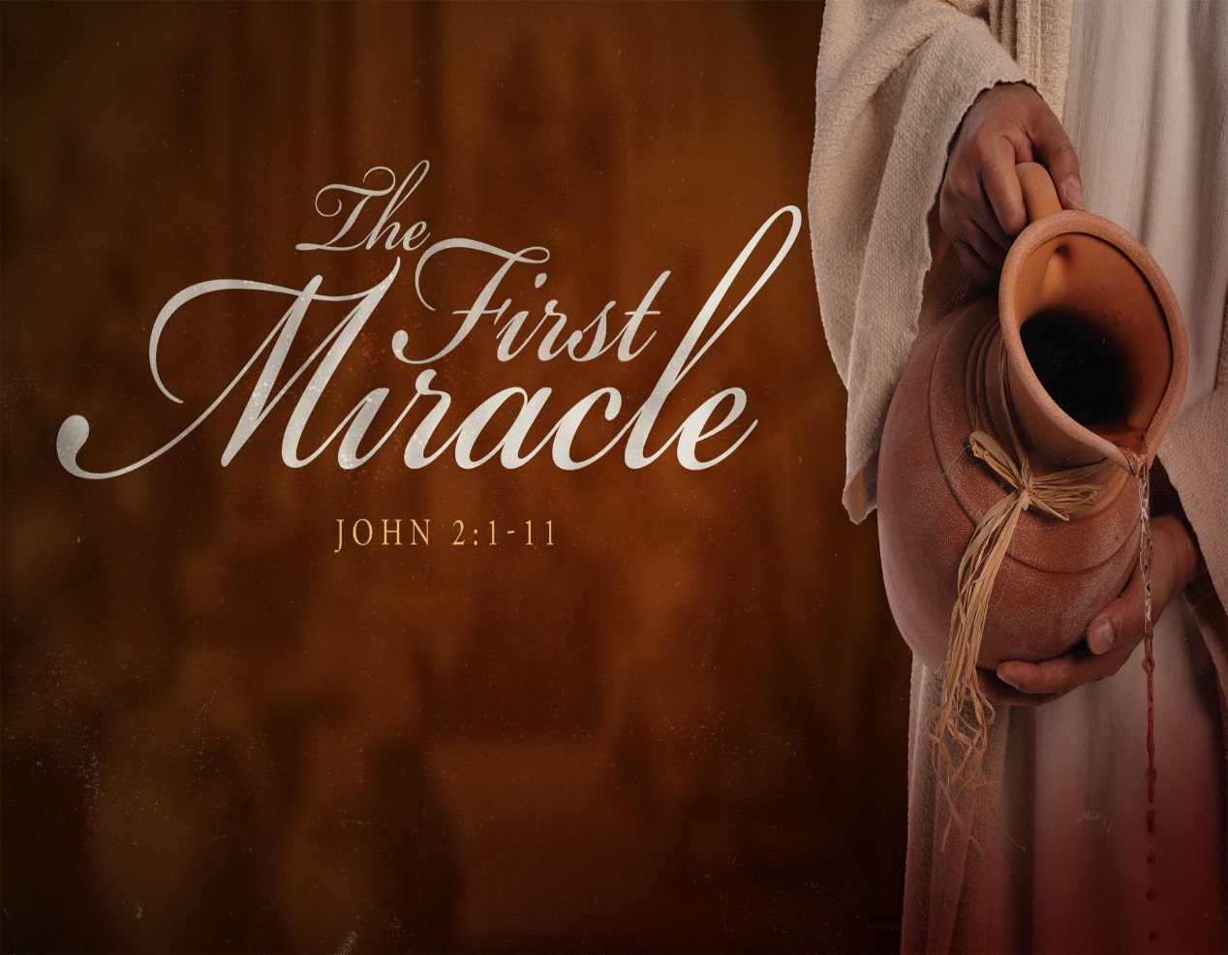
BETHLEHEM-ZION LUTHERAN PARISH
Pastor – Rev. James Norton, (715)514-5478 or cell 1(217)725-2487

Bethlehem, Parish Office (715) 877-3249 - E19675 St. Rd. 27, Fall Creek, WI 54742
Zion (715) 877-3128 - 1286 S 150th Ave, Fall Creek, WI 54742

Web address: www.zion-bethlehem.org Facebook: Zion-Bethlehem Lutheran Church e-mail – countryc@centurylink.net

Bethlehem Lutheran Church reaching out to our community and to the world with the gospel of Jesus Christ.
Zion Lutheran Church seeks to preach and teach God’s word to all people of all ages and show
God’s love through our witness, fellowship and service.

