Bethlehem Lutheran Church
E19675 State Road 27
Fall Creek, WI 54742

OCTOBER 2018 HIGHLIGHTS
Worship Services are held Sunday at 9am @ Zion, & 10:30am @ Bethlehem
Communion is offered on the 2nd and 4th Sundays of the month
SUNDAY SCHOOL: ZION 10:15AM, BETHLEHEM 9AM
CONFIRMATION is every Wednesday 5-6pm

October 3d – Zion Ladies Aid @ noon with potluck
October 4th - Council Meetings @ Bethlehem 7:00pm
October 11th – Bethlehem Ladies Aid @ noon with potluck
October 14th – Bethlehem’s Fall Fest
October 25th – Bethlehem Sunday School Teachers Meeting

Zion Lutheran Church
1286 S 150th Ave.
Fall Creek, WI 54742

OCTOBER 2018 HIGHLIGHTS
Worship Services are held Sunday at 9am @ Zion, & 10:30am @ Bethlehem
Communion is offered on the 2nd and 4th Sundays of the month
SUNDAY SCHOOL: ZION 10:15AM, BETHLEHEM 9AM
CONFIRMATION is every Wednesday 5-6pm

October 3d – Zion Ladies Aid @ noon with potluck
October 4th - Council Meetings @ Bethlehem 7:00pm
October 11th – Bethlehem Ladies Aid @ noon with potluck
October 14th – Bethlehem’s Fall Fest
October 25th – Bethlehem Sunday School Teachers Meeting

THE BEGINNING OF EVIL

After creation, God declared everything to be good. How long Adam and Eve lived in peace and harmony is not known. What we do know is that according to Revelation 12:7, some of the angels in heaven rebelled against God and were removed from their exalted position and thrown down to earth.
Instead of bettering their condition, they lost everything good and could now do nothing but evil. In revenge for what had befallen them, the devil plotted harm against God and His Kingdom.
Concealing himself in a serpent, the devil led Eve to act on her own free will to disobey God’s command to not eat from the tree in the middle of the Garden of Eden. Against his better knowledge Adam made the same wrong choice and followed his wife in the same disobedience. Mankind was now sinful and condemned.
Were Adam and Eve now like God as the devil promised? Instead of greater wisdom and happiness, they now saw that they were naked and were ashamed. They had lost the gift of eternal life and now were subject to death.
This is what we have inherited from our first parents. Disobedience is now the norm for us earthly creatures.
But God did not reject us from the family. He did not justifiably turn His back on us because we had disobeyed. Right after their disobedience, God promised Adam and Eve that He would send a deliverer who would crush the head of the devil and restore mankind to family status.
This deliverer we know to be Jesus Christ. He was born as a baby in Bethlehem, took our place under God’s law, suffered the pain and humiliation and shame of the cross to take the punishment we deserve for our sins. He died our death, suffered hell and rose from the grave, thus crushing the head of the devil and taking away the power of death for all mankind.
In Jesus Christ, God has good news for the world. Take heart—your sins are forgiven. Stay close to your only Savior, Jesus Christ and eternal life is once again My gift to you.
Pastor James E. Norton

BETHLEHEM LUTHERAN CHURCH
Website: zion-bethlehem.org
Facebook Address: Zion-Bethlehem Lutheran Church
Email: countryc@centurylink.net
Office Telephone (715)877-3249
Address: E19675 State Road 27, Fall Creek, WI 54742
Bethlehem Lutheran Church reaching out to our community and to the world with the gospel of Jesus Christ.

BETHLEHEM LADIES AID:
Joan Boyea, our president, attended the LWML Retreat at Camp Luther. She found it very, very inspiring.
The Lutheran World Relief quilts will be delivered soon. Thanks to those of you who helped in any way. We plan to sell the three ex-large quilts at Fall Fest. LWML Sunday is on October 7. We plan to serve ice cream and pie following the church service and we will wear our Thrivent shirts. We begin our Fall Quarterly on October 11, “Grace upon Grace.” October is Mite Box month.

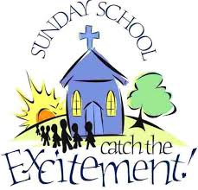
In October, Sunday School students will begin a series of lessons about Moses: the birth of Moses, Moses and the burning bush, Moses and the Plagues, & the account of the Passover. Also remember to ask students about their memory work and bible verse each week. Sunday School teachers next meeting will be Thursday, October 25th. Children will be singing on Reformation Sunday, October 28th.

IT’S COMING! Be sure to sign up for helping out on the list posted by the kitchen door. Pick up your tickets to sell for Fall Fest. They are available from MaryAnn Koch in the narthex every Sunday. We also have posters available for you to pick up and post in your town/area. With everyone’s help we can get the word out to make our Fest a successful one this year.
October 14th is our Fall Fest date. We need pies for the dessert, cakes for the cakewalk, items for the bake sale, craft items, and donations for the raffle prizes. Whatever you can do is greatly appreciated. Let’s work together to make this an exciting Fest, and generate income to do the Lord’s work here at Bethlehem!

Bethlehem’s Adult Bible Study Class has resumed and will meet every Sunday at 9:00am. They are currently studying Confession and Absolution, & Communion. Feel free to come and attend whenever you can.

The tentative date for the start of this year’s youth group meetings will be Sunday Oct 14th from 6:30-8 PM. This is open to all youth 5th-12th grade. Come and join us for an exciting evening.
Chior Practice after service for upcoming season. Join us!

BETHLEHEM - Monthly Council Meeting Minutes, September 6th, 2018
Treasurers Report: August report of income/expenses was reviewed and will be posted on the bulletin board. There is currently $9, 117.71 in the Building Fund.
- MOTION (Dennis Anderson/Steve Davidson) to use $3,500 to purchase prepaid fuel for the heating season. PASSED, without negative vote.

Board of Education Report:
1.) Rally Sunday – is September 9th. Third grade students will be receiving their bibles, confirmands will be recognized, and teachers will be installed. Following church services, the youth will be serving a spaghetti dinner with proceeds going to the building fund.

Old Business:
1.) Remodel Project Dedication – date has been rescheduled for Sunday, November 4th.
2.) Website – there is a new address to send info for posting on the congregation website. Karon will put a notice in the bulletin.
3.) Fall Fest 2018 – Boyd Catering has agreed to cook the chicken again this year, posters are available to be posted, a work schedule sign-up sheet will be posted soon, Earl Jaenke has offered to supply cake carriers with lids for the cake walk.
4.) Narthex/Restroom Remodel Project – the jobs left include trim work, new entry rugs, coat racks, exterior lights, adjusting timer lights in restrooms, diaper changing station in women’s restroom, possible relocation of decorative lights by entrance doors, stain glass, a new stand for the children’s activity bags, and paving the driveway and east entrance.
Dennis Anderson presented information on photo frames for the confirmation pictures. The location and space for this, along with the bulletin board, will be taken into consideration.
5.) Parsonage Update – Tom Woodford presented 2 bids for replacing the picture window at the parsonage: Chwala $1,632 and John Dugill $1,668.
- MOTION (Erin Pilgrim/Steve Davidson) giving Tom Woodford authority to contact Chwala to schedule the work to be done this fall. PASSED, without negative vote.

New Business:
1.) Groundskeeping Project – Volunteers are needed to fill in the space between the new sidewalk and the east side of the church, and near the north entrance. To prevent breaking up the sidewalk the fill will have to be wheel-barrowed in. Dennis Anderson offered the use of his garden tractor. An announcement will be put in the bulletin, and Marv will order the materials.
2.) October is Pastor Appreciation Month – Last year Marv purchased a gift for the Pastor from the congregation. He will do that again this year.
3.) Confirmation Class – Pastor reported that there are a total of 10 kids in confirmation this year, 5 kids from each church. The classes are held on Wednesday evenings at Bethlehem.

The Lord's Prayer was prayed in closing. Joan Drehmel, Secretary

Zion Lutheran Church 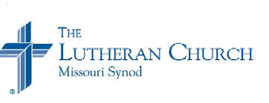
Zion Lutheran Church seeks to preach and teach God’s Word to all people of all ages, and to show God’s love through our witness, fellowship, and service.

October 2018 Newsletter

Joint Council Meeting is at Bethlehem, October 4, beginning at 7:00, followed by each congregation’s council meetings, and then the Elder’s meeting.
October is Pastor Appreciation Month!

Autumn Harvest Dinner, was a huge success. Thank you to all who came to help prepare on Saturday, and also to those who helped to serve and clean up. A Special Thank you to Dan and Brenda for all the work that they put in to make this event a success; thank you also to Elton and Sue, as well as Dan and Brenda for the food that they donate for this event. Thank you, too, for those who brought cars for our second annual car show. Thank you, also to Walter for organizing the car/Tractor show.

The choir has resumed singing during our worship services. We always welcome anyone who would like to join us.

Be Sure to Check the Bulletin Board for Community Events and Opportunities.

Zion Council Meeting Highlights September 6, 2018

President Dave Kiesow called the meeting to order at 7:20 p.m. There were 12 members present.
Secretary’s Report: The minutes from the last meeting were read.
Treasurer’s Report: Chris Hausmann gave the treasurer’s report.
Elder’s Report: The average attendance for August was 38, one child, and 37 average for communion.
Trustee’s Report: The basement exit sign bulbs were replaced with LED bulbs, the sink in the upstairs women’s bathroom was replaced, the skylights which are well known for leaking were calked and the flashing was screwed down. It was also reported that the downspout blew off and water came in the basement. The spotlights on the north wall in the basement were replaced with LED BR 20’s and the altar lights with BR 30’s. It was mentioned that LED’s are the way to go and Eau Claire Energy offers a rebate on them.
Sunday School Report: Debbie Prill is working on seeing the parents of the Sunday school children and she will be inviting parents and children to the harvest meal. VBS turned out well with 21 children attending. Of these 21 children, 12 were children of members and 9 belonged to other churches. Elaine Frank said she needs to retire from the Board of Education by the first of the year.
Mission Board Report: There wasn’t anything to report.
Old Business: It was mentioned that the deadline has passed for removing flowers and decorations from the cemetery.
New Business: Since we will be in need of a treasurer, Dave Kiesow mentioned that he received a letter from a business that does financial records for churches. It was also mentioned that the deed to the parking lot was found.
Adjournment: We closed with the Lord’s Prayer.

“In happy moments, PRAISE GOD. In difficult moments, SEEK GOD. In quiet moments, WORSHIP GOD. In painful moments, TRUST GOD. Every moment, THANK GOD.” –Rick Warren

Happy Anniversary
“You’re a wonderful couple, joined by God above. May your marriage continue in God’s love.”

10/1 Sharon & Orville Green 10/2 Dennis & Arlene Anderson 10/2 Randy & Trudy Horlacher 10/10 Sandra & Rory Fye
1010 Eugene & Dorothea Neumann 10/15 Gavin & Melissa McCann

October 2018

10/4 Tess Frank
10/6 Sharalyn Jenkins, Debra Lane, Jamie Noel, Jacob Pilgrim
10/7 Jane Weggen
10/11 Renee Bauch
10/13 Josephine Sperber
10/16 Robert Grunewald
10/20 Anica Fye
10/24 Torre Thalacker
10/26 Lois Kolpien
10/29 Kasey Maland

BAPTIZED IN OCTOBER

10/1 Sandra Huth 10/18 Caitlyn Berlin, Scott Weggen
10/2 Carol Huff 10/4 Kayla Anderson, Matthew Lyons 10/20 Kyle & Tess Frank
10/5 Megan Humphreys, Kira Schmidt, Joshua Wangen
10/6 Betty Woodford 10/20 Dakota & Mckenzy Hopkins
10/7 Jared Horlacher 10/21 Marjorie Buchholz, Dennis Pilgrim
10/8 Andrew Rene 10/26 William Ruff
10/9 James Stephan Sr. 10/29 Gina Huth, Jamie Noel
10/11 Greg Weggen 10/30 Maxie May Huth
10/12 Penny Woodford
10/15 Sawyer Pilgrim
10/16 William Pilgrim
10/17 Marlene Herman, Noah Streif
[Errors or corrections? Date Missing? Please notify us. Thank you.]

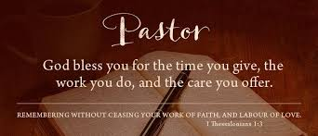

OCTOBER 30TH IS REFORMATION SUNDAY
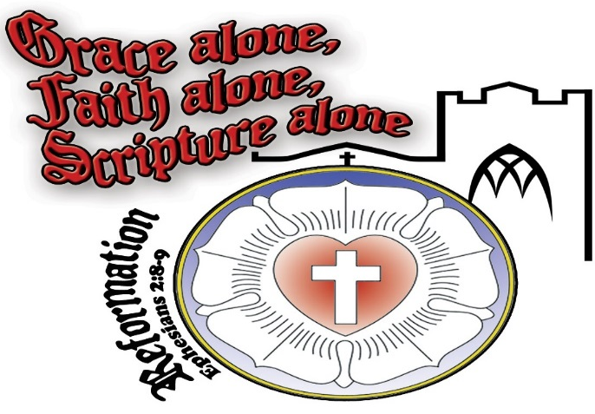

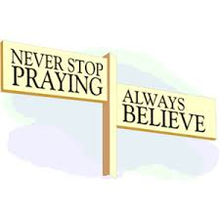

Please remember in your prayers: Pastor’s new grandson, Christopher Kelly, Marianne Kiesow, Don Lane, Bev Curler, Penny & Olivia Schmidt, Brian Markham, Ron Olson (Brandon Knuth's father-in-law with Leukemia), Winifred Boyea-Wicksey, Martha Jaenke, Pastor Jones at Zion-Chippewa, Diane Goss, shut-ins and members living in Care Facilities.

OUR NURSING HOME RESIDENTS HOMEBOUND
Augusta---Diane Goss--Zion Brian Markham--Beth
Geneva Smith--Beth. Carol Huff--Zion
Eileen Hagedorn--Zion
Selma Lane--Zion Amy Bergman--Zion
Naomi Sudbrink--Beth. Ellie Grunewald-Beth.
Don Berlin--Beth.
Also in Nursing Homes or Assisted Living:
The Manor, Chippewa Falls--- Delores Staats, (Marilyn [Sam] Norton’s mother)
Grace-Woodlands, Eau Claire---Florence Korn-Beth. Neillsville-Dorothy Solberg-Beth.
Stanley---Robert Reppe-Zion River Pines, Altoona---Julia Phillips-Beth
Reminder – both Zion and Bethlehem have prayer chains, that is people who will pray for someone who is ill, in need of a job, or need God’s loving support in another way. Zion members can call Betty Woodford @ 715 877-3225 & Bethlehem members can call Sharon Tumm @ 715 877-2402, with a prayer request for yourself or for anyone else.

Make plans now to attend the next NWD Adult Gathering on Tuesday, October 30, 2018 at Mt. Olive Lutheran Church in Weston, WI from 10:00 - 2:30 p.m. with registration beginning at 9:30 a.m. Rev. Dr. Dean W. Nadasdy, former President Minnesota South District will share "A Blessed Life: A Fresh Look at the Beatitudes". Cost is $20 which includes program, breaks, and lunch. To register and for more information visit the NWD homepage at www.nwdlcms.org under "Events and Information" or use the registration form available on the bulletin board. Participants are encouraged to bring their Bibles.
+
The large print Portals of Prayer are available to be picked up now for the October - December quarter.

Bethlehem-Zion Lutheran Parish Rev. James Norton, Pastor
Cell 1(217)725-2487, Home (715)514-5478
Bethlehem Office (715)877-3249 (Office Hours T, W, TH 9-noon); Zion Office (715)877-3128
Web address: www.zion-bethlehem.org
Facebook: Zion-Bethlehem Lutheran Church e-mail – countryc@centurylink.net

SUNDAY SERVICES: ZION 9AM; BETHLEHEM 10:30AM
SUNDAY SCHOOL: ZION 10:15AM & BETHLEHEM 9:00AM
Elders: Bethlehem – Steve Davidson Altar Guild: Bethlehem – Sharon Tumm & Carol Sperber
Zion – Ken Kiesow Zion – Lois & Jerry Kolpien
October 2018
Sunday | Monday | Tuesday | Wednesday | Thursday | Friday | Saturday
 | 1 | 2 | 3  Zion Ladies Aide @ noon with potluck  Confirmation 5-6pm | 4  JT COUNCIL MTG 7:00p @ Bethlehem | 5 | 6
7 | 8  Columbus Day | 9 | 10  Confirmation 5-6pm | 11  Bethlehem Ladies Aide @ noon with potluck | 12 | 13
14Communion @ Bethlehem | 15 | 16 | 17  Confirmation 5-6pm | 18 | 19 | 20
21 | 22 | 23 | 24  Confirmation 5-6pm | 25  Bethlehem Sunday School Teachers Mtg 7pm | 26 | 27
28  Communion  REFORMATION | 29 | 30 | 31  Confirmation 5-6pm

