Eighteenth Sunday after Pentecost
Bethlehem/Zion Lutheran Parish September 23, 2018 Rev. James Norton
Ludington & Fall Creek, Wisconsin Linda Wiese Organist 715-514-5478
● ● ● ● ● ● ● ● ● ● ● ● ● ● ● ● ● ● ● ● ● ● ● ● ● ● ● ● ● ● ● ● ● ● ● ● ● ● ● ●
Service: LSB #4 P. 203 Hymns: 915, 559, 628, 629, 805
Old Testament Reading: Jeremiah 11:18-20
Epistle: James 3:13-4:10
Holy Gospel: Mark 9:30-37
The Message: “For All—Death Awaits”
Text: Luke 16:19-23
Zion Choir will be singing "His Eye is on the Sparrow", CH #624
● ● ● ● ● ● ● ● ● ● ● ● ● ● ● ● ● ● ● ● ● ● ● ● ● ● ● ● ● ● ● ● ● ● ● ● ● ● ● ●

***Be sure to sign the Red Record of Fellowship Folder on the aisle side of your pew.

HOLY COMMUNION is celebrated today. Mindful of the loving, Scriptural teaching concerning church fellowship, we practice Closed Communion. This means we normally invite to commune, only active communicant members of this congregation or other congregation of the Lutheran Church-Missouri Synod in good standing. All Guests are asked to speak with our pastor before the service before coming to the Lord’s Table. If you have not spoken with our pastor, please do not come forward at this time. If you would like to learn more about Closed Communion or our congregation, we encourage you to talk with our pastor. Please sign & register for communion on the pew pad.

This Week’s Schedule
Sunday, September 23, 2018 9:00am Zion Worship Service
[Communion] 9:00am Bethlehem Sunday School & Adult Bible Study
10:15am Zion Sunday School
10:30am Bethlehem Worship Service
Monday-Wednesday Fall Pastor’s Conference at the Metropolis in Eau Claire
Tuesday September 25th 8:30am LWML Fall Rally @ Zion, Cleghorn
8:00pm Dartball
Wednesday 5:00pm Confirmation
Thursday 7:00pm Beth. Sunday School Teachers Mtg
Sunday, September 30, 2018 9:00am Zion Worship Service
9:00am Bethlehem Sunday School & Adult Bible Study
10:15am Zion Sunday School
10:30am Bethlehem Worship Service

Happy Birthday this week to: Daron Weggen, Verle Green, Dennis Pilgrim, William Pilgrim, & Eugene Neumann.

Happy Anniversary to: Marv & Carol Sperber, Dennis & Linda Pilgrim, and Norman & Jane Anderson.

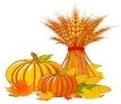
Next Week is Zion's Harvest Dinner and our second annual Car/Tractor Show. Member families are asked to donate a pie or dessert for the meal, items for our bake sale and produce for the produce sale. If you plan to bring a car, tractor or other farm equipment to show, please call Walter Thompson (715-877-3246) for instructions as to where to park.

Proceeds from this week's lunch at Zion will go toward next year's VBS. All are invited to join us for good food and fellowship.
Bethlehem’s Adult Bible Study Class has resumed and will meet every Sunday at 9:00am. They are currently studying baptism. Feel free to come and attend whenever you can.

In today’s Sunday School lesson the children learned how “Joseph Feeds Egypt” during a great famine. “How do our sins cause suffering for both ourselves and others?” God sent His Son, Jesus, to save all humanity from sin, death, and the devil. In spite of how awful life seems, Jesus is with us through His Word and Sacraments, caring for us always.

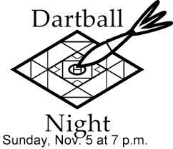
Bethlehem’s Dartball began again on September 18th. We have two dartball teams this year. If you would like to play or find out more information, contact Ronald Wiese or Elvin Bauch. Every Tuesday night one of our teams will play here at Bethlehem against another church’s team. The team that isn’t playing here will travel to another church to compete against that team. At the end of the season a dinner is held and awards are given to the top teams and players.

Bethlehem Members – please be sure to pick up your tickets to sell for Fall Fest. They are available from MaryAnn Koch in the narthex every Sunday. We also have posters available for you to pick up and post in your town/area. With everyone’s help we can get the word out to make our Fest a successful one this year.
October 14th is our Fall Fest date. Fall Fest generates income for our church to continue doing the Lord’s work. Donations for the ticket sales & raffle prizes will be greatly appreciated. Now is the time to start choosing items to donate & using your talents to make crafts for the sale table. Let’s work together to make this an exciting Fest.

FYI, the web address to put information on our Parish web page is: wausharamedia@gmail.com.

Last chance to order: 2018 Concordia Publishing House Bible Sale is on now thru September 30th. Order blanks are on the table in the narthex at Zion and by the bulletin board in the fellowship hall at Bethlehem. You may also go to cph.org/biblesale online to see any of the bibles. However, you will need to order thru church and make your check payable to the church.

Please remember in your prayers: the family of Malayna & David Kelly (baby due, Pastor’s daughter), Marianne Kiesow, Don Lane, Bev Curler, Penny & Olivia Schmidt, Brian Markham, Ron Olson (Brandon Knuth's father-in-law with Leukemia), Winifred Boyea-Wicksey, Martha Jaenke, Pastor Jones at Zion-Chippewa, Diane Goss, shut-ins and members living in Care Facilities.
OUR NURSING HOME RESIDENTS HOMEBOUND
Augusta---Diane Goss--Zion Brian Markham--Beth
Geneva Smith--Beth. Carol Huff--Zion
Eileen Hagedorn--Zion Don Berlin--Beth.
Amy Bergman--Zion Ellie Grunewald-Beth
Naomi Sudbrink--Beth.
Also in nursing homes, or assisted living:
The Manor, Chippewa Falls--Delores Staats, (Sam [Marilyn] Norton’s mother)
Grace-Woodlands, Eau Claire--Florence Korn-Beth. Neillsville--Dorothy Solberg-Beth.
Stanley--Robert Reppe-Zion River Pines, Altoona--Julia Phillips-Beth

Make plans now to attend the next NWD Adult Gathering on Tuesday, October 30, 2018 at Mt. Olive Lutheran Church in Weston, WI from 10:00 - 2:30 p.m. with registration beginning at 9:30 a.m. Rev. Dr. Dean W. Nadasdy, former President Minnesota South District will share "A Blessed Life: A Fresh Look at the Beatitudes". Cost is $20 which includes program, breaks, and lunch. To register and for more information visit the NWD homepage at www.nwdlcms.org under "Events and Information" or use the registration form available on the bulletin board. Participants are encouraged to bring their Bibles.
Our Worship Response 9/16/2018
Bethlehem Zion
Attendance 68 37
Offerings $1062.50 $586.50
Missions $40.00
Building Fund $177.00
Weekly Budget Needs: $1185.24 $1138.00

Upcoming dates to remember:
September 25th – LWML Fall Rally @ Zion Cleghorn
September 27th-Bethlehem’s Sunday School Teacher’s Meeting
September 30th - Zion’s Autumn Harvest Dinner and Car & Tractor Show
October 14th – Bethlehem’s Fall Fest
Eighteenth Sunday after Pentecost - 9/23/2018

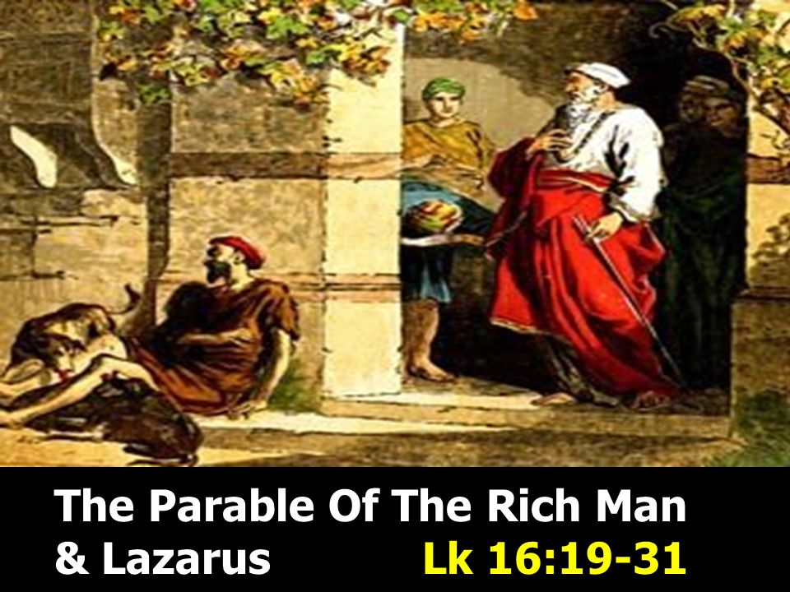
BETHLEHEM-ZION LUTHERAN PARISH
Pastor – Rev. James Norton, (715)514-5478 or cell 1(217)725-2487

Bethlehem, Parish Office (715)877-3249; E19675 St. Rd. 27, Fall Creek, WI 54742
Zion (715)877-3128; 1286 S 150th Ave, Fall Creek, WI 54742
Web address: www.zion-bethlehem.org Facebook: Zion-Bethlehem Lutheran Church e-mail – countryc@centurylink.net
Bethlehem Lutheran Church reaching out to our community and to the world with the gospel of Jesus Christ. Zion Lutheran Church seeks to preach and teach God’s word to all people of all ages and show God’s love through our witness, fellowship and service.

