Fifteenth Sunday after Pentecost
Bethlehem/Zion Lutheran Parish September 2, 2018 Rev. James Norton
Ludington & Fall Creek, Wisconsin Linda Wiese Organist 715-514-5478

● ● ● ● ● ● ● ● ● ● ● ● ● ● ● ● ● ● ● ● ● ● ● ● ● ● ● ● ● ● ● ● ● ● ● ● ● ● ● ●
Service: LSB P260 Hymns: 656, 660, 662

Old Testament Reading: Deuteronomy 4:1-2, 6-9
Epistle: Ephesians 6:10-20
Holy Gospel: Mark 7:14-23
The Message: "Dressed For Battle"
Text: Ephesians 6:10-20
● ● ● ● ● ● ● ● ● ● ● ● ● ● ● ● ● ● ● ● ● ● ● ● ● ● ● ● ● ● ● ● ● ● ● ● ● ● ● ● Please remember in your prayers: Olivia Schmidt, Ron Olson (Brandon Knuth's father-in-law with Leukemia), confirmation beginning, all who labor to support families, upcoming Weggen/Walters marriage, Bev Curler, Winifred Boyea-Wicksey, Brian Markham, Martha Jaenke, Pastor Jones at Zion-Chippewa, Selma Lane, Don Lane, Diane Goss, shut-ins and members living in Care Facilities.
OUR NURSING HOME RESIDENTS HOMEBOUND
Augusta---Diane Goss--Zion Brian Markham--Beth
Geneva Smith--Beth. Carol Huff--Zion
Eileen Hagedorn--Zion Don Berlin--Beth.
Selma Lane--Zion Amy Bergman--Zion
Naomi Sudbrink--Beth. Ellie Grunewald-Beth.
Also in nursing homes, or assisted living:
The Manor, Chippewa Falls--Delores Staats, (Sam [Marilyn] Norton’s mother)
Grace-Woodlands, Eau Claire--Florence Korn-Beth. Neillsville--Dorothy Solberg-Beth.
Stanley--Robert Reppe-Zion River Pines, Altoona--Julia Phillips-Beth

Reminder – both Zion and Bethlehem have prayer chains, that is people who will pray for someone who is ill, in need of a job, or need God’s loving support in another way. Zion members can call Betty Woodford @ 715 877-3225 & Bethlehem members can call Sharon Tumm @ 715 877-2402, with a prayer request for yourself or for anyone else.

***Be sure to sign the Red Record of Fellowship Folder on the aisle side of your pew today.

Happy Birthday this week to: Kylee Thalacker, Barbara Hermann, Shaylee Dekan, & Scott Weggen.

Happy Anniversary to: Jeremy & Anna Jaenke and Scott & Glenda Lyons.
This Week’s Schedule
Sunday, September 2, 2018 9:00am Zion Worship Service
10:00am Bethlehem Worship Service

Wednesday, September 5th Noon Zion Ladies Aid with potluck lunch
5-6pm Confirmation starts for 7th & 8th grades

Thursday, September 6th 10:00am Pastor’s Augusta Nursing Home Service
7:00pm Council meetings @ Zion

Sunday, September 9th- Rally Day 9:00am Zion Worship Service
[Communion] 9:00am Bethlehem Sunday School
10:15am Zion Sunday School
10:30am Bethlehem Worship Service

Confirmation will begin this Wednesday, September 5, running from 5-6 p.m. It is for all 7th & 8th graders from both churches. On Rally Day, September 9th, we will recognize the confirmation students in each church. Students from Bethlehem are Brandon & Kenzie Bauch, John Hakes, Cash Noel, Spencer Pilgrim and Emma Houston; from Zion are Victoria Marten, and Adam & Anthony Kersten.
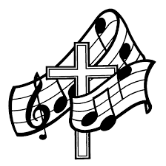 Zion's choir practice is today after worship. We will begin singing in Sunday worship services beginning Sunday, September 9th. We welcome anyone interested in joining us. Bethlehem’s choir is also today after services. If you like to sing, join us! We are getting ready for Rally Day, Sept. 9th.
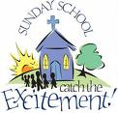
Rally Day is next Sunday, September 9th at both of our churches.
Zion’s Sunday School children will be singing during the 9:00 worship. Zion will be serving a pancake meal to kick off the beginning of the Sunday School year. All are encouraged to join us for pancakes and sausage after the worship service as we kick off our new Sunday School year.
Bethlehem: “Rally Day Spaghetti Feed” by Youth! September 9th after church. Members are asked to bring a dessert. Free will offering will be given to Building Fund! Plan now!

It’s almost time for Zion's Autumn Harvest Dinner, along with the Second Annual Car/Tractor Show September 30, 2018. Putting out a call for anyone who has a car, truck, or tractor that you would be willing to bring on September 29th or 30th. Please contact Walter Thompson (715-877-3246) if you are interested in bringing a vehicle to the car/tractor show. Be sure to sign up for where you can help to make our dinner a success.
If anyone is interested in painting at Bethlehem, we have another small area to paint.

Bethlehem Members – please be sure to pick up your tickets to sell for Fall Fest. They are available from MaryAnn Koch in the narthex every Sunday. We will also have posters available for you to pick up and post in your town/area. With everyone’s help we can get the word out to make our Fest a successful one this year.
October 14th is our Fall Fest this year at Bethlehem. Fall Fest generates income for our church to continue doing the Lord’s work. Any donations for the ticket sales & raffle prizes will be greatly appreciated. Now is the time to start choosing items to donate & using your talents to make crafts for the sale table. Let’s work together to make this an exciting Fest.

American Legion Post 376 wishes to again thank all the churches for their great efforts and help with the fund raiser last Sunday. It was very successful and will be a great help moving forward with the veterans’ memorial project.

2018 Concordia Publishing House Bible Sale is on now thru September 30th. There are a couple of new bibles on the sale – a Growing Faith Bible for Early Readers, and a Journaling Bible, called The Enduring Word Bible, with extra wide margins for notes about scripture, or creating & drawing your impression of bible verses or stories. Order blanks are on the table in the narthex at Zion and by the bulletin board in the fellowship hall at Bethlehem. You may also go to cph.org/biblesale online to see any of the bibles. However, you will need to order thru church and make your check payable to the church.

Our Worship Response 8/26/2018:

Bethlehem Zion
Attendance 66 42
Offerings $1069.62 $765.00
Missions $80.00
Building Fund $120.00
Weekly Budget Needs: $1185.24 $1138.00

Upcoming dates to remember:
September 5th - Confirmation Starts
September 9th, Rally Day – Sunday School starts
September 30th - Zion’s Autumn Harvest Dinner and Car & Tractor Show
October 14th – Bethlehem’s Fall Fest

Fifteenth Sunday after Pentecost – September 2, 2018
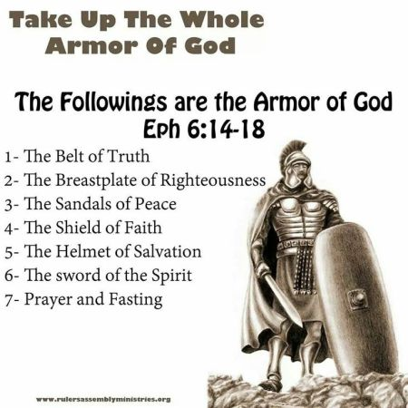

BETHLEHEM-ZION LUTHERAN PARISH
Pastor – Rev. James Norton, (715)514-5478 or cell 1(217)725-2487

Bethlehem, Parish Office (715)877-3249; E19675 St. Rd. 27, Fall Creek, WI 54742
Zion (715)877-3128; 1286 S 150th Ave, Fall Creek, WI 54742

Web address: www.zion-bethlehem.org Facebook: Zion-Bethlehem Lutheran Church e-mail – countryc@centurylink.net

Bethlehem Lutheran Church reaching out to our community and to the world with the gospel of Jesus Christ. Zion Lutheran Church seeks to preach and teach God’s word to all people of all ages and show God’s love through our witness, fellowship and service.

