Bethlehem Lutheran Church
E19675 State Road 27
Fall Creek, WI 54742

August 2018 HIGHLIGHTS
Worship Services are held Sunday at 9am @ Zion, & 10:30am @ Bethlehem
Communion is offered on the 2nd and 4th Sundays of the month
Bible Study @ Zion following Sunday Services “Renaming the Parables”

August 2nd - Council Meetings @ Bethlehem 7:00pm
August 9th – Bethlehem Ladies Aid @ noon with potluck
August 5th -9th – Vacation Bible School @ Zion
September 30th - Zion Autumn Harvest Dinner

Zion Lutheran Church
1286 S 150th Ave.
Fall Creek, WI 54742

August 2018 HIGHLIGHTS
Worship Services are held Sunday at 9am @ Zion, & 10:30am @ Bethlehem
Communion is offered on the 2nd and 4th Sundays of the month
Bible Study @ Zion following Sunday Services “Renaming the Parables”

August 2nd - Council Meetings @ Bethlehem 7:00pm
August 9th – Bethlehem Ladies Aid @ noon with potluck
August 5th -9th – Vacation Bible School @ Zion
September 30th - Zion Autumn Harvest Dinner

UNWILLING IS NOT THE SAME AS UNABLE
Why should I attend public worship when I can listen to it on the radio?
There is a big difference between unwilling and unable, especially in Theology. For example, the question always comes up about baptism. The Bible teaches that baptism saves (Mark 16:16). But, what about the person who dies before baptism? The way to answer this question depends on if the person was unwilling to be baptized (they reject Jesus in baptism), or they would have been baptized, but were unable-----like the thief on the cross. Though both the unwilling and unable died before baptism, there is a huge difference in their repentance and faith.
The same is true in regards to the Third Commandment (Remember the Sabbath Day by keeping it holy). This is what the Catechism says:
37. Does God require the church to worship together on any specific days? A. God requires Christians to worship together. (Acts 2:42, 46) Hebrews 10:25, “Not neglecting to meet together as the habit of some is. 38. “When do we sin against the Third commandment? We sin against the Third commandment when we despise preaching and the Word of God. 39. How is this done? We despise preaching and the Word of God— A. When we do not attend public worship. B. When we do not use the Word of God and the Sacraments. C. When we use the Word of God and the Sacraments negligently or carelessly.
Christians are gathered into communities, communions, fellowships, local congregations. They gather together and are fed spiritual food through their pastors. Jesus says ‘where two or three are gathered together in My name, there I am among them.’ (Matt. 18:20). There must be at least 2. One to preach and one to hear.
But, what about listening to a Divine service on the radio? Well, it is similar to those who are unwilling to obey Jesus’ gracious command to be baptized and those who are unable. Those who are unwilling to obey Jesus’ gracious command to gather together in person with other Christians to be fed by a pastor in Word and Sacraments and encourage one another are different than those who want to, but are unable. It is a matter of faith in the heart and not simply in the outward act. Additionally, one cannot receive Christ’s body and blood over the radio. This is why the pastor makes visits to our homebound or to those in the nursing homes, so that the two of us are gathered to receive the gifts of our Lord, who is really present.
Yes, the radio is great for those members who are unable to attend public worship. But, when we, the able, neglect public worship and choose comfort, fun, or other things elsewhere----we must ask ourselves how our actions are effecting others, especially those who notice our absence. What example are we setting for the children in our family or in the church?
It is a great thing that God’s Word can be heard on the radio and on TV, but for those who are able to attend public worship, they certainly should. It doesn’t simply hurt the one who skips public worship for something less important, but the absence of any member of the body of Christ hurts the whole congregation. Let us therefore, not neglect to gather together to receive good things from our good and gracious God. Pastor Norton

BETHLEHEM LUTHERAN CHURCH
Website: zion-bethlehem.org
Facebook Address: Zion-Bethlehem Lutheran Church
Office Telephone (715)877-3249
Address: E19675 State Road 27, Fall Creek, WI 54742

Building Update: By now you will be noticing our plans coming together. The narthex is under remodeling with new lights, sheetrock, exterior doors and more. We will have things to do for awhile to finalize bathrooms and items in the narthex. Watch for an upcoming celebration to be announced. Such a blessing to see God at work! Fundraisers will be planned for later this year or into next year. Please do not tack, pin, tape or screw anything up. We will have furniture, a new look and in time will have everything returned. Thank you to all who have worked on this project. The mailboxes will soon be back in place with a refreshed look. Thanks to Darlene and Dale Noel. Thank you to Marv for his extra work to save labor hours and oversee the project. Please see special clean up instructions for the new floors posted in the cleaning closet. Many things such as the sidewalk and exterior work for the remodeling project will be completed as appropriate.
*Keys will be made soon for the new north door.

BETHLEHEM LADIES AID:
In August we begin our summer quarterly. The bible study, “Peace Makers” is on page 16. Our July pot-luck was enjoyed in a delightful setting. It was a combination of delicious food, and christian fellowship. Many thanks to Pastor Norton, Marilyn, and their granddaughter, Lydia.

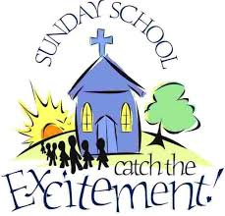
*Save the date: Sunday School starts with Rally Day on September 9th.

If you would like a large print version of the bulletin insert, please pick one up in the back of the church by the bulletins. I had discontinued printing them because no one used them. In the past I did put all large print inserts in a Sunday bulletin, most people indicated they didn’t need them. However, this past week someone wanted one, so I have printed those again. They will be there every Sunday. Feel free to help yourself.
The Bethlehem Council has decided on October14th as our Fall Fest date this year. Fall Fest generates income for our church to continue doing the Lord’s work. We need to list the prizes we will be giving away. We are looking for items that people would want to WIN. Give us your ideas. Any donations for the ticket sales & raffle prizes will be greatly appreciated. Now is the time to start thinking about items to donate & using your talents to make crafts for the sale table. Let’s work together to make this an exciting Fest. Tickets will be available to sell for raffle soon. Speak to Marv for further information.

Many thanks have been heard regarding the great job Steve Davidson does to keep the lawns and cemetary looking good. Thank You Steve.
Thank You Karon for all the office and beyond work that you do as well.

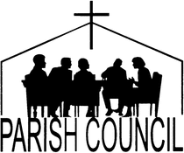BETHLEHEM - Monthly Council Meeting Minutes, July 5, 2018

Treasurers Report:
1.) Annual Web Hosting Fee – has increased a little from last year. The bill will be paid by a donation.
2.) Building Fund Donations Balance - $8,480.16

Elders Report:
- Average Attendance – 55-60 people per week

Board of Education Report:
- VBS Update – Had 17 kids attending throughout the week, with 1 new family from Fall Creek.

Old Business:
1.) Confirmation Pictures – Dennis Anderson reported about how the pictures were displayed at Jerry Raether’s church. It was a large book that was attached to the wall that held several pictures on each page. He will bring back to the council information about the vendor.

New Business:
1.) Fall Fest 2018 – A tentative date was set for Sunday, October 14th.
Discussed getting the license for the raffle, printing the tickets, price of the meal will be the same as last year, contacting Boyd Locker to cook the meat, and prizes for the raffle including a hand-made quilt, TV, $100 meat package from Augusta Meats, and a John Deere wagon. A notice will be put in the bulletin asking for other prizes.

2.) Lighting in Sanctuary – Marv asked the electricians that are working on the remodel project to work up a plan for better lighting in the sanctuary. He will bring back their suggestion to the council. Kim Drehmel can help with available rebates for switching to LED lights.

Joan Drehmel, Secretary

Ever wonder what to say to people? Maybe this will help you:
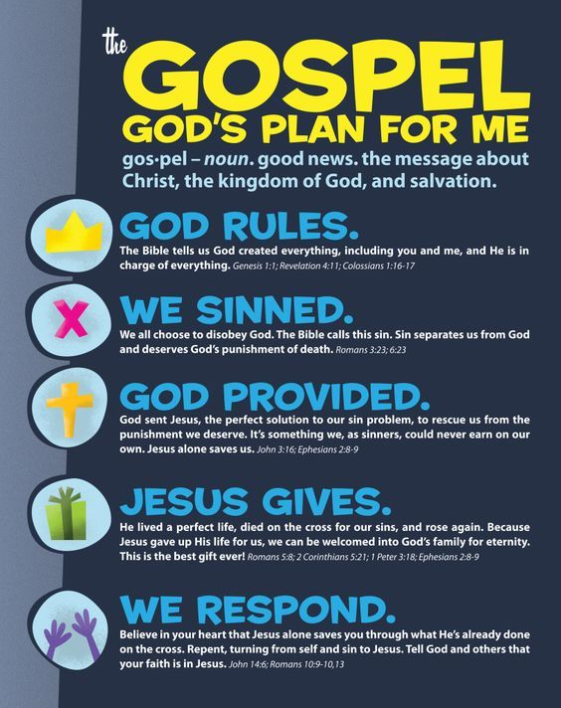

Zion Lutheran Church 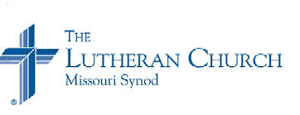

Zion Lutheran Church seeks to preach and teach God’s Word to all people of all ages, and to show God’s love through our witness, fellowship, and service.
August 2018 Newsletter
Joint Council Meeting is at Bethlehem, August 2, beginning at 7:00, followed by each congregation’s council meetings, and then the Elder’s meeting.

…It’s Here!
August 5th through 9th, 5:30-8 pm
Strap on your life jacket and get ready for a rip-roaring river ride with Splash Canyon: God's Promise on Life's Wild Ride. Our theme for VBS is "Splash Canyon". Gods promises - God is with us! God gives us life! God is faithful! God gives us hope! And Jesus is our Savior!
Vacation Bible School is a fun place to learn about Jesus. It is for all children, members as well as non-members. Reach out and invite your neighbors and friends.
Vacation Bible School, at Zion, will be held August 5th through August 9th, 5:30-8 pm. We will have our closing program on Thursday the 9th at 5:30,

followed by a delicious meal. All family and friends are invited to join us as the children share what they have learned.
Be sure to get your child registered. Contact Deb Prill, 715-464-1002.
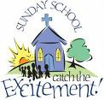
Sunday School is coming. Rally Day, the first day of Sunday School for this year, is September 9! Watch the bulletin for more details.
The choir will begin singing again beginning with Rally Day on September 9. We will begin practicing on Sunday , August 19, after worship service. We always welcome anyone who would like to join us.

It’s almost time for our Autumn Harvest Dinner, along with the second annual Car/Tractor Show September 30, 2018. Putting out a call for anyone who has a car, truck, or tractor that you would be willing to bring on September 29th or 30th. Please contact Walter Thompson (715-877-3246) if you are interested in bringing a vehicle to the car/tractor show.

Council Meeting Highlight
Council Meeting Minutes July 5, 2018
President Dave Kiesow called the meeting to order at 7:20 p.m. There were eight people in attendance.
A motion was made and seconded to accept Cheryl Knuth as recording secretary. The motion carried.
Secretary’s Report: The secretary’s report from the June 7, 2018 meeting was read
Treasure’s Report: Chris H. gave the treasurer’s report.
Elder’s Report: The average attendance for June was 44, 3 children and 40 for communion.
Trustee’s Report: The downspout had been run over so a piece of plastic was put in place so water wouldn’t run in the front door. The adhesive on the cement at the front doors needs to be cleaned up, pine needles were cleaned up. Selling the church van was discussed. It was suggested that we install a better flushing toilet in the basement women’s bathroom.
There was no mission board report.
It was reported that Debbie Prill has sent out VBS notices.
Old Business: It was mentioned that the new order of service used on July 1, 2018 was too hard to follow. So it was suggested that we have some chorus members go through the order of matins that was used that day with the congregation.
New Business: It was decided to order a couple of bulletin covers. 50 calendars have been ordered.
. Adjournment: We closed with the Lord’s Prayer.

Autumn Harvest Dinner
Please join us for good food, good friends, and good fellowship. Zion Church 1286 S. 150th Ave. Seven miles north of Fall Creek on the corner of County Road Q (Olson Dr.) and 150th Ave
Sunday, September 30, 2018
9 am Worship service Featuring worship songs from
“With One Voice Gospel Choir”
Dinner will be served from 10:30 – 1:30
Menu features all homemade Items.
Main Course: Baked Ham, Roast Pork, Real mashed potatoes and gravy
Side Dishes: Squash-pecan bake, baked beans with weenies, fruit salad, dinner rolls, coleslaw, cranberries, and pickles
Desserts: Bars, Cakes, Pie, and ice cream
Beverages: 1919 Root beer on tap, Lemonade, Milk, and Coffee
Children 12 and under with an adult eat Free,
Ages 13 and over $8.00 per person.
All You Can Eat, Take outs available, Produce and Bake Sale.
Be sure to check out the 2nd Annual car/Tractor Show on the church grounds

July 18, 2018
Dear Bethlehem/ Zion Congregation,
This week marks week 7 on mission. So much has happened since I sent the last update. In Medora, July is the busiest month of the summer and is how the town makes all of its money for the year. Needless to say, I have been super busy. I am in a full routine now where life has become second nature. I work 6 days a week averaging 40-45 hours a week. My job at the ticketing place has been really busy especially on weekends. I am getting to know my coworkers more and more and it has been really fun spending every day with them. I have a new coworker from Turkey that is starting at my store this week. I am excited to get to know more about him. However, with working so much and balancing everything that we do as a team during the week our team is experiencing burn out a little bit. We are all very exhausted. As a team we have been praying for energy to carry on the rest of the mission and this week we are all starting out in a good place.
When we started this mission, we had 8 staff members that came with us. They were essentially in charge and were training us on how to do relational evangelism and were the backbone of our mission. Part of this mission is that after a month the staff leave Medora and appoint 3 new directors and 4 team leaders to help carry out the rest of the mission. I was awarded a team leader position where it is my job to work with 4 other people to plan our Sunday night meetings and our next project day off which is next week. Having that position adds more to my plate but I am very excited with how things are going. With the staff leaving, we are now on our own to carry out and plan all of our normal events we put on during the week. So far it is still going well, and we have a large amount of our coworkers attend our events. It is cool to see how well we can work together to get things done even though the staff are gone. We will see them again in 4 weeks when we do our end of mission debrief time.
This week we are holding a “country dance” where we as a team will be teaching our international friends how to swing dance and line dance. It will be so fun to teach them about American dance Last week I got to spend my day off with my coworker from Mongolia. We talked a lot about our experiences as college students and I got to learn more about her upbringing in a major Buddhist country. Though I still haven’t fully shared the gospel with her she is starting to open up to me more and I am excited to have more opportunities with her in the next four weeks. I have also been spending time with one of my friends from Malaysia. We went to the gym this week and I got to learn about her upbringing and found out that Malaysia is another country that heavily practices Buddhism. She noticed that I had a cross tattoo on my back and I got to talk to her about Jesus from something as simple as that. God is providing so many opportunities for us as a team here and overall things are going really well. Pray for my team and me as we finish out the mission with 4 weeks to go. We are getting into the grind of summer and pray that we all stay focused on our goal of bringing Jesus to our many coworkers from all over the world. Thank you so much for your continued support.
Halle Luedtke

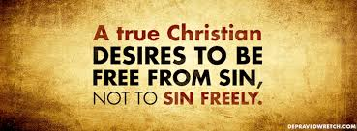

SPIRITUAL GIFTS & TALENTS
In case you missed this on Sunday, July 22nd, please complete this and return it to Church, & put it in the offering plate.

NAME________________________________________________________________________________
As a redeemed and forgiven child of God I wish to make use
of the gifts God has given me that I am to use for the good of
all.
I will gladly put my God-given talents to work for the Lord in one or more of the following.
----------Elder
-----------SS Teacher
------------Trustee
------------Ladies Aid
------------A men's group
------------Altar Guild
-------------Yearly church cleaning
--------------Cemetary Committee
--------------Snow removal
--------------Decorating for Christmas
-------------Bible study group
--------------Youth ministry
---------------Any way I can--just call me.
--------------choir
------------VBS
Any other comments are welcome.

AUGUST 2018

8/3 Kayla Andrson, Kira Schmidt
8/5 Grace Weggen 8/9 Sandra Huth
8/10 Debbie Hudson
8/11 Benjamin Huth, Diane Huth, Gerald Starck
8/15 Skyler Hudson/Walmsley, Michael Weggen
8/17 Sarah Weltzin
8/18 Anna Thomas
8/19 Dorothy Luedtke, Greg Weggen
8/20 Robert Reppe
8/22 Megan Humphreys
8/23 Amy Bergman
8/24 Deloris Honadel
8/25 Jeremy Jaenke
8/26 Jared Horlacher
8/30 Aidan Schmidt

[Errors or corrections? Date Missing? Please notify us. Thank you.]

Happy Anniversary
“You’re a wonderful couple, joined by God above. May your marriage continue in God’s love.”

8/10 Jon & Telia Dekan 8/12 David & Cheryl Knuth
8/16 Josh & Sarah Weltzin
8/17 Steve & Karon Davidson
8/26 Gerald & Cleo Carpenter

BAPTIZED IN AUGUST

8/1 Jamison Sperber 8/21 Brenda Smith 8/1 Lucas Hermann 8/22 Cheryl Knuth, Charity Maland
8/4 Camryn Grunewald, Susan Stephan 8/23 Weston Huth
8/5 Audrey Sonnentag 8/24 Wade Anderson
8/8 Beckett & Breleigh Berlin 8/27 Freda Shong
8/10 Norman Anderson, MaryAnn Koch, Alissa Sperber 8/28 Trudy Horlacher
8/12 Penny Schmidt 8/29 Verle Green
8/13 Randy Horlacher 8/29 Dale Noel
8/17 Kayla Colburn, Donald Lane 8/29 Danielle Murphey
8/19 Jeffrey McCann
8/20 Cory Mcann

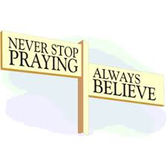
Please remember in your prayers: Bev Curler, Delores Staats, (Marilyn Norton’s mother) Pastor Jones at Zion, Chippewa, Selma Lane, Don Lane, Diane Goss, and Olivia & Aiden Schmidt, shut-ins and members living in Care Facilities.

OUR NURSING HOME RESIDENTS HOMEBOUND
Augusta---Diane Goss--Zion Brian Markham--Beth
Geneva Smith--Beth. Carol Huff--Zion
Eileen Hagedorn--Zion
Selma Lane--Zion Amy Bergman--Zion
Naomi Sudbrink--Beth. Ellie Grunewald-Beth.
Don Berlin--Beth.
Also in Nursing Homes or Assisted Living:
The Manor, Chippewa Falls--- Delores Staats, (Marilyn [Sam] Norton’s mother)
Grace-Woodlands, Eau Claire---Florence Korn-Beth. Neillsville-Dorothy Solberg-Beth.
Stanley---Robert Reppe-Zion River Pines, Altoona---Julia Phillips-Beth

Reminder – both Zion and Bethlehem have prayer chains, that is people who will pray for someone who is ill, in need of a job, or need God’s loving support in another way. Zion members can call Betty Woodford @ 715 877-3225 & Bethlehem members can call Sharon Tumm @ 715 877-2402, with a prayer request for yourself or for anyone else.
Bethlehem-Zion Lutheran Parish Rev. James Norton, Pastor
Cell 1(217)725-2487, Home (715)514-5478
Bethlehem Office (715)877-3249 (Office Hours T, W, TH 9-noon); Zion Office (715)877-3128
Web address: www.zion-bethlehem.org
Facebook: Zion-Bethlehem Lutheran Church e-mail – countryc@centurylink.net

Sunday Services: Zion 9am, Bethlehem 10:30am
***Zion Bible Study follows the 9am service – “Renaming the Parables”
Elders: Bethlehem – Dennis Anderson Altar Guild: Bethlehem – Joan & Kim Drehmel
Zion – Earl Jaenke Zion – Ted & Pat Biegel
August 2018
Sunday | Monday | Tuesday | Wednesday | Thursday | Friday | Saturday
 |  |  | 1 | 2  JT COUNCIL MTG 7:00p @ Bethlehem | 3 | 4
5  ZION VBS | 6  ZION VBS | 7  ZION VBS | 8  ZION VBS | 9  Last Day for  ZION VBS  Bethlehem Ladies Aide @ noon with potluck | 10 | 11
12  Communion | 13 | 14 | 15 | 16 | 17 | 18
19 | 20 | 21 | 22 | 23 | 24 | 25
26  Communion | 27 | 28 | 29 | 30 | 31

