Eighth Sunday after Pentecost
Bethlehem/Zion Lutheran Parish July 15, 2018 Rev. James Norton
Ludington & Fall Creek, Wisconsin Linda Wiese Organist 715-514-5478

● ● ● ● ● ● ● ● ● ● ● ● ● ● ● ● ● ● ● ● ● ● ● ● ● ● ● ● ● ● ● ● ● ● ● ● ● ● ● ●
Service: LSB P 260 Hymns: 915, 559, 571
Old Testament Reading: Amos 7:7-15
Epistle: Ephesians 1:3-14
Holy Gospel: Mark 6:14-29
Children's Message: God Cares for You
The Message: "Why Did God Save the Ninevites?"
Text: Jonah 3:10
● ● ● ● ● ● ● ● ● ● ● ● ● ● ● ● ● ● ● ● ● ● ● ● ● ● ● ● ● ● ● ● ● ● ● ● ● ● ● ●

July’s Elders: Bethlehem – Steve Davidson & Altar Guild: Beth.- Lois Sperber & Janet Weltzin
Zion – Ken Kiesow Zion – Lois & Jerry Kolpien

Please remember in your prayers: Pastor Jones at Zion, Chippewa, Selma Lane, Don Lane, Diane Goss, and Olivia & Aiden Schmidt, shut-ins and members living in Care Facilities.

OUR NURSING HOME RESIDENTS HOMEBOUND
Augusta---Diane Goss--Zion Brian Markham--Beth
Geneva Smith--Beth. Carol Huff--Zion
Eileen Hagedorn--Zion Don Berlin--Beth.
Selma Lane--Zion Amy Bergman--Zion
Naomi Sudbrink--Beth. Ellie Grunewald-Beth.

Also in nursing homes, or assisted living:
The Manor, Chippewa Falls--Delores Staats, (Sam [Marilyn] Norton’s mother)
Grace-Woodlands, Eau Claire--Florence Korn-Beth. Neillsville--Dorothy Solberg-Beth.
Stanley--Robert Reppe-Zion River Pines, Altoona--Julia Phillips-Beth
**You may put any prayer request in the box in the Narthex, or the fellowship hall at Bethlehem.

This Week’s Schedule

Sunday July 15, 2018 9:00am Zion Worship Service
10:30am Bethlehem Worship Service

Sunday July 22, 2018 9:00am Zion Worship Service
[Communion] 10:30am Bethlehem Worship Service

Be sure to sign the Red Record of Fellowship Folder on the aisle side of your pew today.

Happy Birthday This Week to: Liz Green, Noah Streif, Janet Weltzin, Randy Horlacher, Trudy Horlacher, Lois Sperber, Norman Anderson, Donald Woodford, Sr., Cody Luedtke, Miranda Dekan, and Alissa Sperber.

Happy Anniversary to: Virgil & Barbara Hermann, and Randy & Pamela Luedtke.

Bethlehem members, Fall Fest is quickly approaching. The Council has decided on October14th as our Fall Fest date this year. Fall Fest generates income for our church to continue doing the Lord’s work. We need to order tickets and list the prizes we will be giving away. If you have any ideas about an item for us to give away that would create more ticket sales, please tell one of the elders or Marvin. We are looking for items that people would want to WIN. Also, any donations for the ticket sales or the raffle prizes will be greatly appreciated. Now is the time to start thinking about items to donate or using your talents to make crafts for the sale table. Let’s work together to make this an exciting Fest.

Bethlehem VBS students collected money to send biblical books to children in Madagascar. There is a jar on the table in the fellowship hall, if you would like to contribute for the books. Also on the table is a “Mailbox” for Halle Luedtke. You can write her an encouraging note and drop it in the mailbox. The jar and the mailbox will remain there for the month of July.

There will be a VBS meeting for teachers, July 24th at 7 PM, at Zion. Vacation Bible School at Zion is August 5th through 9th, please be sure to register your child. Contact Deb Prill, 715-464-1002. See the July newsletter for more information.

Thank you for all the prayers and expressions of sympathy over the loss of our grandson, Wendy & Elaine Frank.
It’s time to start getting ready for our Autumn Harvest Dinner, along with the second annual Car/Tractor Show September 30, 2018. Putting out a call for anyone who has a car, truck, or tractor that you would be willing to bring on September 29th or 30th. Please contact Walter Thompson (715-877-3246) if you are able to help with the car/tractor show.

Patty Marten has resigned as our council secretary at Zion. Cheryl Knuth has agreed to take the position. We appreciate you both for your service in helping us continue to do the Lord’s work.
Christian Music Event: ONE FEST, Saturday July 28 and Sunday July 29, at the Northern Wisconsin State Fair Grounds, Chippewa Falls, WI. This our opportunity to see contemporary Christian music artists. We have so many music genres coming to the Chippewa Valley, it’s nice to see big name Christian artists coming to our area, as well. Check out the poster on the bulletin board.

Remember, there are Portals of Prayer and Our Daily Bread daily devotions on the table in the narthex at Zion, and on the tray at the end of the middle isle at Bethlehem. There are both regular sizes and large print sizes. Help yourself, if you’d like one.

Our Worship Response 7/8/2018:
Bethlehem Zion
Attendance 66 43
Offerings $1207.50 $1370.00
Building Fund $1100.00
Missions 43.00
Weekly Budget Needs: $1185.24 $1138.00

Upcoming dates to remember:
Ladies - JULY IS MITE BOX MONTH
August 5th to the 9th Zion’s Vacation Bible School

Eighth Sunday after Pentecost – July 15, 2018

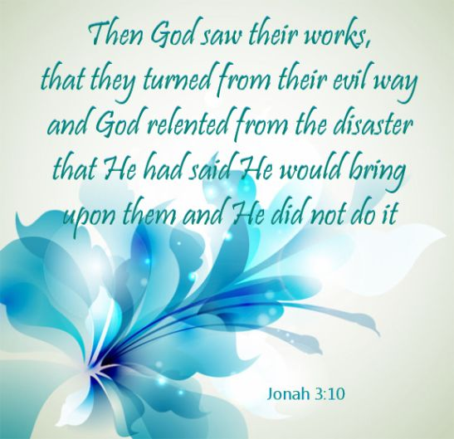

Bethlehem Lutheran Church reaching out to our community and to the world with the gospel of Jesus Christ.
Zion Lutheran Church seeks to preach and teach God’s word to all people of all ages and show God’s love through our witness, fellowship and service

BETHLEHEM-ZION LUTHERAN PARISH
Pastor – Rev. James Norton, (715)514-5478 or cell 1(217)725-2487
Bethlehem, Parish Office (715)877-3249, E19675 St. Rd. 27, Fall Creek, WI 54742
Zion (715)877-3128, 1286 S 150th Ave, Fall Creek, WI 54742
Web address: www.zion-bethlehem.org
Facebook: Zion-Bethlehem Lutheran Church e-mail – countryc@centurylink.net

