Seventh Sunday after Pentecost
Bethlehem/Zion Lutheran Parish July 8, 2018 Rev. James Norton
Ludington & Fall Creek, Wisconsin Linda Wiese Organist 715-514-5478

● ● ● ● ● ● ● ● ● ● ● ● ● ● ● ● ● ● ● ● ● ● ● ● ● ● ● ● ● ● ● ● ● ● ● ● ● ● ● ●
Service: LSB #4, P 203 Hymns: 876, 732, 637, 629, 643, 805
Old Testament Reading: Ezekiel 2:1-5
Epistle: 2 Corinthians 12:1-10
Holy Gospel: Mark 6:1-13
The Message: "The Kingdom of Heaven is . . . . ." Text: Matthew 13:44, 45, 47, 51
● ● ● ● ● ● ● ● ● ● ● ● ● ● ● ● ● ● ● ● ● ● ● ● ● ● ● ● ● ● ● ● ● ● ● ● ● ● ● ●
July’s Elders: Bethlehem – Dennis Anderson & Altar Guild: Beth.- Lois Sperber & Janet Weltzin
Zion – Ken Kiesow Zion – Lois & Jerry Kolpien

Please remember in your prayers: Pastor Jones at Zion, Chippewa, Selma Lane, Don Lane, Diane Goss, and Olivia & Aiden Schmidt, shut-ins and members living in Care Facilities.

OUR NURSING HOME RESIDENTS HOMEBOUND
Augusta---Diane Goss--Zion Brian Markham--Beth
Geneva Smith--Beth. Carol Huff--Zion
Eileen Hagedorn--Zion Don Berlin--Beth.
Selma Lane--Zion Amy Bergman--Zion
Naomi Sudbrink--Beth. Ellie Grunewald-Beth.

Also in nursing homes, or assisted living:
The Manor, Chippewa Falls--Delores Staats, (Sam [Marilyn] Norton’s mother)
Grace-Woodlands, Eau Claire--Florence Korn-Beth. Neillsville--Dorothy Solberg-Beth.
Stanley--Robert Reppe-Zion River Pines, Altoona--Julia Phillips-Beth
**You may put any prayer request in the box in the Narthex, or the fellowship hall at Bethlehem.

This Week’s Schedule

Sunday July 8, 2018 9:00am Zion Worship Service
[Communion] 10:30am Bethlehem Worship Service

Thursday, July 12 6:00pm Beth. Ladies Aid Summer Picnic at
Pastor and Marilyn’s home

Sunday July 15 9:00am Zion Worship Service
10:30am Bethlehem Worship Service

Be sure to sign the Red Record of Fellowship Folder on the aisle side of your pew today.

Happy Birthday This Week to: Jenna Bauch, Kim McNamara, Scott Lyons, Penny Schmidt, Terisa Glenz, Dominique Lirones, Marjorie Buchholz, Norman Luedtke, Jr., & John Hakes.

Happy Anniversary to: Debbie and Raymond Peterson, & Elvin and Renee Bauch.

Bethlehem VBS students collected money to send biblical books to children in Madagascar. There is a jar on the table in the fellowship hall, if you would like to contribute for the books. On the table is a “Mailbox” for Halle Luedtke. The students did drawings and wrote letters to her. You can also write her an encouraging note and drop it in the mailbox. They will remain there for the month of July.

Bethlehem members if you did not pick up a July newsletter, extra copies of the newsletter are available in the fellowship hall on the bookcases by the curtain.

Vacation Bible School at Zion is August 5th through 9th, please be sure to register your child. Contact Deb Prill, 715-464-1002. See the July newsletter for more information.
It’s time to start getting ready for our Autumn Harvest Dinner, along with the second annual Car/Tractor Show September 30, 2018. Putting out a call for anyone who has a car, truck, or tractor that you would be willing to bring on September 29th or 30th. Please contact Walter Thompson (715-877-3246) if you are able to help with the car/tractor show.
Christian Music Event: ONE FEST, Saturday July 28 and Sunday July 29, at the Northern Wisconsin State Fair Grounds, Chippewa Falls, WI. This our opportunity to see contemporary Christian music artists. We have so many music genres coming to the Chippewa Valley, it’s nice to see big name Christian artists coming to our area, as well. Check out the poster on the bulletin board.

The next youth group activity is a Youth Group Fun Night at the Noel Pond. There will be a bonfire with hot dogs, marshmallows/smores, also games, fishing (bring your own poles) kayaks and paddle boats. Parents are welcome. This will be on Tues. July 10th at 6 pm with a rain date of Wed July 11 same time.
All youth grades 5-12 for the upcoming school year are encouraged to join in the fun. If you are in need of directions please contact Darin or Jamie at 715-877-3721.

The Bethlehem Ladies Aid July potluck picnic will be at the Norton’s home on July 12 at 6pm. All ladies of Zion and Bethlehem are invited. Spouses are also welcome. Please RSVP Marilyn by this Wednesday at 715-514-5478. That way, she will have an idea of how many chairs to put up. Join Us!

Our Worship Response 7/1/2018:
Bethlehem Zion
Attendance 58 32
Offerings $1162.00 $744.00
VBS $30.00
Missions 40.00
Weekly Budget Needs: $1185.24 $1138.00

Upcoming dates to remember:
Ladies - JULY IS MITE BOX MONTH
July 10th Youth Group Fun Night at the Noel Pond
July 12th – Ladies Aid potluck picnic 6pm @ Pastor and Marilyn’s home
August 5th to the 9th Zion’s Vacation Bible School

+++

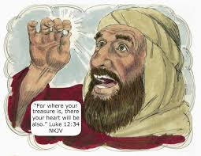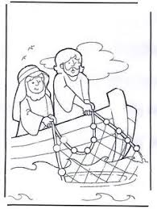

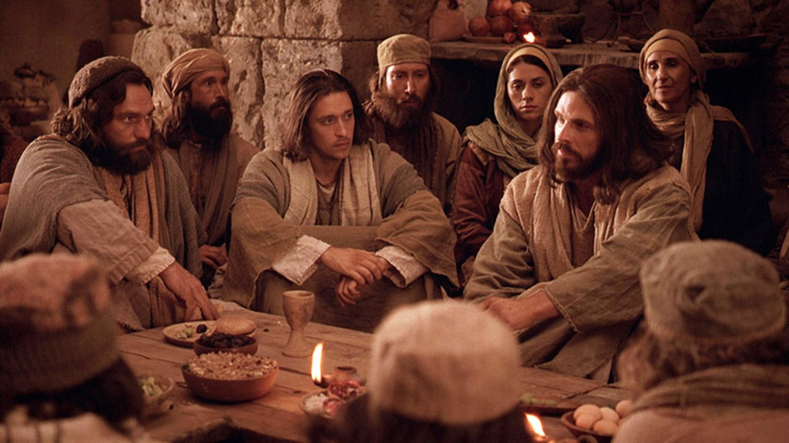
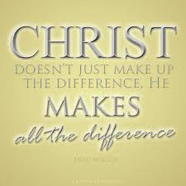
Bethlehem Lutheran Church reaching out to our community and to the world with the gospel of Jesus Christ.
Zion Lutheran Church seeks to preach and teach God’s word to all people of all ages and show God’s love through our witness, fellowship and service

BETHLEHEM-ZION LUTHERAN PARISH
Pastor – Rev. James Norton, (715)514-5478 or cell 1(217)725-2487
Bethlehem, Parish Office (715)877-3249, E19675 St. Rd. 27, Fall Creek, WI 54742
Zion (715)877-3128, 1286 S 150th Ave, Fall Creek, WI 54742
Web address: www.zion-bethlehem.org
Facebook: Zion-Bethlehem Lutheran Church e-mail – countryc@centurylink.net

