The Third Sunday after Pentecost
Bethlehem/Zion Lutheran Parish June 10, 2018 Rev. James Norton
Ludington & Fall Creek, Wisconsin Linda Wiese Organist 715-514-5478
● ● ● ● ● ● ● ● ● ● ● ● ● ● ● ● ● ● ● ● ● ● ● ● ● ● ● ● ● ● ● ● ● ● ● ● ● ● ● ●

Service: LSB #4 P. 203 Hymns: 816, 527, 617, 620, 805
Old Testament Reading: Genesis 3:8-15
Epistle: 2 Corinthians 4:13-5:1
Holy Gospel: Mark 3: 20-35
The Message: The Message: "Sin Is Terrible in its Consequences, But..."
Text: Genesis 3:8-15
Please remember in your prayers: Sam’s sister, Barb, Wendy Frank, Selma Lane, Don Lane, Diane Goss, and Olivia & Aiden Schmidt, shut-ins and members living in Care Facilities; our Seminary Student, Kevin Dykstra, Halle Luedtke for her mission work in North Dakota, & Zach Johnson (Dottie’s grandson) beginning his seminary studies at Ft. Wayne this Fall.
OUR NURSING HOME RESIDENTS HOMEBOUND
Augusta---Diane Goss--Zion Brian Markham--Beth
Geneva Smith--Beth. Carol Huff--Zion
Eileen Hagedorn--Zion Don Berlin--Beth.
Selma Lane--Zion Amy Bergman--Zion
Naomi Sudbrink--Beth. Ellie Grunewald-Beth.
Also in nursing homes, or assisted living:
The Manor, Chippewa Falls--Delores Staats, (Marilyn (Sam) Norton’s mother)
Grace-Woodlands, Eau Claire--Florence Korn-Beth. Neillsville--Dorothy Solberg-Beth.
Stanley--Robert Reppe-Zion River Pines, Altoona--Julia Phillips-Beth
**You may put your prayer request in the box in the narthex.
District Convention Highlights:
President Dwayne Lueck was reelected.
There were 280 pastors present plus guests
There are 459 Synod vacancies
Our District has 217 congregations; 45 that are dual; 3 have closed; 2 are new; 23 are vacant with no full-time pastor.
District giving has gone from 2.3 million in 07 to 1.7 million in 2017.
Of money sent to District by congregations, 39% goes to Synod, 40% stays in District, 15% goes to District missions and 6% goes to Camp Luther.
Synod President, the Rev. Dr. Matthew Harrison had the message at the opening worship service and later gave a report events in Synod.
The convention essay was given by the Rev. Dr. Dale Meyer, President of Concordia Seminary in St. Louis.
This Week’s Schedule

Sunday June 10 9:00am Zion Worship Service
[Communion] 10:30am Bethlehem Worship Service

Thursday June 14 noon Bethlehem Ladies Aid/potluck

Sunday June 17 9:00am Zion Worship Service
Happy Father’s Day! 9:00am Vacation Bible School @ Bethlehem starts
(VBS Monday thru Thursday is 6-8:00pm)
10:30am Bethlehem Worship Service
Potluck picnic after church service

Happy Birthday This Week to: Donald Berlin, Peyton Berlin, Jeffrey McCann, Linda Glenz, Karen Stensen, Beckett Berlin, and Breleigh Berlin.

Happy Anniversary this week to Duane & Jolene Hermann, Penny & Bradley Schmidt, Ted & Pat Biegel, and Mike & Christina Hausmann.

Did you notice something missing today at Bethlehem? Due to construction items from the narthex and bathrooms have been put away in the closet behind the office or moved into the fellowship hall/Sunday School area.

Be sure to sign the Red Record of Fellowship Folder on the aisle side of your pew today.

Splash Canyon, Bethlehem’s VBS starts next Sunday, June 17, and continues thru June 21. There will be a potluck picnic following church service next Sunday. Remember, all children are welcome: members, neighborhood children, your grandchildren, Zion’s children, etc. Children do not have to be a member to attend vacation bible school. Come & watch the children’s VBS program at 7:30 on Thursday, the 21st. It’s always fun to see what the children have done.

Thank you to Gene Neumann for constructing a new desk in the Sunday School office area at Bethlehem across from Pastor’s office. Great job Gene!

Margie and Jeff Buchholz’s family would like to extend their thanks for the cards and gifts in Jeff’s memory. Some money has been given by people directly to Bethlehem’s building fund and memorial fund also in Jeff’s memory. Sincere thanks for your thoughtfulness.

Today, we are sending four kids to camp (2 from Bethlehem, and 2 from Zion). There will be a picnic lunch at Zion after the 9:00 worship service. The congregation is asked to bring desserts. We will send our kids off by 11:00am. Join us as we wish these kids and the drivers safe travels and a fun filled week at camp.
Bible Study at Zion, TODAY! Last week we had 15 members join us as we take a new look at the parables. Please join us for our new Bible study opportunity, "Renaming the Parables" (following our church service) Pastor Tom Baker, who is on KFUO Radio in St. Louis, with his Law and Gospel program. Each lesson is one-hour long. You are encouraged to stay, have a cup of coffee and treats, and listen to Pastor Tom explain why each parable is misnamed.
Vacation Bible School at Zion is August 5th through 9th, please be sure to register your child.
Planning ahead for Zion's Annual Autumn Harvest Dinner...Mark your calendars...Sunday, September 30, Harvest Dinner and Car/Tractor Show.
Check out the bulletin board:
Christian Music Event: ONE FEST, Saturday July 28 and Sunday July 29, at the Northern Wisconsin State Fair Grounds, Chippewa Falls, WI. This our opportunity to see contemporary Christian music artists. We have so many music genres coming to the Chippewa Valley, it’s nice to see big name Christian artists coming to our area, as well. Check out the poster on the bulletin board for details.
There will be a Divine Service and Rite of Farewell and Godspeed for Rev. Mark Mischnick,
Sunday June 24, 2018, 9:00 am, at Zion Lutheran Church, Chamberlain, SD. See the invitation on the bulletin board for details.

Our Worship Response 6/3/2018:
Bethlehem Zion
Attendance 71 33
Offerings $1166.00 $1410.50
Missions $40.00
Building Fund $35.00
Weekly Budget Needs: $1185.24 $1138.00

Upcoming dates to remember:
June 14th Bethlehem Ladies Aid
June 17th to the 23rd - Bethlehem Vacation Bible School
June 24th to the 26th – North WI District Lutheran Women’s Missionary League 37th Biennial Convention in Steven’s Point, WI
August 5th to the 9th Zion’s Vacation Bible School

The Third Sunday after Pentecost - June 10, 2018
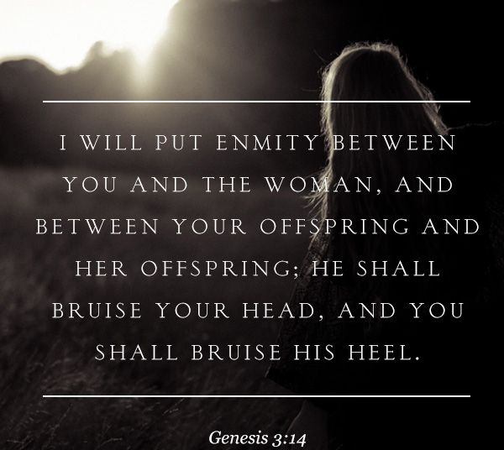

Bethlehem Lutheran Church reaching out to our community and to the world with the gospel of Jesus Christ.
Zion Lutheran Church seeks to preach and teach God’s word to all people of all ages and show God’s love through our witness, fellowship and service!

BETHLEHEM-ZION LUTHERAN PARISH
Pastor – Rev. James Norton, (715)514-5478 or cell 1(217)725-2487
Bethlehem, Parish Office (715)877-3249
E19675 St. Rd. 27, Fall Creek, WI 54742
Zion (715)877-3128, 1286 S 150th Ave, Fall Creek, WI 54742
www.zion-bethlehem.org
Facebook: Zion-Bethlehem Lutheran Church e-mail – countryc@centurylink.net

