Bethlehem Lutheran Church
E19675 State Road 27
Fall Creek, WI 54742

MAY 2018 HIGHLIGHTS
Worship Services are held Sunday at 9am @ Zion, & 10:30am @ Bethlehem
Communion is offered on the 2nd and 4th Sundays of the month
Sunday School 9:00am @ Bethlehem and 10:15am @ Zion
May 2nd – Zion Ladies Aid @ noon with a potluck
May 3rd – Council meetings @ Zion 7:00pm; Pastor @Augusta Nursing Home for Services
May 5th – Spring Cleanup Day 8-12 @ Bethlehem
May 6th – Confirmation Day @ Bethlehem (there are no confirmands from Zion this year)
May 10th – Bethlehem Ladies Aid @ noon with potluck
May 13th – Happy Mother’s Day!
May 17th – Bible Study @ Fall Creek Commons 9:30am
May 20th – Last day of Sunday School @ Bethlehem; special service to honor workers

Zion Lutheran Church
1286 S 150th Ave.
Fall Creek, WI 54742

MAY 2018 HIGHLIGHTS

Worship Services are held Sunday at 9am @ Zion, & 10:30am @ Bethlehem
Communion is offered on the 2nd and 4th Sundays of the month
Sunday School 9:00am @ Bethlehem and 10:15am @ Zion

May 2nd – Zion Ladies Aid @ noon with a potluck
May 3rd – Council meetings @ Zion 7:00pm; Pastor @Augusta Nursing Home for Services
May 5th – Spring Cleanup Day 8-12 @ Bethlehem
May 6th – Confirmation Day @ Bethlehem (there are no confirmands from Zion this year)
May 10th – Bethlehem Ladies Aid @ noon with potluck
May 13th – Happy Mother’s Day!
May 17th – Bible Study @ Fall Creek Commons 9:30am
May 20th – Last day of Sunday School @ Bethlehem; special service to honor workers

CONFIRMATION DAY 2018
+++++++++++++++++++++++++++++++++++++++++++++++++++++++
The two young people listed below have been studying Luther’s Small Catechism, the Bible and the Book of Concord for the past two years. They, by no means know everything there is to know about these three sources of knowledge but they do have a working knowledge of the Christian faith. They are ready to take their place as Communicant members of their church. They are:
MIRANDA DEKAN SHANE PILGRIM
Their Confirmation Day is an important milestone on their journey to the mansions of heaven promised by Jesus to all who believe and are faithful unto death.
They have been told that this is not the end of their Christian education but just the beginning of a life-long search for the truth that is contained in the Bible which is the manual of BASIC INSTRUCTION BEFORE LEAVING EARTH.
All of us who look to Jesus Christ as our Savior from sin, death and the devil have been given the gift of forgiveness and eternal life. What a blessing to know our future.
What a blessing it is to be able to have God’s saving Word and His Sacraments to help us to remain firm in our faith until called home to heaven.
As all of us read this article, we should all ask ourselves, ‘am I keeping my confirmation promise to Jesus to make regular use of the means of grace, word and sacrament?’ Or, am I in danger of hell-fire due to my unfaithfulness and disregard for the saving Word of my dear Lord?
We will all have to give an account of our life on earth---whether or not each of us was a faithful follower of Jesus Christ. Meaning, did God see me in the pew each Sunday to worship His Son, our only Savior from sin, death and the devil?
Eternal life is God’s free gift to all who are faithful until death. May the Good Lord bless Miranda and Shane with strong faith to keep their confirmation promise made May 6th and may He also impress upon all of us the importance of being in His House of Worship every Sunday to receive the peace that passes our understanding.

Pastor James E. Norton
Romans 1:16

BETHLEHEM LUTHERAN CHURCH
Website: zion-bethlehem.org
Facebook Address: Zion-Bethlehem Lutheran Church
Office Telephone (715)877-3249
Address: E19675 State Road 27, Fall Creek, WI 54742

Help Wanted: Spring Clean-up rescheduled. All hands needed-all ages welcome. Bethlehem church and the parsonage yard clean up will be Saturday morning May 5th 8-12. Bring your tools and offer your help. If you would rather work on your own Friday May 4th, contact Marv Sperber.

Sunday May 20th 10:30 service. A special service will be held to honor all our church workers. A special thank you will be provided to our Sunday School Staff and others. We appreciate all you do and use your ability in many ways to serve our Savior. Cake and ice cream will follow the service.

Building Committee Update: The committee is making selections or looking at interior items such as flooring, vanities etc. This is an exciting time. Donations continue to be needed and are welcome.

Reminder: If you park in the middle row of the south parking lot, please make sure there is room for another vehicle to park behind you. We should be able to have 3 rows for parking – against the building, in the middle, and another one behind that. Thank you.

YOUTH -The Youth Group will meet on Sunday May 15th.

BETHLEHEM LADIES AID:
Many of us attended the LWML Spring Rally in Durand. Joan Boyea was voted to be our new Zone 15 president. The Bible study was on the names of Jesus. “When believers consider Suicide” was the guest speaker, Rev. Peter Pheus’s topic. Sharon Tumm purchased a book for our library that he had for sale.
Coming Up: May 8th – serve the Fall Creek Lions. May 10 – next aid meeting at noon. Our lesson is on page 16 in our spring quarterly.

Confirmation is May 6th. Congratulations to Miranda Dekan and Shane Pilgrim on this faith milestone.
Last day of Sunday School is May 20th.

SAVE THE DATE: VBS -
Vacation Bible School is a fun packed time of learning about Jesus thru lessons, crafts, music and more. Children ages 3 thru 8th grade welcome. Share this with a friend or neighbor. The community children are invited. Sunday, June 17 9-10:15am, Mon-Thurs 6-8pm with a program Thurs. evening. Looking forward to this great outreach! Contact Sharon Tumm or Joan Drehmel to enroll your children, or if you’d like to help.
Theme is : “Splash Canyon”: God’s Promise on Life’s Wild Ride!! “He that believes and is baptized shall be saved.” Mark 16:16

Bethlehem Monthly Council Meeting Minutes

Secretary’s minutes read and accepted.
Treasurers Report: Erin presented the report and noted the following:
$12,500 balance in Future Insurance Package, $500/month
$2,662.70 balance in Choice Points
$16,483.40 balance in Building Fund
1.) Geek Squad Annual Contract - Discussed continuing the Geek Squad Annual Contract for the computer. Erin will contact Karon.
2.) Yellow Pages Listing - Discussed the $399/year invoice to list the churches phone number in the Yellow Pages. It is listed under churches with only the name and phone number. As the church has a landline, the number is already printed in the phone book for free. Consensus of those present was to discontinue this service.
3.) Wayne Hanson Pay Request – Marv presented a pay request from Wayne Hanson in the amount of $9,000.
MOTION (Sharon Tumm/Steve Davidson) to approve the pay request from Wayne Hanson, authorizing the Treasurer to issue payment of $9,000 from the Building Fund. PASSED, without negative vote.
Elders Report:
1.) Light bulbs around the cross – have been replaced.
2.) Carillon/Church Bell – has been fixed. All it required was resetting the system by unplugging and letting it reconfigure after plugging back in.

Old Business:
1.) Halle Luedtke Mission Project – April 15th is Mission Sunday, and Halle Luedtke will speak at both churches about her project. Pastor Lueck will also be speaking during the services. The potluck lunch at Bethlehem following services will include a free will offering which will go to Halle’s fund-raising efforts.
MOTION (Steve Davidson/Sharon Tumm) to direct $500 in Choice Points to Halle Luedtke’s mission project. PASSED, without negative vote.
2.) Food Pantry Donations –
MOTION (Tom Woodford/Dennis Anderson) to send $300 to each Food Pantry (Augusta, Fall Creek, Cadott) from Choice Points. PASSED, without negative vote.
3.) Spring Cleaning Day, April 21st – Marv explained that the scope of the work may have to change, as the construction project should be in full swing, and the Ladies Aid have scheduled their thrift sale for the same day. He suggested doing any outside work at the church or parsonage, and planning another day for cleaning inside the church.
4.) Parsonage Update Informational Meeting – is scheduled for April 22nd following church services. All voting members will be given information as to the options of selling or renting the parsonage. A future date will be determined for a Special Voter’s Meeting to act on the information presented.

New Business:
1.) Request to Borrow Tables and Chairs – Dennis Anderson would like to borrow some tables and chairs from the Fellowship Hall for his grandson’s confirmation on April 29th. Permission was granted.
Adjourn:
MOTION (Steve Davidson/Dennis Anderson) to adjourn at 8:02 p.m. PASSED, without negative vote.

The Lord's Prayer was prayed in closing. Joan Drehmel, Secretary

Zion Lutheran Church

Zion Lutheran Church seeks to preach and teach God’s Word to all people of all ages, and to show God’s love through our witness, fellowship, and service.
MAY 2018 Newsletter

Joint Council Meeting is at Zion, May 3, beginning at 7:00, followed by each congregation’s council meetings, and then the Elder’s meeting

Lunch is served at Zion each Sunday, following the worship service: First Sunday is hosted by the Sunday School. Second Sunday is hosted by the Church Council. Third Sunday is hosted by the Mission Board. Fourth Sunday is hosted by the Ladies’ Aid. All are invited to join us for good food and fellowship

Looking ahead… VBS will be August 5-9

Sunday School News
The Sunday School children sang at the Easter Sonrise Service. It was great to hear the children sing. The choir also sang. The breakfast after each service was also well attended, and the food was very good, too. We thank everyone who worked so hard and generously gave of their time to prepare for this day. The last day of Sunday School will be on May 20th. The children will sing during the worship service on this day. Vacation Bible School, at Zion, will be held August 5th through August 9th.

Greatest man in history, named Jesus, had no servants, yet they called him Master. Had no degree, yet they called him Teacher. Had no medicines, yet they called him Healer. He had no army, yet kings feared Him. He won no military battles, yet He conquered the world. He committed no crime, yet they crucified Him..... He was buried in a tomb, yet He lives today.

Council Meeting Highlights

Council Meeting Minutes April 5, 2018
Meeting was called to order at 7:18pm. There were 5 present plus pastor.
Secretaries Report: The minutes from March 1, 2018 were read by Sue Stephan. Earl stated that the location of the key should not have been made public. Dan asked about the card table in the library. Dan also asked about the mats at the entrance doors.
Treasurer’s Report: Chris H read the treasurer’s report Ladies Aid was reimbursed for a vacuum cleaner.
Elders Report: 43 Average attendance, 4 children, and 40 communing. Candles were filled Maundy Thursday, will be filled this Sunday.
Pastor reported that he took the communion flagon to Williams’s jewelry, it would need to be sent out for repairs, no guarantee that it could be repaired. Pastor will continue looking into getting it fixed or purchasing a new one. It was suggested to check with the CVTC. Pastor also started that the President of the District would be here for the Sermon on Mission Sunday. He asked about our delinquents’ policy.
Trustee Report: No trustee present to give report.
There was discussion about the mats at the entrances. Dave will look into getting bigger mats. Discussion was held concerning the rugs in the basement and the hazard that they pose. Water report showed high nitrates. Signs will be posted.
Mission Board: Earl reported that there will be 4 students going to Camp during the first period in June.
Ladies Aide/Sunday School Report: No one present to give report.
Old Business: Jordan Mewhorter has been hired as organist. He will be given keys for church and organ. It was noted that the old vacuums were given as a trade in for the new vacuums but, there had been no offer to return the old vacuums to those who had donated them to the church.
New Business: None
Meeting was adjourned at 8:04. Closed with The Lord’s Prayer.

Our Heavenly Father, How can I ever thank You enough for giving Your life and dying on the cross in my place so that I could inherit Your gift of eternal life. Help me to always live in an attitude of gratitude for all that you have done for me. Thank You for hearing my prayer. Gratefully, in Jesus’ Loving Name I pray. Amen.

MAY 2018
God bless your “New Year”

5/5 Kenzie Bauch
5/8 Jameson Sperber
5/9 Aaden Raether
5/11 Cleo Carpenter
5/13 Pamela Luedtke
5/15 Linda Wiese
5/20 Linda Pilgrim
5/21 Sharon Green
5/22 James Huff Sr
5/24 Shane Pilgrim
5/25 Carter Kaufman, Pat Glenz
5/26 Elly Grunewald, Pat Biegel
5/27 Marisa Walmsley
5/30 Carol Sperber
Happy Anniversary
“You’re a wonderful couple, joined by God above. May your marriage continue in God’s love.”
5/2 Mr. & Mrs. Dale Noel 5/18 Steve Single & Freda Shong
5/7 Mr. & Mrs. Ed Raether 5/23 Mr. & Mrs. Roger Kohls
5/12 Mr. & Mrs. Travis Moss 5/23 Mr. & Mrs. Robert Grunewald
5/27 Mr. & Mrs. John Peterlik
5/14 Mr. & Mrs. Donald Woodford Sr 5/28 Mr. & Mrs. Valint Hadorn
5/14 Mr. & Mrs. Stephan Walmsley 5/29 Mr. & Mrs. David Kiesow

BAPTIZED IN MAY:
5/5 Mitchell & Samantha Lyons 5/5 Dave Kiesow
5/8 Geneva Smith
5/9 Rebecca Peterlik, 5/13 Eric Weggen
5/14 Steve Pilgrim, Levi & Tyler Christenson
5/15 Loretta McCann 5/16 Jane Anderson 5/17 Shannon Sachsenmaier, Tristan
5/19 Dorothea Neumann Maland
5/27 Rainy Furler-Marion, Brandon Wedlund 5/28 Jackson Jaenke

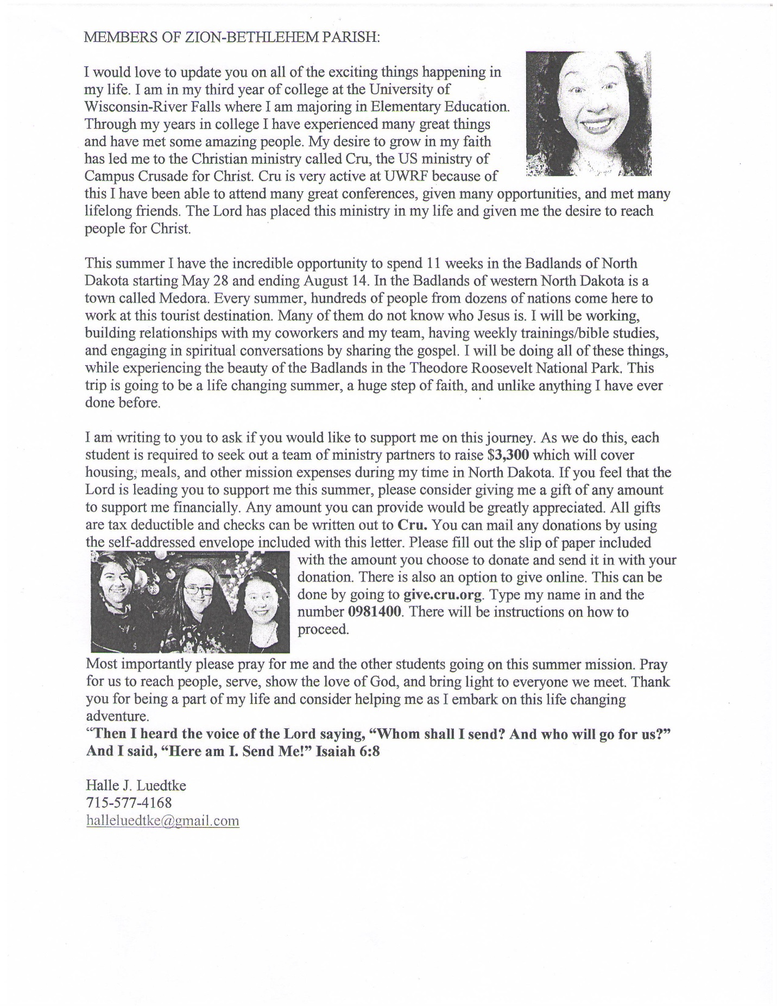
Please remember in your prayers: Cheryl Knuth, Jeff Buchholz (Margie’s son), Selma Lane, Don Lane, Diane Goss, & Olivia Schmidt. Shut-ins and members living in Care Facilities. Our Seminary Student, Kevin Dykstra, & Halle Luedtke for her coming missions in North Dakota.
OUR NURSING HOME RESIDENTS HOMEBOUND
Augusta---Diane Goss--Zion Brian Markham--Beth
Geneva Smith--Beth. Carol Huff--Zion
Eileen Hagedorn--Zion Julia Phillips--Beth
Selma Lane--Zion Amy Bergman--Zion
Naomi Sudbrink--Beth. Ellie Grunewald-Beth.
Don Berlin--Beth.
Grace-Woodlands, Eau Claire---Florence Korn-Beth. Neillsville-Dorothy Solberg-Beth.
Stanley---Robert Reppe-Zion
Smile of the month! Woke up with the song “Go My Children, with My Blessing” in my head! I had just dreamt that my sister left me at a restaurant and I had to walk home thru a lot of snow and ice. When I woke up, I had thrown off the covers and my arms and legs were freezing! . . . . Lord, the brain you gave me, just astounds me!!!
Bethlehem-Zion Lutheran Parish Rev. James Norton, Pastor
Cell 1(217)725-2487, Home (715)514-5478

Bethlehem Office (715)877-3249 (Office Hours T, W, TH 9-noon); Zion Office (715)877-3128
Sunday Services: Zion 9am, Bethlehem 10:30am Sunday School: Bethlehem 9am - Zion 10:15am
Elders: Bethlehem – Steve Davidson Altar Guild: Bethlehem – Sharon Tumm & Carol Sperber
Zion – Earl Jaenke Zion – Ted & Pat Biegel

May 2018

Sunday | Monday | Tuesday | Wednesday | Thursday | Friday | Saturday
God’s Blessings |  | 1  May Day | 2  Zion Ladies Aid @ noon | 3  Pastor has services at  Augusta N.H.  Council Mtg @ Zion 7:00p  Zion | 4 | 5
6  CONFIRMATION  DAY | 7 | 8  Ladies Aid is serving Fall Creek Lions @ Bethlehem | 9 | 10  Bethlehem Ladies Aid @  noon | 11 | 12
13  Communion  Youth Group Meeting | 14 | 15 | 16 | 17  9:30am Bible Study @ Fall Creek Commons | 18 | 19
20  Last day of Sunday School @ Bethlehem | 21 | 22 | 23 | 24 | 25 | 26
27  Communion | 28 | 29 | 30 | 31

