Bethlehem Lutheran Church
E19675 State Road 27
Fall Creek, WI 54742

APRIL 2018 HIGHLIGHTS
Worship Services are held Sunday at 9am @ Zion, & 10:30am @ Bethlehem
Communion is offered on the 2nd and 4th Sundays of the month
Sunday School 9:00am @ Bethlehem (also Adult Bible Study) and 10:15am @ Zion
Every Wednesday – Confirmation @ 5pm @ Bethlehem
April 1 Easter Sunrise Service @ Zion 7:00am with Communion
April 1 Easter Sunday Service with Communion, Zion 9am, Bethlehem 10:30
April 4 Zion Ladies Aid with Potluck @ noon
April 5 Council Meetings @ Bethlehem, 7:00p
April 8 Youth Meeting 6:30 @ Bethlehem
April 10 LWML Spring Rally 8:30a @ St. Johns, Durand
April 12 Bethlehem Ladies Aid with Potluck @ noon
April 15 Mission Sunday, Duane Lueck is speaker, potluck following Bethlehem’s service
April 17 Pastor’s Spring Conference @ Camp Luther
April 19 Bible Study @ Fall Creek Commons 9:30am
April 21 Bethlehem Church Spring Cleanup 8am – members, please come to help
April 21 & 22 Bethlehem Ladies Aid Thrift Sale, Bake Sale, & Lunch
April 22 Bethlehem Congregation Informational meeting directly after Sunday Service
April 26 Bethlehem Sunday School Teachers Meeting 7:00pm
April 29 Dinner for Confirmands @ Bethlehem
May 6 Confirmation @ Bethlehem
Zion Lutheran Church
1286 S 150th Ave.
Fall Creek, WI 54742

APRIL 2018 HIGHLIGHTS

Worship Services are held Sunday at 9am @ Zion, & 10:30am @ Bethlehem
Communion is offered on the 2nd and 4th Sundays of the month
Sunday School 9:00am @ Bethlehem (also Adult Bible Study) and 10:15am @ Zion
Every Wednesday – Confirmation @ 5pm @ Bethlehem
April 1 Easter Sunrise Service @ Zion 7:00am with Communion
April 1 Easter Sunday Service with Communion, Zion 9am, Bethlehem 10:30
April 4 Zion Ladies Aid with Potluck @ noon
April 5 Council Meetings @ Bethlehem, 7:00p
April 8 Youth Meeting 6:30 @ Bethlehem
April 10 LWML Spring Rally 8:30a @ St. Johns, Durand
April 12 Bethlehem Ladies Aid with Potluck @ noon
April 15 Mission Sunday, Duane Lueck is speaker, potluck following Bethlehem’s service
April 17 Pastor’s Spring Conference @ Camp Luther
April 19 Bible Study @ Fall Creek Commons 9:30am
April 21 Bethlehem Church Spring Cleanup 8am – members, please come to help
April 21 & 22 Bethlehem Ladies Aid Thrift Sale, Bake Sale, & Lunch
April 22 Bethlehem Congregation Informational meeting directly after Sunday Service
April 26 Bethlehem Sunday School Teachers Meeting 7:00pm
April 29 Dinner for Confirmands @ Bethlehem
May 6 Confirmation @ Bethlehem

PEACE FROM THE RISEN CHRIST
The disciples of Jesus were full of fear and doubted that they would ever see their beloved Master ever again. He had been crucified and had died and was buried. What now?
When Jesus appeared to them after He rose from the dead, their fears and doubts vanished and they were filled with joy and hope. With this unbelievable good news, filled with the Holy Spirit after the day of Pentecost, the 12 went forth as instructed by their living Lord to spread the news of forgiveness and life to be found in Jesus.
This is fantastic!! Why is that you ask? Death and despair have spread their evil the world over, choking life and happiness from people.
How can anyone have any hope for anything good after death has robbed you of life? There was nothing to look forward to except the end of life.
Jesus changed all that when He walked from His grave very much alive and in charge. As each of us must face the end of life on earth, we can now have peace of mind because death here is not the end----all who look to and believe Jesus to be their Savior will, at death, go to be with Jesus in spirit.
Then, when Jesus returns at the end of time, all believers in Jesus will begin a whole new life in heaven that will never end. Can you believe it? Reunited with all who have fallen asleep in Jesus.
As we celebrate the resurrection each Easter, let these thoughts give you hope of a better day. All the trouble and turmoil of this present life will one day be gone and we will finally have the peace and joy that Jesus has promised.
HE IS RISEN! HE IS RISEN INDEED!
Yours in Christ,
Pastor Norton

BETHLEHEM LUTHERAN CHURCH
Website: zion-bethlehem.org
Facebook Address: Zion-Bethlehem Lutheran Church
Office Telephone (715)877-3249
Address: E19675 State Road 27, Fall Creek, WI 54742

Important Upcoming dates: April 21: Outside yard cleanup. Please make every effort to spend an hour or more helping with yard cleanup, outside repairs. YOUR HELP IS NEEDED AND APPRECIATED.
Time: 8:00am-? Bring rakes, shovels, maybe wheelbarrow. Lunch will be served.

April 21: Bethlehem Ladies Aid Thrift Sale, Bake & Lunch Sale.

April 22: After church service, informational meeting regarding the parsonage. Parsonage Committee update.

April 29: Dinner for confirmands. There are 2 this year. Miranda Dekan & Ryan Pilgrim.

Building Committee continues to work on selection of items needed such as flooring, bathroom fixtures and so on. Due to State inspections and approvals it has taken longer. Contractor, Wayne Hanson, keeps us posted.

CHOIR: Sincere thanks to Sam (Marilyn) Norton & Ken Kiesow for all their wonderful help with our Lent and Easter choirs. We truly appreciate you.

YOUTH -The Youth Group enjoyed fellow-shipping with the congregation on Youth Sunday. They had a great turnout. They hope the congregation enjoyed the service and would encourage any youth between the grades 5-12 to join them for their regular meetings. The meetings are usually the 2nd Sunday of the month during the school year. The youth plan on finishing their Alpha video study, with plans of bonfires and other fun activities this spring and summer.

BETHLEHEM LADIES AID:
Date Change – The date for the Zone 15 LWML Rally, in Durand, has been changed from April 17 to April 10. Our next aid meeting is April 12. The Bible Study is from our Spring Quarterly. Sharon Tumm informed us that two books on Dr. Rosa J. Young, the Mother of Black Lutheranism, have been purchased for the library. There are 46 quilts completed, despite weather problems. The date for our thrift sale is April 21, and before and after church on the 22nd. The Confirmation Banquet is April 29.

Sunday School Children collected $172.37 for “Building With Love” Hearts For Jesus mission project. Our Bible lessons will be from Acts 12 – 15; studying Peter, and Cornelius and Paul’s 1st Missionary journey.
Confirmation is May 6th.
Last day of Sunday School is May 20th.
VBS “Splash Canyon” is coming in June! “He that believes and is baptized shall be saved.” Mark 16:16
Also, new books & a DVD on Rosa Young are in the library.

Sunday Morning Bible Study – every Sunday @ 9:00am @ Bethlehem. Come join us!

Monthly Council Meeting Minutes
Secretary Minutes and Treasurer’s Report were given. Then:
Treasurers Report: 1.) Monthly collections are down by $800, as reported by the new treasurer, Erin Pilgrim.2.) Official Notice of change in Treasurer is required by Co-op Credit Union in Fall Creek, and Citizens State Bank (Cadott). Joan Drehmel will mail notice to each, stating Dorothy Luedtke as the alternate Treasurer. This will aid in allowing Erin access to the accounts as needed.
Trustees Report: 1). Light bulbs need to be replaced behind the cross, over the Lectern and by the Baptismal font.
Board of Education Report:
1.) Hearts For Jesus collection that is going for the building fund will be turned in March 11th.
2.) Sunday School is studying 4 Bible lessons that lead up to the Easter Story.
3.) Palm Sunday Fair will feature “Journey to the Cross” lessons and activities.
Old Business:
1.) Carpet Installation – invoice to Color Center of Cadott has been paid.
New Business:
1.) Carillon/Church Bell System – The church bells are not working properly. The instruction manual needs to be located; may have to contact someone for repairs.
2.) Dorothy Luedtke resignation as Treasurer – The Council thanked Dorothy for 10 years of service to the church as Treasurer. She was appreciative of their support, and happy to see Erin willing to take the job.
MOTION (Karon Davidson/Tom Woodford) to accept the resignation of Dorothy Luedtke as Treasurer, and to approve the appointment of Erin Pilgrim to the position. PASSED, without negative vote.
3.) Halle Luedtke Mission Project – Dorothy Luedtke had reported at the Joint Council Meeting that her granddaughter Halle (a member of Bethlehem) will be part of a mission project in Medora, North Dakota this summer. She will be learning how to share the gospel at this tourist destination through Bible studies and spiritual conversations. Each member is required to raise $3,300 which covers all their expenses for this 11-week project. She asked if Halle’s request for contributions and prayers could be considered/posted by both congregations.
It was decided that Halle’s letter will be included in the bulletin, the newsletter, the website, Facebook page and posted on the bulletin board.
Mission Sunday is April 15th, so Dorothy will ask Halle if she would speak at both congregations during their church services. A potluck lunch will be served after service at Bethlehem with members of both congregations invited. The freewill offering will go toward Halle’s mission project.
Possible contributions from other funding sources such as Choice Points, Student Aid and the Mission Board will be discussed at the April Council Meeting.
4.) Sunday Service Time Swap – At the Joint Council Meeting, Zion Council President Dave Kiesow had asked if Sunday church service times could be swapped on the day of Zion’s Annual Voters Meeting. This way Pastor Norton could attend the meeting.
MOTION (Karon Davidson/Steve Davidson) to approve changing the time of Bethlehem’s Sunday church service to 9:00 a.m. on the day of Zion’s Annual Voters Meeting. Notice will be posted in the bulletin a month prior as a reminder of the change in the schedule for this day. PASSED, without negative vote.
5.) Spring Cleaning Day – Marv would like to schedule the date for Saturday, April 21st at 8:00 a.m. The date will depend on the Spring weather. He will schedule a meeting with the members of the Spring Cleaning Committee. They will compile and prioritize a list of things that need to be repaired, replaced, and cleaned inside and outside of the church. A lunch at noon could be part of the day’s events.
6.) Kitchen Fan – The Ladies Aid is requesting permission to purchase a ceiling fan with a light fixture to be installed in the kitchen. It will replace the existing light fixture. The Council approved the purchase.
7.) Portals of Prayer Update – Karon reported that we currently mail 71 issues of Portals of Prayer; we get a price break if we mail 75 issues. Let Karon know if you have someone that can be added to the list to make up the difference.
8.) Bulletin Inserts Large Print – Karon asked if there has been any comment about the larger print of the bulletin inserts. The smaller print saves on paper, but the larger print is easier for some people to read. She will ask those people that need larger print for their comments.
9.) Constitution Corrections – Joan Drehmel will update the current copy of the constitution.

Zion Lutheran Church 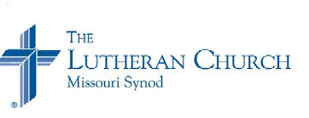

Zion Lutheran Church seeks to preach and teach God’s Word to all people of all ages, and to show God’s love through our witness, fellowship, and service.
April 2018 Newsletter

Joint Council Meeting is at Bethlehem, April 5, beginning at 7:00, followed by each congregation’s council meetings, and then the Elder’s meeting

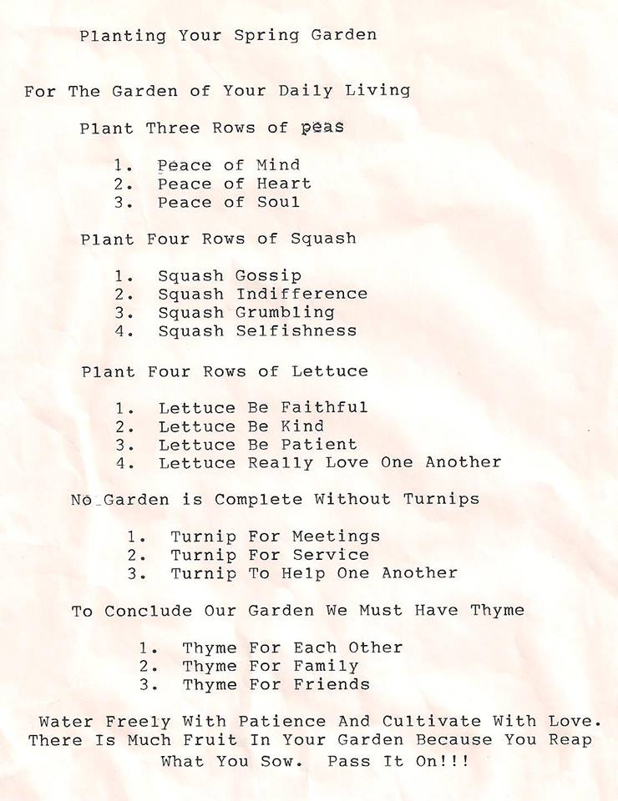

Lunch is served at Zion each Sunday, following the worship service: First Sunday is hosted by the Sunday School. Second Sunday is hosted by the Church Council. Third Sunday is hosted by the Mission Board. Fourth Sunday is hosted by the Ladies’ Aid. All are invited to join us for good food and fellowship. A portion of the offerings each Sunday, this month, will be given to Halle Luedtke for her mission trip.
Thank you to our Sunday School Children, who helped to enhance our worship with their songs on Palm Sunday and Easter.

Looking ahead… VBS will be August 5-9

Zion Ladies Aid and Bible Study –Zion Ladies Aid & Bible Study met on March 7 beginning with a pot-luck lunch. Our bible study had a movie to view called “The First Rosa” based on the life of Dr. Rosa Young. She was often referred to as the Mother of Black Lutheranism. Our business meeting was called to order by Freda Single. secretary and treasurer reports were read & accepted. New business: Pat made a motion to renew our LWML magazine and order 10 copies. Received a letter about an altar guild class being held in Appleton. Freda would let the others know about it. Motion was made to give $100 from our special fund to help Halle Luedtke with expenses on her mission trip. Motion carried. Meeting adjourned.

Council Meeting Highlights

March 1, 2018
President Dave Kiesow called the meeting to order at 7:50pm. There were 12 members in attendance. Secretary’s Report: The minutes from the February 1, 2018 meeting were read, and accepted. Treasure’s Report: Chris H. gave the treasurer’s report. Discussion has held concerning investing some of our surplus. Elder’s Report: Average attendance for January was 40 adults, 3 children, and 33 for communion. Trustee’s Report: Cleaned out front entry. Vacuums are done. There is a lock for storage room and the key is in south boiler room under electric panel along with one in office drawer. Ladies Aid paid for vacuum and council will pay for the one. Insurance went down $250.00 for the building costing roughly $1,714.00. Cleaning of rooms is being done and donations must go thru trustees first. Entry mats for the front door and back door came up. Mission Board: Had 2 Soup Dinners and both were well attended. Zion roughly made $160.00 and Bethlehem roughly made $320.00. Sunday school Report/Ladies Aid: Sunday School - letters were mailed with schedules of when the kids would be singing in Church. Psalm Sunday and Easter for singing. Printer in the library is not working may need to get new printer. Sunday school rooms are staying cold. Could we possible use space heaters? Ladies Aid – bought one of the vacuums. Old Business: Elaine asked what happened to the talent surveys and Debbie asked about home visits New Business: What can we do for Halle Luedtke. Debbie suggest all councils give a donation. It was decided that each council will give a percent to Halle’s mission project. Joint Council will put all of their donations in. Possible Organist for the church (Jordan Mewhorter). Adjournment: The meeting was adjourned at 8:55

We welcome our new organist! Jordan Mewhorter should begin sometime in April
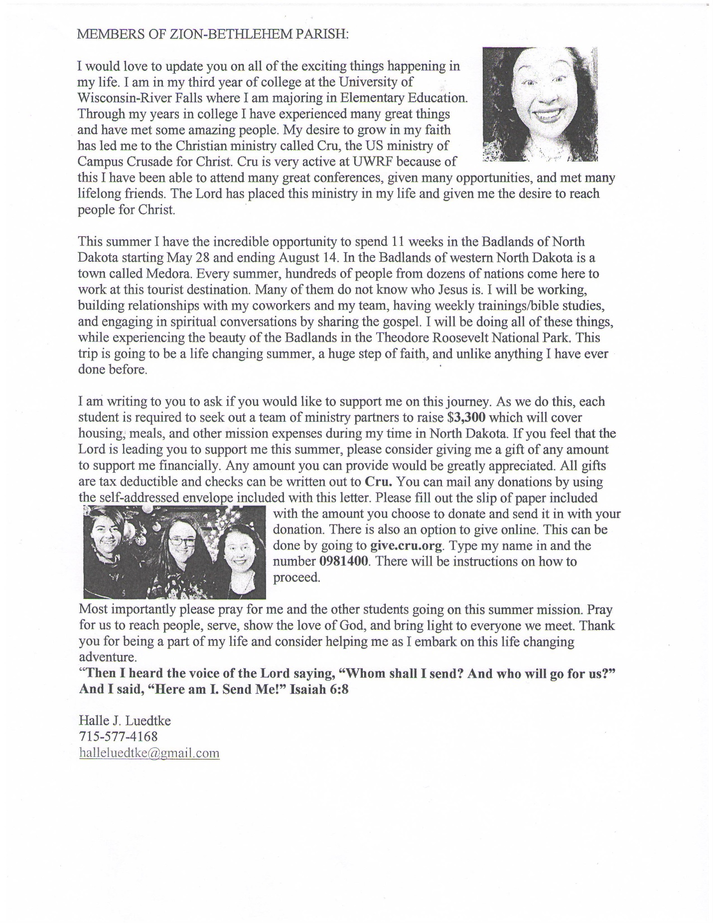
Please remember in your prayers: Selma Lane, Don Lane and Ron Wiese, Melvin Dehnke, Gerald Starck, Bev Curler, Deloris Honadel, Phyllis Mellen, Marlene Tessmer, Diane Goss, Isaac Siegel, Dick Baker, Betty Woodford, Olivia & Aidan Schmidt. Shut-ins and members living in Care Facilities. Our President, our Governor and all elected officials. Men and women in our armed forces and the families of the fallen missionaries, the lost & homeless. Those suffering from violence, war & disaster throughout the world. Christian brothers and sisters who are persecuted for their faith. For people to value Life at all stages. Our Seminary “Adopted” Student, Kevin Dykstra. For Halle Luedtke and her coming missions in North Dakota.
OUR NURSING HOME RESIDENTS HOMEBOUND
Augusta---Diane Goss--Zion Brian Markham--Beth
Geneva Smith--Beth. Carol Huff--Zion
Eileen Hagadorn--Zion Julia Phillips--Beth
Thelma Lane--Zion Amy Bergman--Zion
Naomi Sudbrink--Beth. Ellie Grunewald-Beth.
Don Berlin--Beth.
Grace-Woodlands, Eau Claire---Florence Korn--Beth. Stanley---Robert Reppe—Zion
Clear Water Care Center, Eau Claire--Dick Baker--Beth. Neilsville-Dorothy Solberg--Beth.

APRIL BIRTHDAYS – God bless your special day
1st Scott Pilgrim
2 Pastor Norton, Daniel McCann
5 Victoria Marten 7 Betty Woodford
10 Jessica Fye
12 Loretta McCann
14 Mitchell & Samantha Lyons, Travis Sonnentag
19 Jane Anderson, Skyler Furler
20 David Kiesow
23 Rebecca Peterlik, Eric Weggen
25 Dorothea Neumann
27 Allen Hadorn, Darlene Noel, Steven Pilgrim
29 Theodore Biegel, Linda Hermann, Mikayla McCann
30 Charity Maland

APRIL WEDDING ANNIVERSARIES
4/18 Irene & Harold Schiefelbein
4/20 Elton & Susan Stephan
4/23 Norman & Dorothy Luedtke
4/28 Earl & Debra Jaenke

APRIL BAPTISM BIRTHDAYS

1st Wayne Compeau, Luke Pilgrim
7 Andrew Hermann
10 Elton Stephan
12 Laurie Diaby-Gassama
14 Mikayla Pilgrim
16 Jessica Fye
18 Jodee Moss
22 Joan Drehmel, Scott Pilgrim
23 Jenna Bauch, Anna Jaenke

Bethlehem-Zion Lutheran Parish Rev. James Norton, Pastor
Cell 1(217)725-2487 Home (715)514-5478

Bethlehem Office (715)877-3249 (Office Hours T, W, TH 9-noon); Zion Office (715)877-3128
Sunday Services: Zion 9am, Bethlehem 10:30am Sunday School: Bethlehem 9am - (Adult Bible Study also), & Zion 10:15am
Elders: Bethlehem – Dennis Anderson Altar Guild: Bethlehem – Karon & Steve Davidson
Zion – Ken Kiesow Zion – Lois & Jerry Kolpien
April 2018
Sunday | Monday | Tuesday | Wednesday | Thursday | Friday | Saturday
1  Communion  Easter Sunday  7:00am Sunrise  Service  Then regular  Service times | 2 | 3 | 4  Zion Ladies Aid @ noon  Confirmation  5:00pm | 5  7:00p Council  Meetings @  Bethlehem | 6 | 7
8  Communion  Youth Mtg  6:30p @  Bethlehem | 9 | 10  8:30am  LWML Spring Rally @ St. Johns, Durand | 11  Confirmation  5:00pm | 12  Bethlehem Ladies Aid @  noon | 13 | 14
15  Mission Sunday-  Pastor Dwayne Lueck, speaker,  Potluck after  The Bethlehem Service | 16 | 17  Pastor’s Spring Conference @ Camp Luther | 18  Confirmation  5:00pm | 19  9:30am Bible Study @ Fall Creek Commons | 20 | 21  Bethlehem Ladies Aid Thrift Sale  B Church Spring Cleanup-8a
22  Communion  B. Ladies Aid Thrift Sale  Congregation Informational Meeting after Service | 23 | 24 | 25  Confirmation  5:00pm | 26  Bethlehem Sunday School Teachers Mtg  7:00pm | 27 | 28
29  Communion  Dinner for the Confirmands | 30

