January 14, 2018 – SECOND SUNDAY AFTER THE EPIPHANY

We welcome you today in the name of our Lord and Savior, Jesus Christ! God grant you peace in the hearing of His Word and the praise of His Name as we worship together rejoicing in the name of the Father, Son and Holy Spirit.

Order of Service: LSB Pg 213 Hymns: 394, 398, 618, 627, 805
Officiant: Rev James Norton
Readings: Old Testament Reading: 1 Samuel 3:1-10
Epistle: 1 Corinthians 6:12-20 Holy Gospel: John 1:43-51
Message: "How We Know God" Text: Exodus 33:13
Organist –Linda Wiese
*For the hearing impaired: Headsets are available at both Zion & Bethlehem churches.

Please remember in your prayers: Bev Curler, Eileen Hagedorn, Deloris Honadel, Phyllis Mellen, Marlene Tessmer, Selma Lane, Diane Goss, Isaac Siegel, Dick Baker, Betty Woodford, & Olivia Schmidt. Shut-ins and members living in Care Facilities. Our President, our Governor and all elected officials. Men and women in our armed forces and the families of the fallen missionaries, the lost & homeless. Those suffering from violence, war & disaster throughout the world. Christian brothers and sisters who are persecuted for their faith. For people to value Life at all stages. Our Seminary “Adopted” Student, Kevin Dykstra. There is a prayer request box in the entry of each congregation for your use. Feel free to write down any prayer request.

HOLY COMMUNION is celebrated today. Mindful of the loving, Scriptural teaching concerning church fellowship, we practice Closed Communion. This means we normally invite to commune, only active communicant members of this congregation or other congregation of the Lutheran Church-Missouri Synod in good standing. All Guests are asked to speak with our pastor before the service, before coming to the Lord’s Table. If you have not spoken with our pastor, please do not come forward at this time. If you would like to learn more about Closed Communion or our congregation, we encourage you to talk with our pastor. Please sign & register for communion on the pew pad. Gluten-free wafers are available for communion. Please let Pastor or one of the elders know, if you need them.

Reminder: be sure to sign the Record of Fellowship pad, at middle aisle side of your pew, today.

This Week’s Schedule:
Sunday 01/14/18 9:00am Zion Worship Service
(Communion) 9:00am Bethlehem Sunday School & Adult Bible Study
10:15am Zion Sunday School
10:30am Bethlehem Worship Service
6:30pm Youth Group Meeting

Monday 9:00am Quilting at Bethlehem

Wednesday 5:00pm Confirmation

Thursday 9:30am Bible Study @ Fall Creek Commons

Sunday 01/21/18 9:00am Zion Worship Service
9:00am Bethlehem Sunday School & Adult Bible Study
10:15am Zion Sunday School
10:30am Bethlehem Worship Service -
Followed by Potluck & Annual Meeting

Happy birthday this week to: Sara Luedtke, Delores Starck, Don Schuknecht, & Matthew Grunewald.

A reminder to both congregations: Our Annual Meetings are coming soon. Please plan on attending. Bethlehem’s is on January 21st, with a potluck lunch first. Zion’s is on January 28th after the church service. A lunch will follow the meeting. Any reports for the upcoming meetings must be turned into your secretaries as soon as possible, to be printed for the meetings.

Sincere thanks to all of the church officers, board members, and committee members, who served our churches in 2017. If you would be willing to serve the Lord as an officer or in another position, please let us know. Please prayerfully consider serving the Lord by volunteering to help in needed positions.

Bethlehem ladies will be quilting again, starting Monday, January 15th @ 9. Feel free to come and bring your needle.

Today’s Sunday School lesson taught the children that at Pentecost, God sent the Holy Spirit to His Church (Acts 2:1-21). Now, through Word and Sacrament, God gives us His Holy Spirit to create and sustain saving faith in Jesus. Ask the children to tell you about what happened at Pentecost. Ask them when they received the Holy Spirit (in Baptism).

Bethlehem Members: If you didn’t receive offering envelopes and would like some, let Kim Drehmel know. Also, if you received a manila envelope of offering envelopes rather than a box and need more envelopes, Kim can give you more, just contact her.
Thank you to everyone who stayed after services to help take down and pack up the Christmas decorations at Zion, last Sunday. Also, thank you to all who helped take down the Christmas tree and decorations at Bethlehem last week.
Lunch at Zion this week is hosted by the Church Council, with offerings going to the fuel fund. Next week, lunch will be hosted by the Mission Board.
Save The Date: This year the Annual Valentine's Day Dinner at Zion will be served on Sunday February 11. We will also be showing a movie after the meal. Watch for more details to come.
Zion's choir is working with Linda to get some music recorded so that we will be able to practice and add to the worship, again.
Zion's Annual meeting is January 28, after the worship service, with a meal served after the meeting. If you have not gotten your reports to Sue, please contact her this week, so that she can get it added to the year-end report. Thank you.

Our Worship Response

Bethlehem Zion
Attendance 01/07/18 85 47
Offerings 01/07/18 $1165.50 $1470.50
Building Fund 01/07/18 $1000.00
Weekly Budget $1282.00 $1138.00

January 14, 2018 – SECOND SUNDAY AFTER THE EPIPHANY

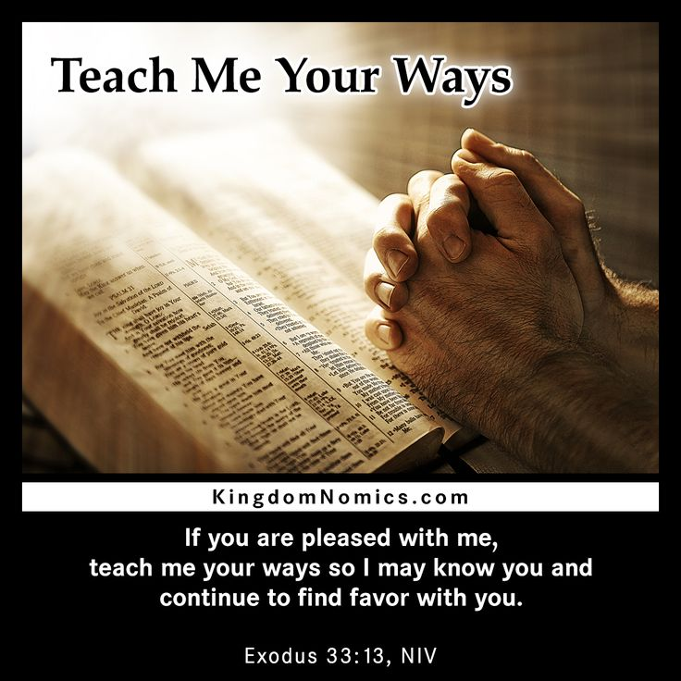
Our Mission:
Bethlehem Lutheran Church reaching out to our community and to the world with the gospel of Jesus Christ. Zion Lutheran Church seeks to preach and teach God’s word to all people of all ages and show God’s love through our witness, fellowship and service!
BETHLEHEM-ZION LUTHERAN PARISH
Pastor – Rev. James Norton, (715)514-5478 or cell 1(217)725-2487
Bethlehem, Parish Office (715)877-3249
E19675 St. Rd. 27, Fall Creek, WI 54742
Zion (715)877-3128, 1286 S 150th Ave, Fall Creek, WI 54742
www.zion-bethlehem.org
Facebook: Zion-Bethlehem Lutheran Church
e-mail – countryc@centurylink.net

