NOVEMBER 19, 2017 24TH SUNDAY AFTER PENTECOST

We welcome you today in the name of our Lord and Savior, Jesus Christ! God grant you peace in the hearing of His Word and the praise of His Name as we worship together rejoicing in the name of the Father, Son and Holy Spirit.

Order of Service: LSB Pg 260 Hymns: 785, 783, 789
Officiant: Rev James Norton
Readings: Old Testament Reading: Zephaniah 1:7-16
Epistle: 1 Thessalonians 5:1-11 Holy Gospel: Matthew 25:14-30
Message: "All We Have and Do is For God’s Kingdom" Text: 1 Corinthians 12:27-31
Organist – Noli Hadt, Linda Wiese
Zion Choir sings: Be Strong in the Lord (CH # 734), Jesus is Coming Again (CH# 753), and God Be With You Til We Meet Again.
*For the hearing impaired: Headsets are available at both Zion & Bethlehem churches.
Please remember in your prayers: Marlene Tessmer, Selma Lane, Isaac Siegel, Diane Goss, Dick Baker, Betty Woodford, & Olivia Schmidt. Shut-ins and members living in Care Facilities. Our President, our Governor and all elected officials. Men and women in our armed forces and the families of the fallen missionaries, the lost & homeless. Those suffering from violence, war & disaster throughout the world. Christian brothers and sisters who are persecuted for their faith. For people to value Life at all stages. Our Seminary “Adopted” Student, Kevin Dykstra.

This Week’s Schedule:
Sunday 11/19/2017 9:00am Zion Worship Service
9:00am Bethlehem Sunday School & Bible Study Group
10:15am Zion Sunday School
10:30am Bethlehem Worship Service
Wednesday 5:00pm Confirmation
7:30pm Thanksgiving Eve Service @ Zion
Thursday God Bless Your Thanksgiving Day – no service today
Sunday 11/26/2017 9:00am Zion Worship Service
[Communion] 9:00am Bethlehem Sunday School & Bible Study Group
10:15am Zion Sunday School
10:30am Bethlehem Worship Service

This will be Noli’s last Sunday with us as she is going to play for St. James. We wish her well and God’s blessings.

Thanksgiving service will be at Zion this year at 7:30. Noli will be playing her last service with us.

Bethlehem’s Choir will practice after service every Sunday. Please join us in celebrating the joy of the Advent and Christmas season (we need alto & bass singers).
Love to sing? Zion's choir is always ready to welcome new singers too...come join us for practice after worship.

Happy Birthday this week to: Frank Thill, Darrel Goss, Triston Kiesow, John Schuknecht, Charles Huth, Dale Noel, Donna Walmsley, Elaine Frank, Sandra Fye, & Katie Boyea.

“Mission Joe” will be speaking to Bethlehem’s Sunday School this morning, about how he became a Christian, and his experiences working with people in Africa, Asia and South America.
Zion’s students will study “Daniel in the Lions’ Den today. Jesus, who saved Daniel would Himself be given over to the satanic lion to save the world. Parents can ask your student “Who did God use to keep Daniel safe? How does God keep us safely with Himself?”

Attention Guys!!! Please help us put together the Christmas tree at Bethlehem after the worship service next Sunday. It will only take a few minutes and your strength would be greatly appreciated.

Christmas is coming. You can make donations to fill Bethlehem’s children’s Christmas sacks by Sunday December 10th. Please give the donation to Sharon or Karon,

Lunch at Zion this week is sponsored by the Mission Board. Donations go toward sending kids to camp. Come join us for good food and fellowship!
Save The Date...Blessings Trio will be at Zion, on December 3, to enhance our worship experience. They will also be giving a short concert after the service. Come join us for a meaningful worship to start out our Christmas season. Then stay after the concert for a potluck lunch. Members should bring a dish to share. Hope to see you all there.
We will be decorating our church for the Christmas season, after the worship service, on Sunday November 26. Stay after to help get ready for Christmas, and stay for a good meal, too.
Zion's Ladies Aid will be starting their Christmas Bazaar on November 26. Anyone who would like to donate something for this sale should bring their items on Saturday the 25th at 1:00 pm.
All ladies of Zion Church, along with Bethlehem ladies are invited to attend our Christmas party hosted by Zion Ladies Aid and Bible Study, on December 6. We will be starting at noon with a potluck lunch. There will be no gifts exchanged, this year. Hope to see you there!
Every year Zion puts together a nice basket of food and other staples to share with families who need a little help this time of year. Jane Anderson is looking for volunteers to assist with this year's "Families in Need Project". If you are willing to help out with this project, please contact Jane.
We are blessed. Show your thankfulness for your many blessings by giving something to missions. Use your missions envelopes, or use a plain envelope and write "missions" on it. Be sure to include your offering number so that it can be added to your year-end giving statement.

A prayer request box is in the narthex of each congregation for your use. Feel free to write down any prayer request.

***Be sure to check your church bulletin board for news, upcoming events, dinners, miscellaneous information, etc. Also check out the free items on the table in the narthex. Take any of them that you would like.

Our Worship Response
11/12/17: Bethlehem Zion
Attendance 83 43
Offerings $1145.40 $762.50
Building Fund donation $5000.00
Weekly Budget $1282.00 $1138.00

Christian Stewardship
What is stewardship? Is it only knowing how to look after finances? No. Being a good steward means to learn the art of helping, loving and caring for others. Good stewardship is living in peace, joy and harmony so that our lives are a tribute to God and good. We must look after what God has given us. Nothing truly belongs to us; everything actually belongs to God.

NOVEMBER 19, 2017 24TH SUNDAY AFTER PENTECOST

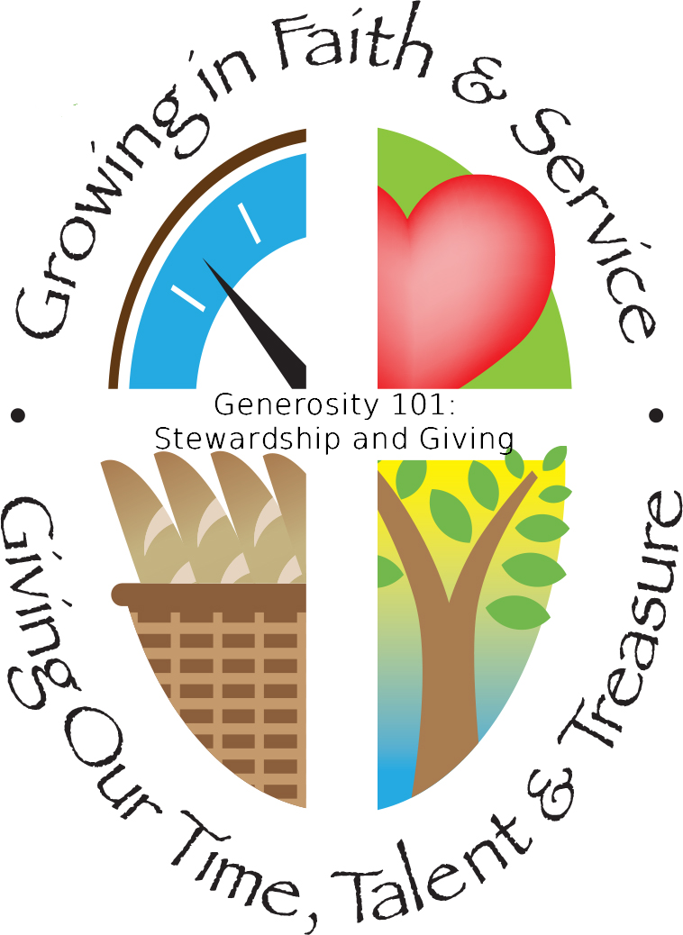
Our Mission:
Bethlehem Lutheran Church reaching out to our community and to the world with the gospel of Jesus Christ. Zion Lutheran Church seeks to preach and teach God’s word to all people of all ages and show God’s love through our witness, fellowship and service!
BETHLEHEM-ZION LUTHERAN PARISH
Pastor – Rev. James Norton, (715)514-5478 or cell (217)725-2487
Bethlehem, Parish Office (715)877-3249
E19675 St. Rd. 27, Fall Creek, WI 54742
Zion (715)877-3128, 1286 S 150th Ave, Fall Creek, WI 54742
www.zion-bethlehem.org
Facebook: Zion-Bethlehem Lutheran Church
e-mail – countryc@centurylink.net

