The First Sunday in Lent, March 10th, 2019
Bethlehem/Zion Lutheran Parish March 10, 2019 Rev. James Norton Ludington & Fall Creek, Wisconsin Linda Wiese, Organist 715-514-5478

● ● ● ● ● ● ● ● ● ● ● ● ● ● ● ● ● ● ● ● ● ● ● ● ● ● ● ● ● ● ● ● ● ● ● ● ● ● ● ●
LSB#4 P203 LSB Hymns: 527, 424, 611, 618, 637, 805

Old Testament Reading: Deuteronomy 26:1-11
Epistle: Romans 10:8b-13
Holy Gospel: Luke 4:1-13

The Message: “Our Flesh is Also Tempted ”
Text: Luke 4:1-13

Zion choir will be singing "Standing on the Promises" (CH #410)
● ● ● ● ● ● ● ● ● ● ● ● ● ● ● ● ● ● ● ● ● ● ● ● ● ● ● ● ● ● ● ● ● ● ● ● ● ● ●

This Week’s Schedule
Sunday, March 10, 2019 9:00am Zion Worship Service
[Communion] 9:00am Bethlehem Sunday School and Adult Bible Study
10:00am Zion Sunday School 10:30am Bethlehem Worship Service
6:30pm Youth Group Meets

Monday, March 11th 9:00am Quilting @ Bethlehem
Tuesday, March 12th 7:30pm Dartball @ Bethlehem
Wednesday, March 13th 5:00pm Confirmation-when there is no school, there is no confirmation.

Wednesday March 13th 7:30pm @ Bethlehem -Lenten Service, light lunch after service.

Thursday, March 14th Noon Bethlehem Ladies Aid with Potluck lunch

Sunday, March 17, 2019 9:00am Zion Worship Service
9:00am Bethlehem Sunday School and Adult Bible Study
10:00am Zion Sunday School 10:30am Youth Sunday/Bethlehem Worship Service
with Youth Taco Dinner after services
Bethlehem Choir Practice
Come join the Youth on March 17th at Bethlehem for their annual Youth Sunday service with a taco meal to follow. Service will include a Sunday School sing and contemporary music." The congregation is asked to bring deserts.

Happy Birthday last week to: Tristan Maland, Riley Charlo, Elton Stephan, Valint (Bud) Hadorn, & Luke Pilgrim.

Lent Service is March 13th at Bethlehem @ 7:30. The theme this year is “Behold the Man”.

Lunch, at Zion today is hosted by the council with proceeds going to the fuel account. Next week's lunch is hosted by the Mission Board, with proceeds going toward sending kids to camp. Be sure to stop in for good food, great fellowship, and to support these ministries.
Zion is still looking for someone to step forward to fill the position of treasurer. This is an important position, which is vital to the continuation of our congregation. Prayerfully consider if this is something that you can do for our church.
Zion congregation and choir are also, still seeking someone to take the position of church organist. If you know of someone who would do this, please talk to Dave Kiesow.

***CHOIR IS PRACTING TODAY AT BETHLEHEM. IF YOU LIKE TO SING, COME AND JOIN US. WE’D LOVE TO HAVE YOU SING WITH US!

The Quilters at Bethlehem are really making progress. If you’d like to help them, feel free
to come any Monday morning at 9am and they’ll gladly show you what to do.

Bethlehem’s Sunday School collected $64.64 for the Camp Luther 2019 Hearts for Jesus mission “Filled with the Spirit” The money will be used to purchase new and larger round tables for the new dining hall and Community Center at Camp Luther. Thank you for your contributions.

Today in Sunday School, we learned about Jesus teaching the Pharisee Nicodemus under the cover of night. Since the fall into sin, all are born spiritually blind, sinful, and unclean. We are like Nicodemus and cannot see our sin or understand who Jesus truly is for us. As children of God, born of water and the Spirit, we can see our sinfulness and the salvation that is ours in Jesus Christ. Discuss with your children, “How did Baptism change you? What does Baptism do?” John 3:1-21.

Check out your bulletin board in the narthex. Also, there are large print Portals of Prayer available,
and free items in the last row of mailboxes at Bethlehem and on the table in the narthex. of them.
Our Worship Response 03/03/2019

Bethlehem Zion
Attendance 65 34
Offerings $1459.00 $1403.50
Missions $125.00
Building Fund $25.00
Weekly Budget Needs: $1185.24 $1138.00

+++++
Please remember in your prayers: Vivian Huff, Matt Boyea, Eugene Neumann, Dorothy (Noel) Smith, Don Lane, Bev Curler, Paul Leverty, Penny & Olivia Schmidt, Martha Jaenke, Pastor Jones at Zion-Chippewa, Diane Goss, the grandson of Eugene and Dotty Neumann, Drake, who was hurt snowboarding; shut-ins and members living in Care Facilities.

OUR NURSING HOME RESIDENTS HOMEBOUND
Augusta--Diane Goss--Zion Brian Markham--Beth
Geneva Smith--Beth. Carol Huff--Zion
Eileen Hagedorn--Zion Don Berlin--Beth.
Amy Bergman--Zion Ellie Grunewald-Beth
Naomi Sudbrink--Beth. Delores Starck-Beth.
Winifred Boyea-Wicksey-Zion
Marlene & Bo Tessmer-Beth.
Also in nursing homes, or assisted living: Phyllis Peterson-Zion
Bev Curler...Oak Gardens Place, Altoona
The Manor, Chippewa Falls--Delores Staats, (Marilyn Norton’s mother)
Grace-Woodlands, Eau Claire--Florence Korn-Beth. Neillsville--Dorothy Solberg-Beth.
Stanley--Robert Reppe-Zion River Pines, Altoona--Julia Phillips-Beth

****** Persons to contact with Prayer Chain requests: Zion, Betty Woodford 715 877 3225; Bethlehem, Sharon Tumm 715 877 2402

+++++

Bethlehem Lutheran Church reaching out to our community and to the world with the gospel of Jesus Christ.

Zion Lutheran Church seeks to preach and teach God’s word to all people of all ages and show
God’s love through our witness, fellowship and service.
The First Sunday in Lent, March 10th, 2019
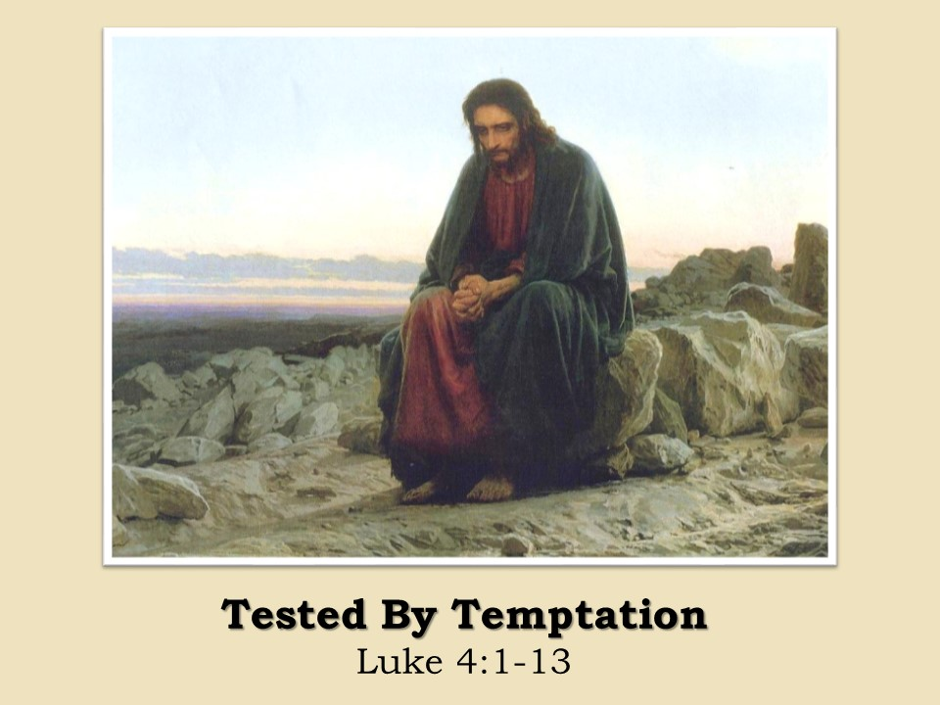

BETHLEHEM-ZION LUTHERAN PARISH

Pastor – Rev. James Norton, (715)514-5478 or cell 1(217)725-2487

Bethlehem, Parish Office (715) 877-3249 - E19675 St. Rd. 27, Fall Creek, WI 54742
Zion (715) 877-3128 - 1286 S 150th Ave, Fall Creek, WI 54742

Web address: www.zion-bethlehem.org Facebook: Zion-Bethlehem Lutheran Church
e-mail – countryc@centurylink.net

