SIXTH SUNDAY AFTER EPIPHANY
Bethlehem/Zion Lutheran Parish February 17, 2019 Rev. James Norton Ludington & Fall Creek, Wisconsin Linda Wiese, Organist 715-514-5478

● ● ● ● ● ● ● ● ● ● ● ● ● ● ● ● ● ● ● ● ● ● ● ● ● ● ● ● ● ● ● ● ● ● ● ● ● ● ● ●
LSB P260 LSB Hymns: 737, 794, 739

Old Testament Reading: Jeremiah 17:5-8
Epistle: 1 Corinthians 15:12-20
Holy Gospel: Luke 6:17-26

The Message: “As Believers, We ARE Blessed”
Text: Luke 6:20-26

Zion choir will be singing "Heaven Came Down" (CH #510)
● ● ● ● ● ● ● ● ● ● ● ● ● ● ● ● ● ● ● ● ● ● ● ● ● ● ● ● ● ● ● ● ● ● ● ● ● ● ●

This Week’s Schedule
Sunday, February 17, 2019 9:00am Zion Worship Service
Mission Board Soup Dinner @ Zion
9:00am Bethlehem Sunday School and Adult Bible Study
10:00am Zion Sunday School 10:30am Bethlehem Worship Service
Bethlehem Choir Practice

Monday, February 18th 9:00am Quilting @ Bethlehem
Tuesday, February 19th 7:30pm Dartball @ Bethlehem
Wednesday, February 20th 5:00pm Confirmation-when there is no school, there is no confirmation.

Sunday, February 24, 2019 9:00am Zion Worship Service
[Communion] 9:00am Bethlehem Sunday School and Adult Bible Study
10:00am Zion Sunday School
10:30am Bethlehem Worship Service
Bethlehem Altar Guild Meeting after church
● ● ● ● ● ● ● ● ● ● ● ● ● ● ● ● ● ● ● ● ● ● ● ● ● ● ● ● ● ● ● ● ● ● ● ● ● ● ●

Happy Birthday this week to: Eric Huth, Steve Single, Mike Pilgrim, and Arlene ANDERSON.
Happy Anniversary to: James and Marilyn Norton
Please remember in your prayers: Dorothy (Noel) Smith, Don Lane, Bev Curler, Paul Leverty, Penny & Olivia Schmidt, Martha Jaenke, Pastor Jones at Zion-Chippewa, Diane Goss, the grandson of Eugene and Dotty Neumann, Drake, who was hurt snowboarding; shut-ins and members living in Care Facilities.

OUR NURSING HOME RESIDENTS HOMEBOUND
Augusta--Diane Goss--Zion Brian Markham--Beth
Geneva Smith--Beth. Carol Huff--Zion
Eileen Hagedorn--Zion Don Berlin--Beth.
Amy Bergman--Zion Ellie Grunewald-Beth
Naomi Sudbrink--Beth. Delores Starck-Beth.
Winifred Boyea-Wicksey-Zion
Marlene & Bo Tessmer-Beth.
Also in nursing homes, or assisted living: Phyllis Peterson-Zion
Bev Curler...Oak Gardens Place, Altoona
The Manor, Chippewa Falls--Delores Staats, (Marilyn Norton’s mother)
Grace-Woodlands, Eau Claire--Florence Korn-Beth. Neillsville--Dorothy Solberg-Beth.
Stanley--Robert Reppe-Zion River Pines, Altoona--Julia Phillips-Beth

****** Persons to contact with Prayer Chain requests: Zion, Betty Woodford 715 877 3225; Bethlehem, Sharon Tumm 715 877 2402

Today, the Mission Board is having their annual Soup dinner at Zion. Come and enjoy good food and fellowship. This fund raiser is to help pay for members of the confirmation class to go to Camp Luther this summer. The Mission Board also uses funds
to pay for larger print portals of prayer and other local mission needs.

***CHOIR WILL STARTS TODAY AT BETHLEHEM. IF YOU LIKE TO SING, TO COME AND JOIN US. WE’D LOVE TO HAVE YOU SING WITH US!

Altar Guild at Bethlehem will meet on February 24th following services.

Lunch at Zion next week is hosted by the Ladies Aid. Plan on joining us for good food and fellowship, as well as to support this ministry.

Zion is still looking for someone to step forward to fill the position of treasurer. This is an important position, which is vital to the continuation of our congregation. Prayerfully consider if this is something that you can do for our church.
Zion congregation and choir are also, still seeking someone to take the position of church organist. If you know of someone who would do this, please talk to Dave Kiesow.
The Sunday School, at Zion, is collecting donations for the "Hearts for Jesus" project. Your donation is appreciated.

The Quilters at Bethlehem are really making progress. If you’d like to help them, feel free
to come any Monday morning at 9am and they’ll gladly show you what to do.

Camp Luther is 2019 Hearts for Jesus mission “Filled with the Spirit” for Bethlehem’s Sunday School. The money will be used to purchase new and larger round tables for the new dining hall and Community Center. We will collect for this mission during February! There is also a collection jar in the back of the church for congregation contributions.

Today in Sunday School we studied the calling of Jesus’ first disciples with “Jesus Calls Philip and Nathanael.” In Jesus, access to heaven is given to all who believe. “How are we tempted to rely on ourselves and trust in our powers?”

Check out your bulletin board in the narthex. Also there are large print Portals of Prayer available,
and free items in the last row of mailboxes at Bethlehem and on the table in the narthex. Feel free to help yourself to any of them.

Our Worship Response 02/10/2019
Bethlehem Zion
Attendance 75 36
Offerings $1168.00 $750.00
Memorial from Enid Drehmel $70.00
Building Fund $100.00
Weekly Budget Needs: $1185.24 $1138.00

+++++

***Remember we have Wednesday evening services for Lent every Wednesday beginning with Ash Wednesday on March 6th at Zion and alternating churches thru April 10th .
+++++

Bethlehem Lutheran Church reaching out to our community and to the world with the gospel of Jesus Christ.
Zion Lutheran Church seeks to preach and teach God’s word to all people of all ages and show
God’s love through our witness, fellowship and service.
SIXTH SUNDAY AFTER EPIPHANY, FEBRUARY 17, 2019
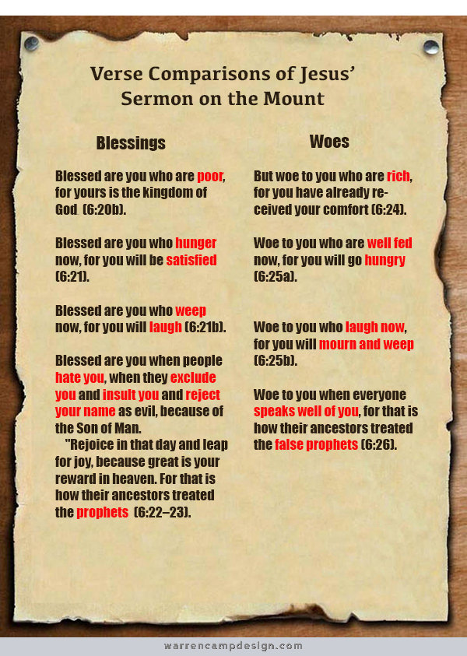
BETHLEHEM-ZION LUTHERAN PARISH
Pastor – Rev. James Norton, (715)514-5478 or cell 1(217)725-2487

Bethlehem, Parish Office (715) 877-3249 - E19675 St. Rd. 27, Fall Creek, WI 54742
Zion (715) 877-3128 - 1286 S 150th Ave, Fall Creek, WI 54742

Web address: www.zion-bethlehem.org Facebook: Zion-Bethlehem Lutheran Church
e-mail – countryc@centurylink.net

