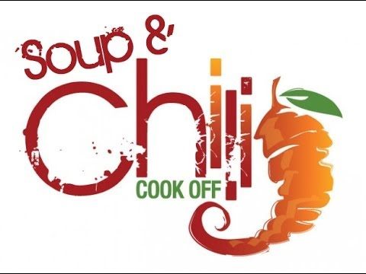
The AAEC’s Soup and Chili Cook off
Sponsorship Information
(October 8, 2016 // 5:30 PM – 7:30 PM // Apollo Hose #3)
Ghost Pepper Sponsor ($500+)
- Inclusion as Habanero Pepper sponsor on all marketing materials including but not limited to: forms, rules and information, flyers
- Mention on all AAEC Social Media Avenues (Facebook, Twitter, Instagram and Snapchat)
- Signage at event and mention throughout the event during announcements and award presentation
- 10 complimentary taster tickets to the event
Habanero Pepper Sponsor ($150-$499)
- Inclusion as Habanero Pepper sponsor on all marketing materials including but not limited to: forms, rules and information, flyers
- Mention on all AAEC Social Media Avenues (Facebook, Twitter, Instagram and Snapchat)
- Signage at event and mention throughout the event during announcements and award presentation
- 6 complimentary taster tickets to the event
Cayenne Pepper Sponsor ($100-$149)
- Inclusion as Cayenne Pepper sponsor on all marketing materials including but not limited to: forms, rules and information, flyers
- Mention on all AAEC Social Media Avenues (Facebook, Twitter, Instagram and Snapchat)
- Signage at event and mention throughout the event during announcements and award presentation
- 3 complimentary taster tickets to the event
Jalapeno Pepper Sponsor ($50-$99)
- Inclusion as Jalapeno Pepper sponsor on all marketing materials including but not limited to: forms, rules and information, flyers
- Mention on all AAEC Social Media Avenues (Facebook, Twitter, Instagram and Snapchat)
- Mention throughout the event during announcements and award presentation
- 1 complimentary taster ticket to the event

The AAEC’s Soup and Chili Cook off
Sponsorship Form
Sponsor Type:
Ghost Pepper Sponsor Habanero Pepper Sponsor
($500+) ($150-$499)

Cayenne Pepper Sponsor Jalapeno Pepper Sponsor
($100-$149) ($50-$99)

Other (Donation): $______________

Please make checks payable to: The Apollo Area Events Committee (AAEC)

Name: _________________________________ Title: _______________________________

Organization: __________________________________________________________________

Phone: ___________________________ Email: ______________________________________

Address: ______________________________________________________________________

City: ___________________________________ State: __________ Zip Code: _____________

Signature: ____________________________________________________ Date: ___________

THANK YOU FOR YOUR SPONSORSHIP AND SUPPORT!

Apollo Area Events Committee
252 South Liberty Street, Blairsville, PA 15717 – (724) 840-8468
www.apolloareaeventscommittee.com // www.facebook.com/ApolloAreaEventsCommittee
Instagram/Twitter/Snapchat @quackapollo

