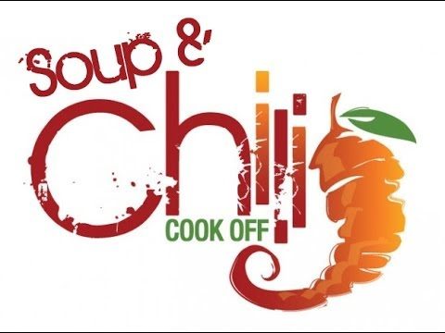
The Apollo Area Events Committee presents…
The Great Apollo Chili and Soup Cook-Off
Saturday, October 8, 2016
5:30 – 7:30 PM at Apollo Hose #3
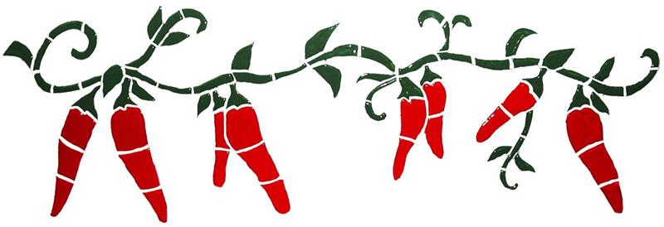
Entry Fee: $15
Taster’s Fee: $10
Any age can enter!
For registration forms and cooking rules
Visit www.apolloareaeventscommittee.com
Questions: Contact Debbie Schrecengost at 724-594-3282 or Brandy Martin at 724-840-8468

