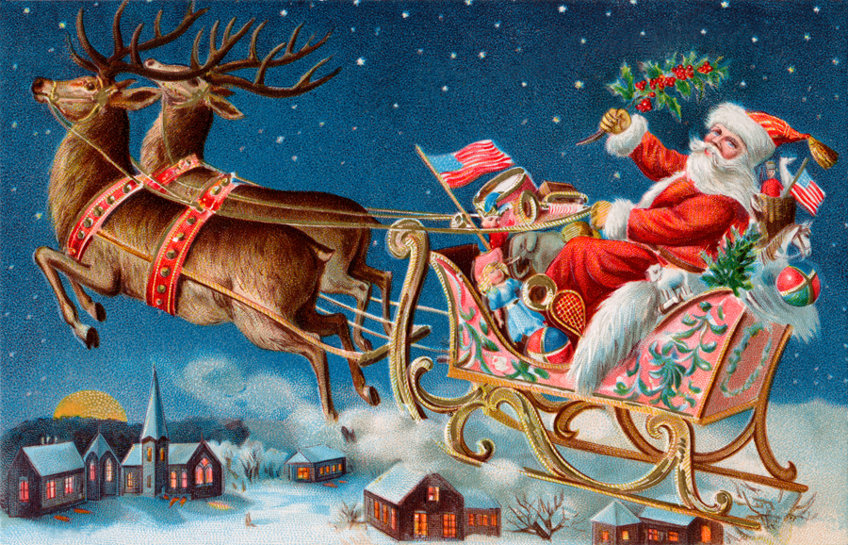

CHRISTMAS LANE
DECEMBER 3, 2016 @ 4:30

WE ARE ASKING ALL APOLLO (AND SURROUNDING) BUSINESSES, CHURCHES, ORGANIZATIONS, ETC. TO BE A PART OF CHRISTMAS LANE THIS YEAR. LAST YEAR WE HAD OVER 300 PEOPLE COME OUT TO ENJOY THE FESTIVITIES.

IT IS TRULY A FAMILY DAY WITH SANTA, TREATS, CHRISTMAS SCENES TO WALK THROUGH, DEBO THE CLOWN, FIRE TRUCK RIDES, COOKIES, HOT COCOA AND MUSIC

TO REPRESENT YOUR BUSINESS, CHURCH OR ORGANIZATION, SIMPLY CREATE A SCENE TO BE PUT ALONG CHRISTMAS LANE AND HAND OUT CANDY OR SOME OTHER TYPE OF TREAT. THE BEST SCENE WILL WIN A PRIZE AND A CERTIFICATE TO HANG IN YOUR WINDOW

GO ON TO APOLLO AREA EVENTS COMMITTEE ON FACEBOOK AND LOOK AT OUR PREVIOUS CHRISTMAS FESTIVITIES TO GET AN IDEA OF WHAT ‘CHRISTMAS LANE’ IS ALL ABOUT.

PLEASE FILL OUT THE FORM BELOW AND MAIL IT BACK IF YOU WANT TO PARTICIPATE. SHOW THE PEOPLE OF APOLLO THAT YOU’R BUSINESS, CHURCH OR ORGANIZATION WANTS TO BE INVOLVED IN THEIR COMMUNITY. IT IS A GREAT WAY TO SAY ‘THANK YOU’

NAME:______________________________________________

CONTACT:___________________________________________

PHONE NUMBER:_____________________________________

TYPE OF SCENE:_______________________________________

ITEM TO BE PASSED OUT: (EXAMPLE: CANDY, BOOK, PENCIL, PEN, ETC)____________________________________________

Mail to Debbie Schrecengost, 616 N. 2nd Street, Apollo, PA 15613
If you have any questions, please call 724-594-3282

