Building Positive Families
Post Office Box 843
Shannon GA 30172-0843

Building Positive Families
Post Office Box 843
Shannon GA 30172-0843

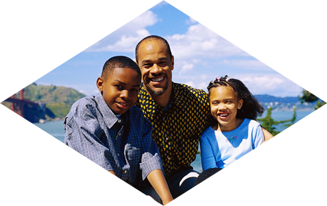

Building Positive Families

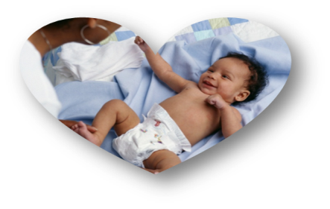

“Providing Parents

the knowledge and skills

to raise successful children.”
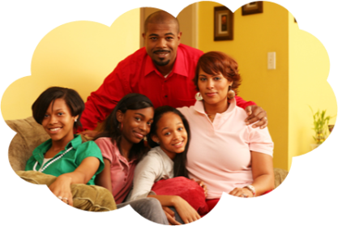
Call 706-346-7205 for Info
________________________ ________________

Moms & Dads Make a Difference!
________________________ ________________
Building Positive Families is a non-profit organization that will train parents on
What Parents Say About
Building Positive Families:

“Great class and very informative”
“Information came from personal experiences so it was powerful”

“Now I feel better informed to help
my child”

“I needed this information, Thank you!”

Methods and techniques to becoming better parents and examples for their children. In addition, we will teach pre-teen and teens life skills in order to teach them the importance of discipline, character, organizational skills, and education.

Goals & Objectives
To train parents on child rearing principles.
To encourage school involvement for parents
To train parents to teach values
To train parents in relationship skills
Provide community resources & information
To teach children discipline skills
To train children the importance of character
Teach skill sets that will give teens good people skills
Provide guest speakers to expose teens and pre-teens to people that are successful
To register complete this form and return to, PO Box 843, Shannon GA 30172-0843

Please register me for the following
________________________________Date___________
Please send information for the next Event
Please add me to your mailing list for future Events/workshops

Parent/Guardian Name ______________________________________________________
Address _________________________________________________________________
City ________________________________ State ____________ Zip _______________
E-mail __________________________________________________________________
Phone (H) ____________________________ (C) ________________________________

Provide guest speakers that have overcome mistakes in their lives to provide teens with both sides of the spectrum.
To help parents with planning & organization

Building Positive Families was founded on the belief that strong parenting skills can make the difference in a child’s success. We also, believe when children are taught specific life skills it allows them to grow into outstanding citizens.

________________________ ________________

Programs & Classes
________________________ ________________

Parenting Consultants
Positive Parenting Classes
1st & 2nd Tuesdays
These interactive workshops are designed to give “in the moment” guidelines and tips, whether you are parenting a newborn or a teenager.

Fatherhood Program
Father Support Groups
2nd & 3rd Monday of each month
Informal support group meetings that gives fathers information and resources to help nurture and raise successful children

Life Skill Classes
Teens and Pre-teen will learn and practice social and life skills that will help develop them into productive adults.

Professional/Staff Development
Seminars, Training, Staff Development and Workshops developed and prepared to address specific training needs of clients.
Call 706-346-7205 for Info

