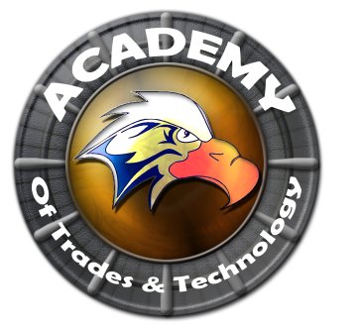

**Academy of Trades and Technology**

**GOVERNING COUNCIL AGENDA**

**Thursday, October 15, 2015**

**5:00 pm**

**Conference Room**

**2551 Karsten SE Suite C, Albuquerque, NM 87102**

**Ph: (505) 765-5517**  **Fax: (505) 765-5925**

1. Call to Order
2. Roll Call
3. Adoption of October 15, 2015 Regular Governing Council Meeting Agenda (Discussion/Action)
4. Approval of September 10, 2015 Regular Governing Council Meeting Minutes (Discussion/Action)
5. Public Forum (5 Min)**
6. Principal’s Report (Arlene Trujillo)
7. Enrollment
8. Attendance
9. Vision Builders Report
10. Food Service Audit
11. Monthly Calendar of Events
12. Student Handbook (Discussion/Action)
13. Financial Report (Alfred Martinez)
14. Finance Committee Report
15. BAR 523-000-1516-0011-IB  Grads Plus $10,000
16. Contract Services
17. Title I waiver to exceed 15% carryover cap for FY 2015-16
18. Approval to contract a long term sub for -Science
19. President’s Report (Henry Lackey)
20. Closed Session
21. Limited Personnel Matters pursuant to NMSA 1978 10-15-h.(2)
22. Return to Open Session
23. Action on Closed Session Executive Session (Discuss Personnel Matters)
24. Adjournment

Next meeting to be held every third Thursday of the month with the next scheduled for November 19, 2015.

All Meetings are conducted in Accordance with Applicable State of New Mexico Open Meeting Act, NMA Fifth edition N2005.

This agenda was posted at least 72 hrs. in advance of the meeting.

Administrator: ____________________________________________ Date:___________________________