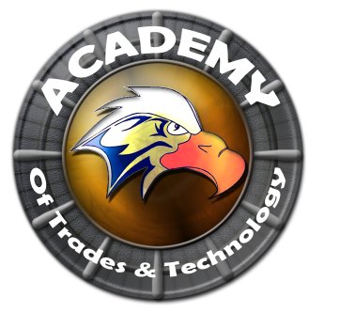

**Academy of Trades and Technology**

**SPECIAL GOVERNING COUNCIL AGENDA**

**Thursday, May 14, 2015**

**5:00 pm**

**Conference Room**

**2551 Karsten SE Suite C, Albuquerque, NM 87102**

**Ph: (505) 765-5517**  **Fax: (505) 765-5925**

1. Call to Order
2. Roll Call
3. Adoption of May 14, 2015 Regular Governing Council Meeting Agenda (Discussion/Action)
4. Approval of April 30, 2015 Special Governing Council Meeting Minutes (Discussion/Action)
5. Public Forum (5 Min)**
6. President’s Report (Henry Lackey)
7. Closed Session
8. Limited Personnel Matters pursuant to NMSA 1978 10-15-h.(2)
9. Return to Open Session
10. Action on Closed Session Executive Session (Discuss Personnel Matters)
11. Adjournment

Next meeting to be held every third Thursday of the month with the next scheduled for June 18, 2015.

All Meetings are conducted in Accordance with Applicable State of New Mexico Open Meeting Act, NMA Fifth edition N2005.

This agenda was posted at least 72 hrs. in advance of the meeting.

Administrator: ____________________________________________ Date:___________________________