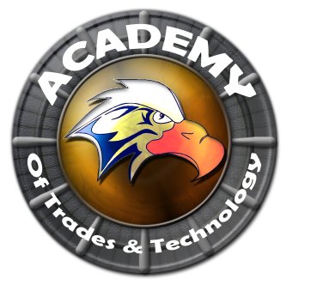

**Academy of Trades and Technology**

**GOVERNING COUNCIL AGENDA**

**Thursday, January 21, 2016**

**5:00 pm**

**Conference Room**

**2551 Karsten SE Suite C, Albuquerque, NM 87102**

**Ph: (505) 765-5517**  **Fax: (505) 765-5925**

1. Call to Order
2. Roll Call
3. Adoption of January 21, 2016 Regular Governing Council Meeting Agenda (Discussion/Action)
4. Approval of November 19, 2015 Regular Governing Council Meeting Minutes (Discussion/Action)
5. Public Forum (5 Min)**
6. Principal’s Report (Arlene Trujillo)
7. Enrollment/Attendance (Skye Norton)
8. Staffing
9. Charter School Site Visit
10. School Grade Review
11. Financial Report (Alfred Martinez)
12. Finance Committee Report
13. Maintenance BARS
14. President’s Report (Henry Lackey)

a. Selecting and Hiring a Director

1. Closed Session
2. Limited Personnel Matters pursuant to NMSA 1978 10-15-h.(2)
3. Return to Open Session
4. Action on Closed Session Executive Session (Discuss Personnel Matters)
5. Adjournment

Next meeting to be held every third Thursday of the month with the next scheduled for February 18, 2016.

All Meetings are conducted in Accordance with Applicable State of New Mexico Open Meeting Act, NMA Fifth edition N2005.

This agenda was posted at least 72 hrs. in advance of the meeting.

Administrator: ____________________________________________ Date:___________________________