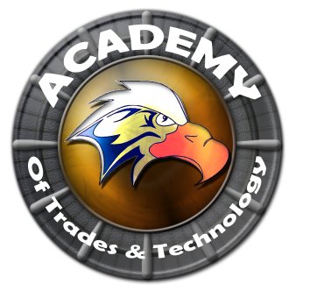

**Academy of Trades and Technology**

**GOVERNING COUNCIL MEETING AGENDA**

**Thursday, February 11, 2016**

**5:00 pm**

**Conference Room**

**2551 Karsten SE Suite C, Albuquerque, NM 87102**

**Ph: (505) 765-5517**  **Fax: (505) 765-5925**

1. Call to Order
2. Roll Call
3. Adoption of February 11, 2016 Special Governing Council Meeting Agenda (Discussion/Action)
4. Adoption of January 23, 2016 Regular Governing Council Meeting Minutes (Discussion/Action)
5. Financial Report
6. Principal’s Report (Discussion/Action) (Arlene Trujillo)
7. ACES Membership
8. Presentation to Rudy Sporing
9. Directors Report
10. Presidents Report
11. Grant Writer – new hire (Discussion/Action)
12. Closed Session
13. Limited Personnel Matters pursuant to NMSA 1978 10-15-h.(2)
14. Return to Open Session
15. Action on Closed Session Executive Session (Discuss Personnel Matters)
16. Adjournment

Next meeting to be held every third Thursday of the month with the next scheduled for March 17, 2016.

All Meetings are conducted in Accordance with Applicable State of New Mexico Open Meeting Act, MMA Fifth edition N2005.

This agenda was posted at least 72 hrs. in advance of the meeting.

Administrator: ____________________________________________ Date:___________________________