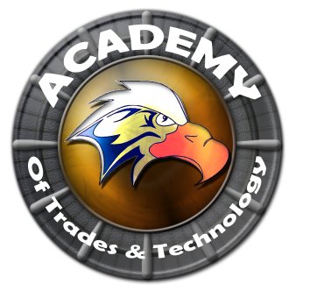

**Academy of Trades and Technology**

**GOVERNING COUNCIL AGENDA**

**Thursday, August 20, 2015**

**5:00 pm**

**Conference Room**

**2551 Karsten SE Suite C, Albuquerque, NM 87102**

**Ph: (505) 765-5517**  **Fax: (505) 765-5925**

1. Call to Order
2. Roll Call
3. Adoption of August 20, 2015 Regular Governing Council Meeting Agenda (Discussion/Action)
4. Approval of June 23, 2015 Regular Governing Council Meeting Minutes (Discussion/Action)
5. Public Forum (5 Min)**
6. Principal’s Report (Arlene Trujillo)
7. Enrollment/Attendance
8. ACES Membership
9. Vision Builders Report
10. Financial Report (Alfred Martinez)
11. Finance Committee Report
12. President’s Report (Henry Lackey)
13. Closed Session
14. Limited Personnel Matters pursuant to NMSA 1978 10-15-h.(2)
15. Return to Open Session
16. Action on Closed Session Executive Session (Discuss Personnel Matters)
17. Adjournment

Next meeting to be held every third Thursday of the month with the next scheduled for September 17, 2015.

All Meetings are conducted in Accordance with Applicable State of New Mexico Open Meeting Act, NMA Fifth edition N2005.

This agenda was posted at least 72 hrs. in advance of the meeting.

Administrator: ____________________________________________ Date:___________________________