THE NOAA ANNUAL GREENHOUSE GAS INDEX (AGGI) 2017
NOAA Earth System Research Laboratory
Updated Spring 2017
Carbon dioxide CO2 The atmospheric abundance of CO2 has increased by an average of 1.80 ppm per year over the past 38 years (1979-2016). The CO2 increase is accelerating: it averaged about 1.5 ppm per year in the 1980s and 1990s, and it was 2.2 ppm per year during the last decade (2007-2016). The annual CO2 increase from 1 Jan 2016 to 1 Jan 2017 was 2.9 ± 0.1 ppm (see https://www.esrl.noaa.gov/gmd/ccgg/trends/global.html), which is the second largest increase observed in the measurement record since 1980; the largest increase was measured during 2015.
Methane CH4 Since 2007 (following flat from 2000), globally averaged methane CH4 has been increasing again. Causes for the increase during 2007-2008 included warm temperatures in the Arctic in 2007 and increased precipitation in the tropics in 2007 and 2008 and isotopic measurements argue for continued increasing microbial emissions after 2008 [Comment i.e. amplifying global warming feedback] (e.g., from wetlands or agriculture). Recent papers have also suggested contributions to the plateau and subsequent increase in methane’s global abundance from changes in the loss rate of methane. Since 2013, the global within-year increase (1 Jan to 1 Jan) in methane has become even larger, with increases between 8.7 and 12.6 ppb/yr through 2016 compared to an average annual increase of 5.7 ± 1.2 ppb yr-1 between 2007 and 2013.
Nitrous oxide N2O The atmospheric burden of nitrous oxide continues to slowly increase over time, with an average rate of 0.9 ppb yr-1 over the past decade.
Due to the increasing atmospheric GHG concentrations, for 2016 the total direct radiative (heat) forcing had increased of 40% since 1990.
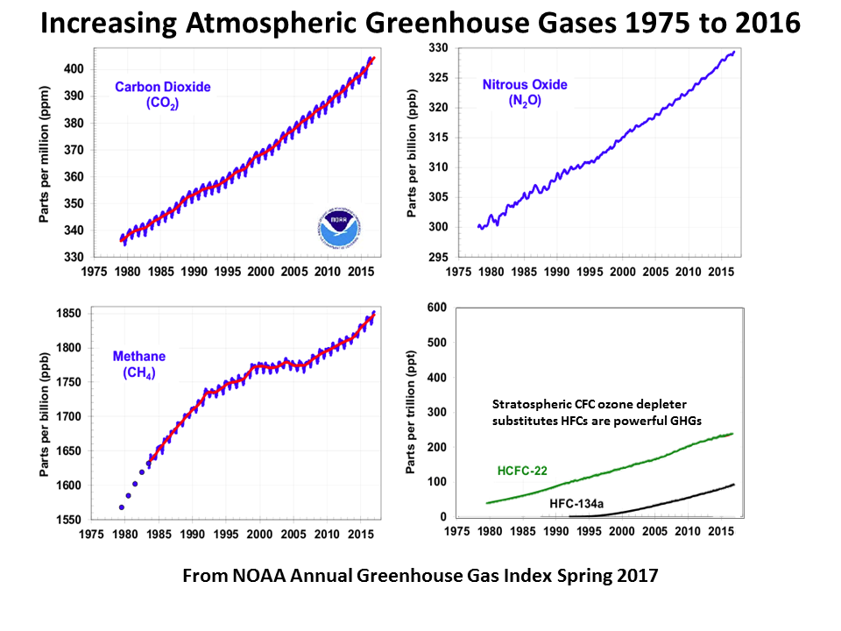
https://www.esrl.noaa.gov/gmd/aggi/aggi.html
Comment: obvious atmospheric GHG planetary emergency
Peter Carter Climate Emergency Institute July 2017

