Clipping A Dog's Claws (Toenails)

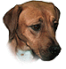
This information is not meant to be a substitute for veterinary care. Always follow the instructions provided by your veterinarian.
In the photographs below, unless otherwise noted, the top if the paw is facing up. The dog who was photographed has black pads on her toes. The black pads on the bottom of her toes will help you orient yourself as you view the photographs.
Variations on these instructions exist.
Most dogs do not like having their claws trimmed. Start trimming claws in young animals so that they get used to the process. Some dogs will happily sit in your lap or on a table while you trim their claws but many require some form of restraint.
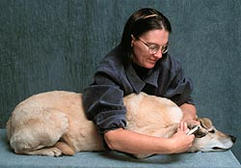 | One method to restrain the dog is to place her/him on a table. Stand on the side of the table opposite to the claws you are trimming.  Drape your arms and upper body over the dog. When trimming the front claws, keep your left forearm over the neck to keep the dog from lifting its head. Hold the paw in your left hand and hold the trimmer in your right hand.  If the dog tries to stand, lean your upper body over his/her shoulders to prevent him/her from rising.

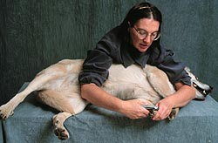 | If your dog is too wiggly, try laying him/her on his/her side.  Use your right arm and upper body to keep the dog laying on his/her side. Hold the trimmer in your right hand.  Use your left arm to keep the head on the table and use the left hand to hold the paw.

It is easier to perform this procedure if you have a helper. See the section on restraining a dog for some additional suggestions.
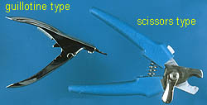 | There are several styles of nail trimmers, including a guillotine type and a scissors type. The guillotine type is the easiest to use in dogs.

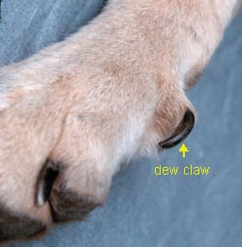 | The scissors-type is used to trim a toenail that is so long that it is curling in a circle. Long claws can grow into the toe-pad. This most often happens to dew claws, the claw on the inner side of the paw. Dew claws do not touch the ground so they are not worn down as the dog walks.  The dew claw is attached to the leg by loose skin. The dew claw can usually be bent away from the leg so that you can fit a guillotine type trimmer over the tip of the dew claw.

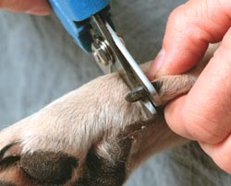 | The scissors-type cutter is placed at a right angle to the toenail.
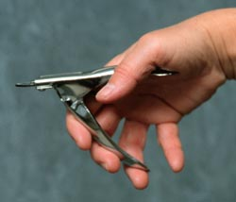 | Hold the trimmer in your right hand if you are right handed.
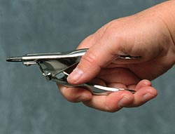 | Close your hand around the clipper to squeeze the handle which will move the cutting blade.

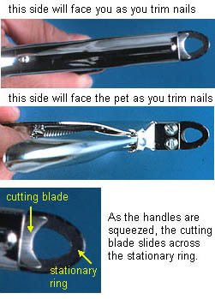
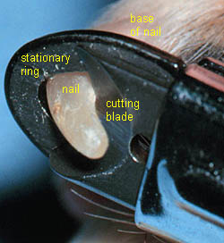 | The guillotine type trimmers have stationary ring through which the nail is placed, and a cutting blade that moves up to slice off the nail when the handles of the trimmer are squeezed.

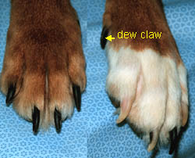 | Unlike cats, dogs do not have retractile claws. The color of the nail is determined by the color of the surrounding skin and hair. This dog has black claws on the brown paw and a mixture of white and black claws on the white paw.  Always remember to trim the dew claws that are located on the inner surface of the paw.

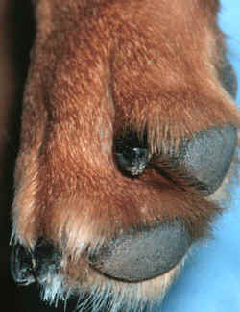 | The claws on the rear feet are often shorter and require less frequent trimming than those on the front feet.  Always remember to trim the dew claws that are located on the inner surface of the paw unless they were removed as a puppy. Some breeds of dogs such as the St. Bernard have 2 sets of dew claws on the rear feet.

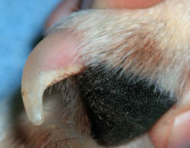 | Light colored claws are easier to cut than dark claws as the blood vessels and nerves that supply the toenail, called the quick, is easier to see.

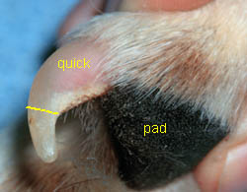 | Cut the toenail to within approximately  2 millimeters of the quick. 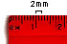  If you cut into the quick, the toenail will bleed and the dog will experience pain.
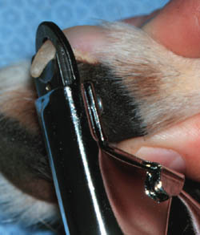 | The handles of the trimmer can be held pointing toward the floor, as pictured at the left (cutting the nail from bottom to top) or the handles of the trimmer can be held pointed towards the ceiling (cutting the nail from top to bottom); which ever is more comfortable in your hands.  The tip of the nail is placed in the stationary ring in the trimmer with the clipper perpendicular to the nail (cutting either top to bottom or bottom to top). If the trimmer is placed parallel to the nail (cutting from side to side), the nail is crushed and may splinter.  The cutting blade should be facing you, NOT the dog. The screws on the handle of the trimmer should be facing the dog.  If you turn the trimmer around with the screws toward you, the cutting blade is cutting closer to the quick than if the trimmer is held with the cutting blade toward you. You are less likely to cut into the quick if the cutting blade faces you.

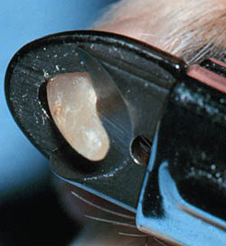 | The handles of the trimmer are squeezed to advance the cutting blade through the nail.  Light colored claws can be trimmed with one cut on each nail.

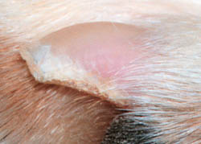
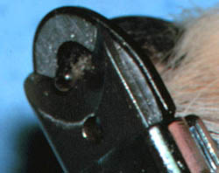 | You cannot see the quick on dark colored claws, making them more difficult to trim without cutting into the quick.
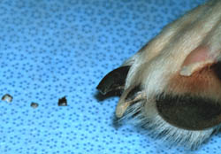 | Cut dark colored claws in several small cuts to reduce the chance of cutting into the quick.
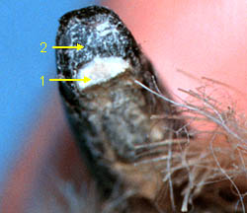 | 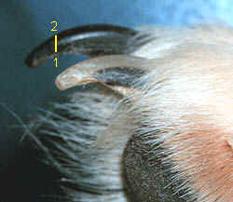
As you cut off small pieces of the nail, look at the cut edge of the nail. The light tissue (1) is the curved bottom part of the nail. The mottled light and dark tissue (2) is the top part of the nail.
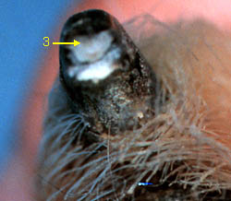 | As you cut the nail deeper, you will see a homogeneous gray to pink oval (3) starting to appear at the top of the cut surface of the nail. Stop cutting the nail at this point as additional cutting will cut into the quick.  The sharper the trimmer, the cleaner the cut. The cutting blade on guillotine-style cutters can be replaced when it is no longer sharp.  You can file the end of the nail to smooth the cut surface.

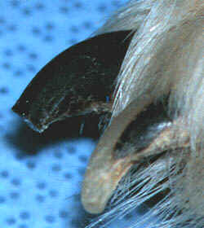 | A correctly cut dark colored nail next to an uncut mixed colored nail. The mixed color nail is darker close to the base of the nail preventing one from seeing the quick. This nail should be trimmed in several small cuts.
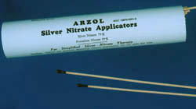 | If the toenail is cut too short, you can use a styptic pencil containing silver nitrate to stop blood flow, although many animals object to the styptic pencil as much, or more, than toenail cutting. The black end of the stick is held to the bleeding nail and gently rotated until bleeding stops.  Even without any treatment the nail should stop bleeding in about 5 minutes or less.

