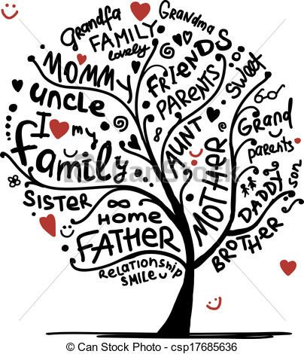
Live Rite Structured Recovery Corp Presents:
Family Recovery Coaching
@ 20880 10 Mile Rd.
St. Clair Shores, 48080
Live Rite Structured Recovery Corp, a non-profit organization under 501(c)(3) of the Internal Revue Code, Section 170.
(586) 217-5899  www.liveritestructuredcorp@gmail.com  liveritestructuredcorp@gmail.com

