Live Rite Structured Recovery Corp Presents:
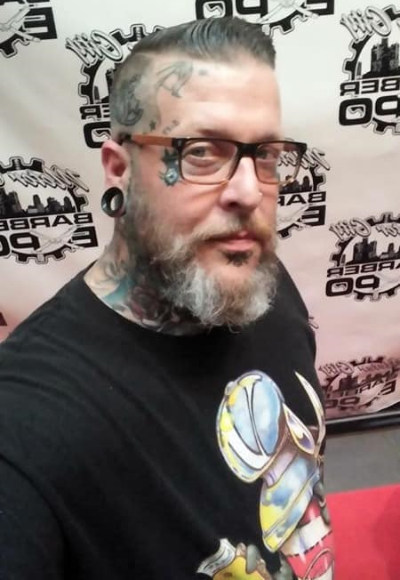
Peer Recovery Coach Program
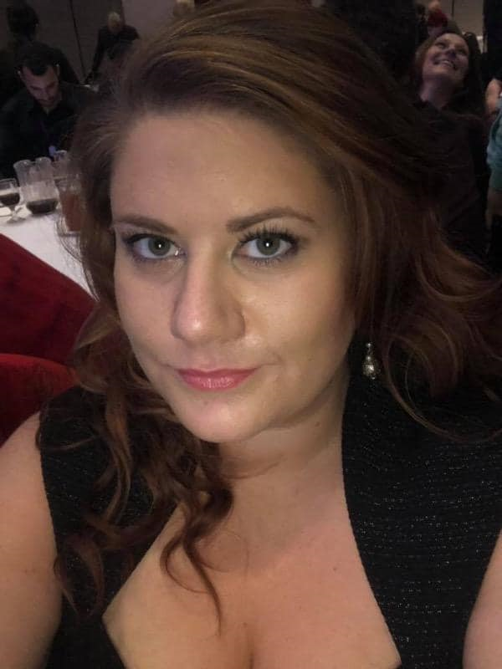

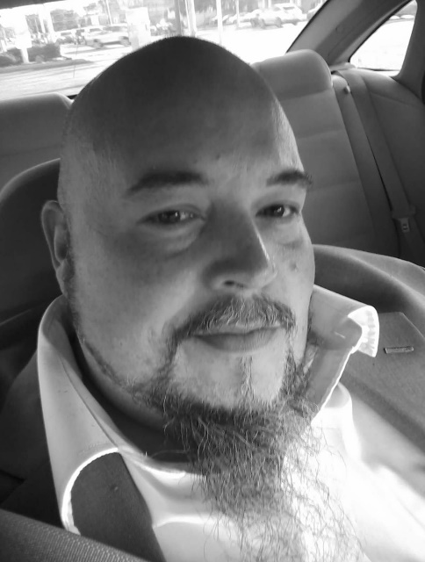

Are you interested in having a Peer Recovery Coach at no cost to you?
Please call (586) 217-5899 for your personal PRC.
Additionally, we have a PRC class that meets every Monday at 11:30 am @ 15465 E. 14 Mile Rd, Fraser 48026.
Live Rite Structured Recovery Corp, a non-profit organization under 501(c)(3) of the Internal Revue Code, Section 170.
(586) 217-5899  www.liveritestructuredcorp@gmail.com  liveritestructuredcorp@gmail.com

