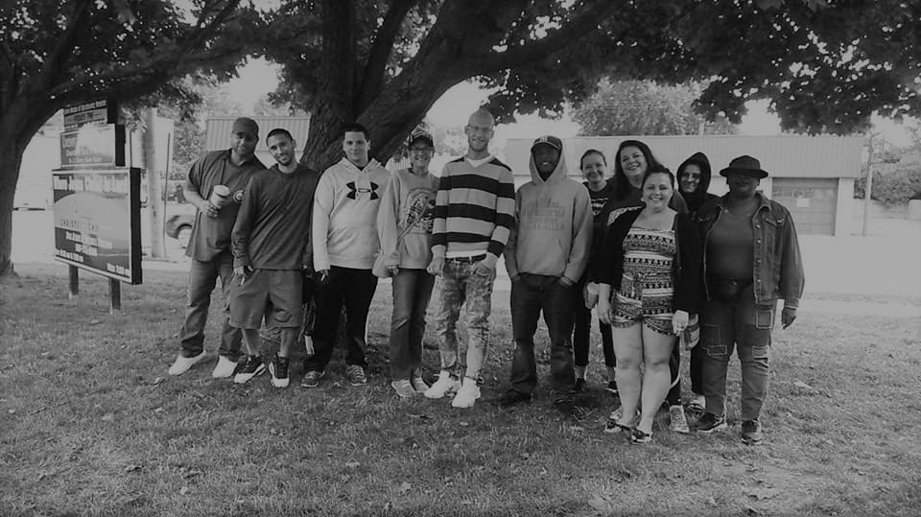

Subsidizing the recovering individual’s housing,
education, therapy and aftercare.
SPONSOR.
You can sponsor an individual’s first week in a recovery home. $170 could save someone’s life. A tremendous obstacle faced by individuals entering recovery is the lack of an environment that provides structure and support. A structured and supportive environment allows individuals to establish a solid foundation upon entering recovery.
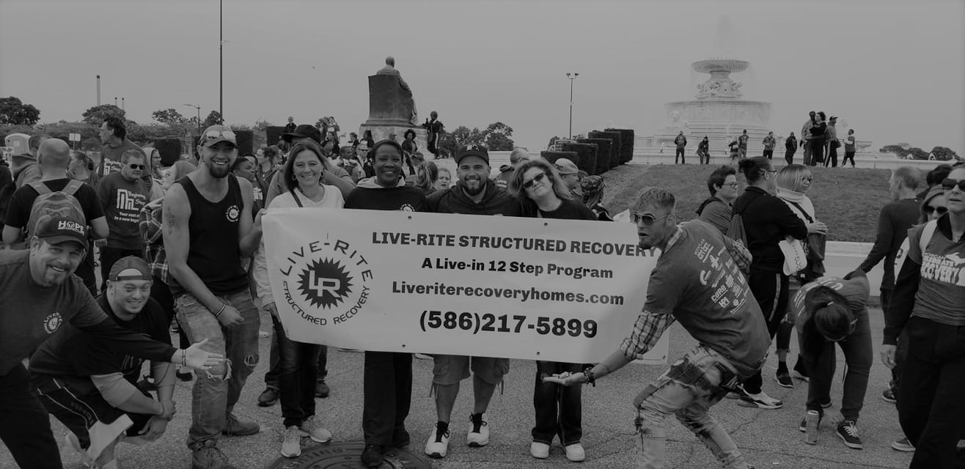
$170 covers rent and intake fees for one person. The individual will be provided with the tools necessary to establish their journey of recovery and succeed. Live Rite Structured Recovery Corp is a state certified provider of substance abuse prevention programming. Our homes are licensed through the Michigan Association of Recovery Residences (MARR.)
DONATE.
CHANGE A LIFE.
Live Rite Structured Recovery Corp is a non-profit organization under 501(c)(3) of the Internal Revenue Code. Donations are tax-deductible to the extent allowed by law.
(586) 217-5899 www.liveritestructuredcorp.com liveritestructuredcorp@gmail.com

