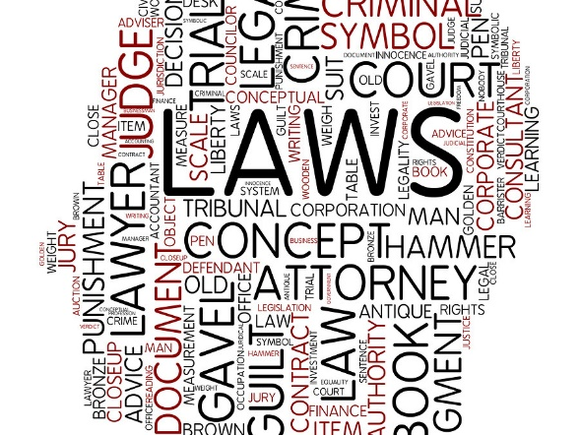
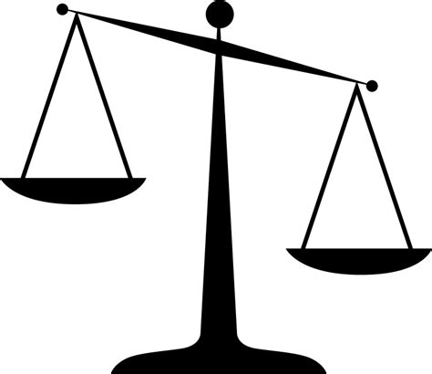

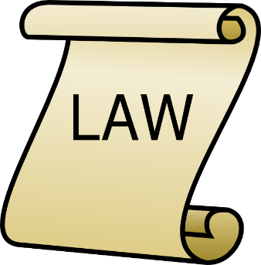

Legal Assistance Event

Location: 20880 10 Mile Rd, St. Clair Shores, Michigan
Bernadette’s Faith in Action Community Outreach Center+

This is a free event open to the Recovery Community! Attorneys will be present to answer questions regarding criminal law, family law, license restoration and expungements.

Legal Advisors: Saleema Goodman Sheikh, Esq. and Roy Gruenburg, P.C.

Brought to you by Live Rite Structured Recovery Corp, a non-profit organization.
(586) 217-5899 liveritestructuredcorp@gmail.com www.liveritestructuredcorp.com

