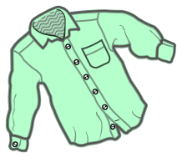
LIVERITE STRUCTURED RECOVERY CORP. A NON-PROFIT
Stacy’s Boutique
Come shop our gently used clothing.
Pick up available Monday, Tuesday & Thursdays
11-1pm, by appointment only!!
Call 586-217-5899 to set up your appointment
**Detach bottom of flyer and turn in when scheduling appointment or bring with you if scheduled over the phone ______________________________________________
Stacy’s Boutique
Clothing Need Questionnaire

Name: ______________________________
Contact number: _________________________
Reason for need: ___________________________________________________
Size(s) needed: ___________________________________________________
Items needed: ___________________________________________________
Appointment Scheduled: ______________________________________________

