

The Olive Shoots

St. Symeon Orthodox Church

February 14, 2016

+Zacchaeus Sunday+

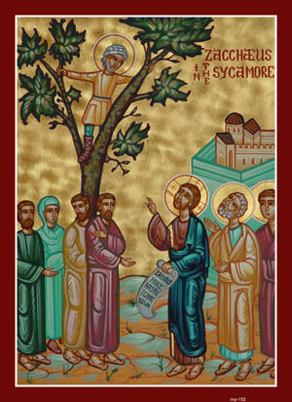

“Behold! Salvation comes into thine own home, Zacchaeus!” –Jesus

[*www.theoliveshoots.webstarts.com*](http://www.theoliveshoots.webstarts.com)

**Upcoming Services**

Monday- Memorial Service for Fr. Demetrious at 5:30PM



**Troparion Tone 3**

Thou didst treasure the wealth of salvation!  
 And hated unjust gains, O blessed Zacchaeus!  
When the Savior came to thy house thou didst bring forth the fruits of repentance:  
The righting of wrongs, the protection of the poor!  
And a new, God-pleasing life!

**Kontakion Tone 4**

When He that bowed the Heavens came to save sinners, Zacchaeus, great in zeal. but little of stature, beheld the Tree of Life from in the Sycamore; lifted up above the earth, he saw Jesus, who called him: coming down in lowliness, he repenting, received Him; and so salvation came into his house, and he was shown forth a true son of Abraham

**This Week’s Bible Verse**

***“****And Zacchaeus stood, and said unto the Lord; Behold, Lord, the half of my goods I give to the poor; and if I have taken anything from any man by false accusation, I restore him fourfold.”* – Luke 19:9

**What does this mean?**

Zacchaeus stood up, and said to the Lord, Look! I will give half of my money and food to the poor, and if I have lied and stolen from anybody, I will give back to them what I took four times each!

**The story of Zacchaeus**

**Zacchaeus** was a tax collector who got rich by making others pay lots of **taxes**. When Zacchaeus heard **Jesus** was in town, he wanted to see Him. But Zacchaeus was **short**, and Jesus was always surrounded by a crowd. So Zacchaeus decided to run ahead of the crowd and climb a **sycamore** tree. From there he could watch for Jesus. He watched as Jesus drew closer. He held his breath when Jesus stopped right beneath his tree. Then Jesus looked straight up at him! "Zacchaeus," said Jesus with a smile, "come on down. I want to stay at your house today!" Zacchaeus hopped down. "You are welcome at my house, Jesus," said the little man with a big smile. But others grumbled, muttering to each other. "Why does Jesus want to go home with a sinner?" Zacchaeus turned to Jesus and said, "Look, Lord. Here and now, I promise to give half of my **money** to the poor. If I have **cheated** anyone in taxes, I will pay them back **four times** that amount." "**Salvation** comes to Zacchaeus' house today!" announced Jesus. "For I have come to look for and to save those who are lost." Zacchaeus probably became rich by cheating people, something tax collectors were known for in those days. But Zacchaeus met Jesus, and he became a new man. He had faith in Jesus' **power** and **love**. Zacchaeus promised to pay back - even more than he had taken - those he had cheated. But the crowd didn't like this. They needed new hearts too, but they didn't realize it. Real faith is not a matter of simply **believing** in and loving Jesus. It involves turning from old ways that go against God's commands and starting a new life. Real **faith** acts to make things right again.

**Zacchaeus Word Search**

Write the bold words from the story on the lines below and try and find them in the word search!

