Resurfacing Diamond Wheels
By Kinney Polve

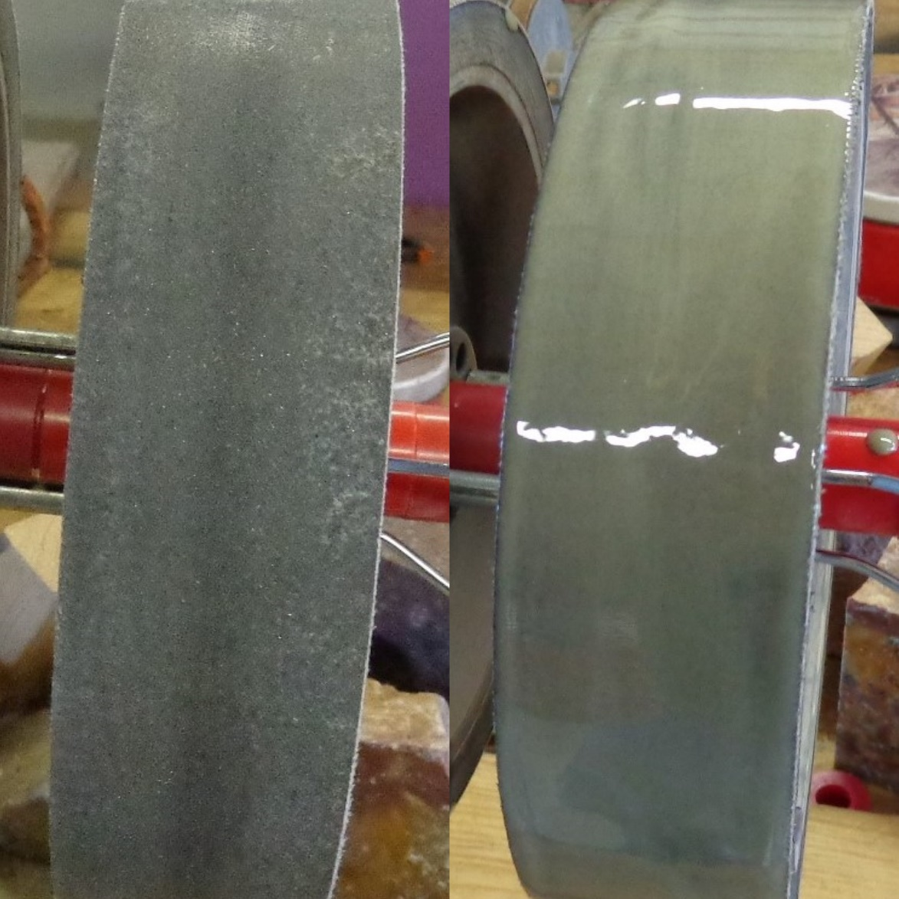
Illustrated instructions on how to recoat diamond lapidary wheels.
Introduction
This booklet is designed to instruct the reader in the step by step process on how to resurface diamond lapidary wheels. With the rising cost on diamond lapidary wheels, many lapidary hobbyists and clubs may find a need to resurface their worn diamond wheels. This process is not new, many individuals and club currently resurface their diamond wheels. This process can be used on soft (Nova) or hard metal wheels.

Safety
I can never say enough on the importance of safety. Because lapidary wheels spin at speeds near 1800 RPMs, it is important to follow each step carefully. Failure to do so may result in serious bodily injury. If you do not feel comfortable with the process, please do not attempt it.

Inspection
Okay, let’s get started. The inspection process is very critical, when it comes to resurfacing your diamond wheels. First thing you will want to do is thoroughly clean, you want to clean every bit of dirt and debris from all surfaces of the wheel. This can be done with soap and water, and a stiff bristle brush. I must stress, the wheel must be thoroughly cleaned. Now you want to inspect the wheel for any problems that may be cause for rejection. Resurfacing should never be attempted on a damaged wheel. Look for any cracks or damaged areas. Also on soft wheels look for any separation and cracking of the foam liner. If you find any problems, do not continue, reject the wheel. After a thorough inspection of the wheel, and you find no problems, continue to the resurfacing process.

Materials
Acetone, Diamond powder of proper grit, 220 epoxy, a piece of glass (about 4” X 4”), stir stick, single edged razor blade and a ½” utility brush.
Preparing the Surface
Now that your wheel has been thoroughly cleaned, and has passed the inspection process, you are ready to prepare the surface to be recoated. You need to be in a well ventilated area. It is recommended that you wear protective latex gloves throughout the process. Put some acetone on a rag and thoroughly clean the surface that you plan to recoat. This will remove anything on the surface that might keep the epoxy resin from bonding to the surface. At this point make a final inspection of the surface for any problems you may have missed. If everything looks good, move on to the next step.

Mounting Your Wheel
You will need to mount the wheel in way that it can be rotated for a period of time until the epoxy starts to harden. For best results, the wheel should turn constantly at a slow speed. I use a fabricated stand and a barbeque rotisserie for that purpose (Figure 1). You will need to center the wheel on the rotisserie shaft, I use the bushings that come with the new diamond wheels.
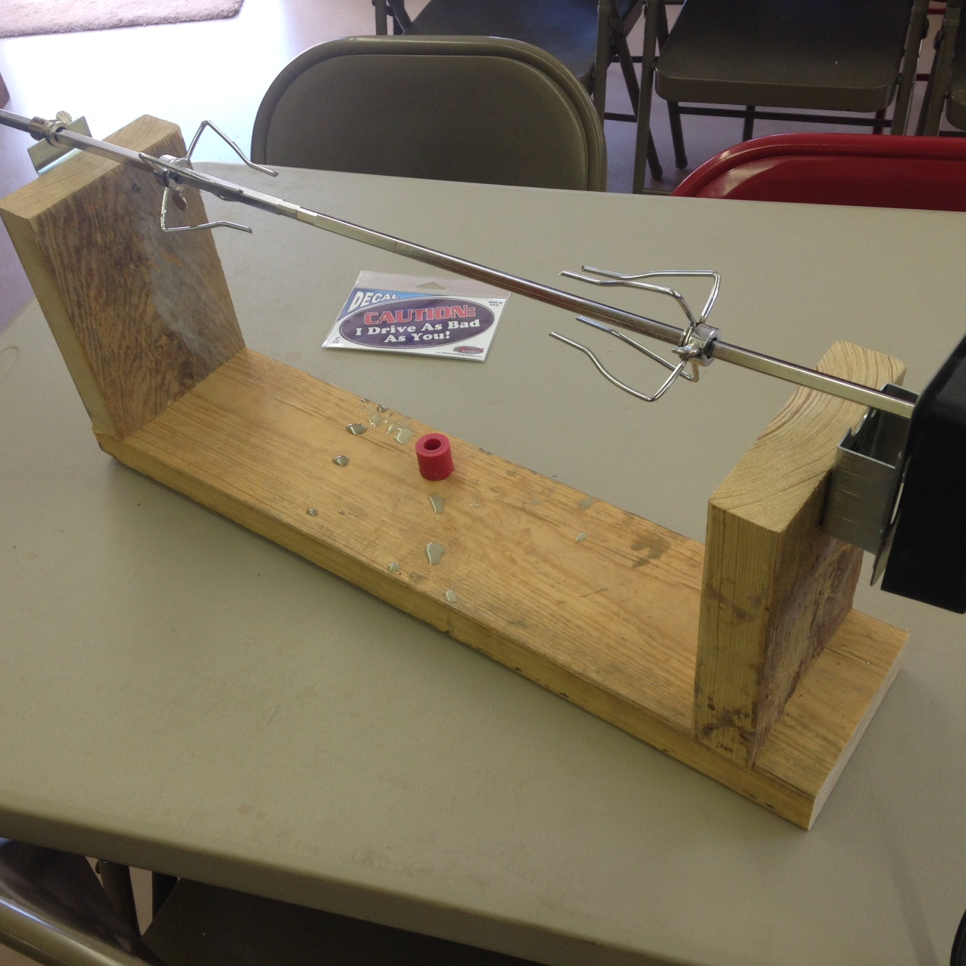
Figure 1

Mixing
We will be make a mixture of 220 two part epoxy and diamond powder. 220 epoxy has a long cure time, so don’t feel you have to rush through the mixing process. If you will be recoating multiple wheels that are different grits, always start with the finest grit first. I mix my epoxy on a piece of glass, because it’s easier to get all of the mixture off of it, and on to the wheel. When mixing the epoxy, you want to mix the least amount needed to coat the wheel. The reason is, the thicker the epoxy resin is applied to the wheel, the less flexible the wheel will be. 220 epoxy is a two part mixture, resin and hardener, mixed in equal parts. For a 6” wheel, you will need to about a 1 oz. mixture, and about 1 ½ oz. for an 8” wheel. And you will need 5 to 10 ct. of diamond powder for a 6” wheel, and about 10 to 15 ct. for an 8”. With that being said, I use 25 ct. on my 8” wheels. Begin by measuring out your resin and hardener (Figure 2). Never use more resin than hardener, your mixture will not set up properly. If in doubt add extra hardener. Thoroughly mix the epoxy (Figure 3). Now add the diamond powder (Figure 4). Use the razor blade to scrape the mixture off the glass, to ensure everything gets mixed up. Thoroughly mix the mixture until all the powder is evenly mixed throughout. Once your mixture is thoroughly mixed, move on to the next step.

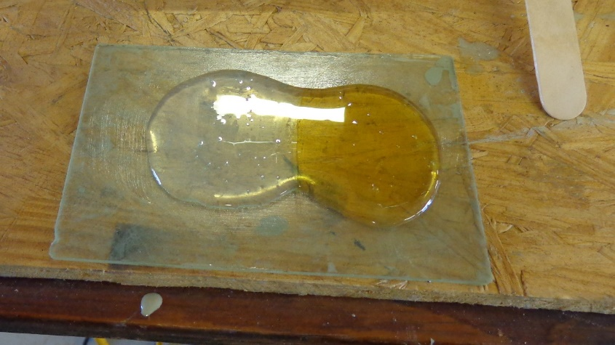
Figure 2
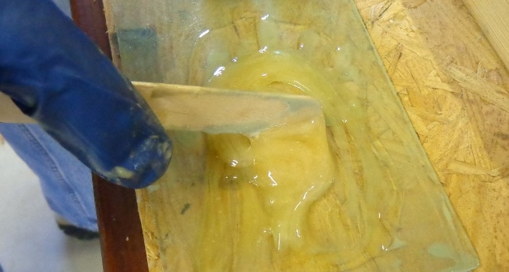
Figure 3
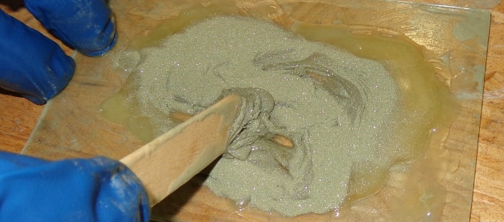
Figure 4

Applying the Coating
Using the ½” utility brush, brush the mixture off of the glass and onto the wheel, trying to evenly distribute it around the wheel. Use the razor blade to get as much as possible off of the glass. Now use the brush to evenly distribute the coating across the entire surface of the wheel, being careful not to brush it off the edges. At this point I use the piece of glass to smooth the coating a little more, being careful again, not to rake any off of the edges. It will look similar to the wheel in figure 5, or possibly a little rougher. The coating will self-level from this point, as you can see in figure 6, the same wheel fully cured, and ready to be put to work. The wheel will need to rotate for approximately 1 hour, to give the epoxy enough time to get stiff enough that it doesn’t flow. Full cure time is 24 hour, and I let set for a full 48 hours before I use it.

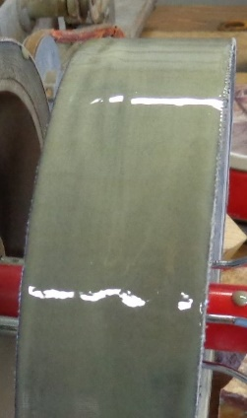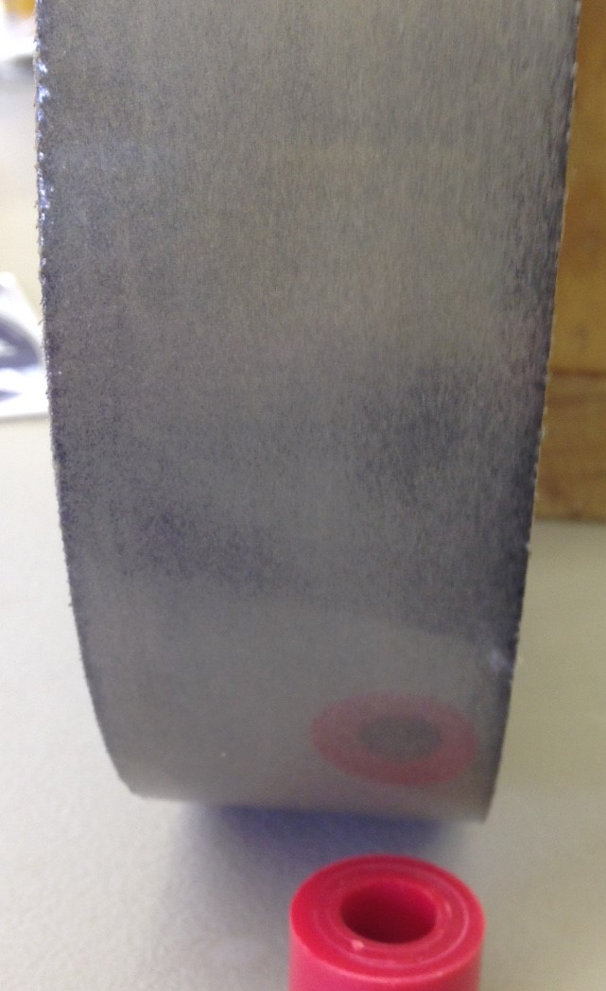
Figure 5 Figure 6

Conclusion
There is no limit to the number of wheels you can resurface at one time, just be sure to pay attention to each step. Always be safety minded. And don’t attempt it if you’re not sure of your abilities. Acetone and 220 Epoxy can be purchased locally. Diamond powder can be purchase on eBay, or other internet sources. I hope these instructions have been helpful, good luck, and happy cabbing.
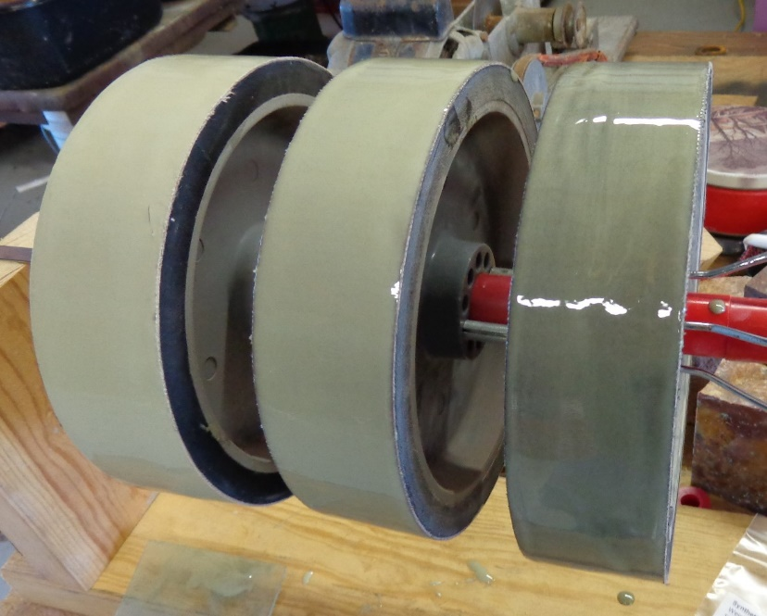
Resurfacing multiple wheeis.

