ETGMS Field trip February 2018
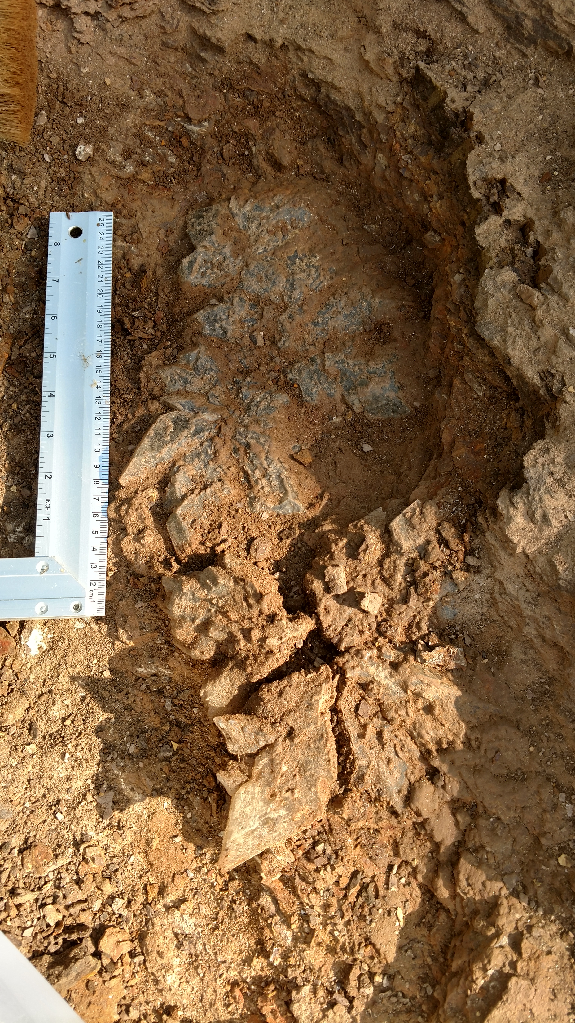  Specimen found at this location 2017  Picture by Kelly Ford |  | In search of Selenite clusters…  - Group will caravan approximately 14 miles to dig destination from meeting point  - Terrain is sloped but not too difficult to climb  - Will want small shovel, wide brush, spray water bottle, newspaper, box  - When finished, will progress approximately 5 miles to Trinity River for Indian artifacts  - Steep slope to climb down/up to the river bed where finds are most likely  - Will need bag to carry specimens  - When finished will proceed to El Toro Mexican Restaurant for late lunch  - Be sure to wear good shoes and bring plenty of water.  - Questions? Contact Kelly Ford
February 17, 2018 9:00 a.m.
Meet at McCoy’s Building Supply, Hwy 79 @ Loop 256 South, Palestine, TX
East Texas Gem & Mineral society field trip chairman
2015 Deerbrook Drive, Tyler, TX 75703
903-647-0878 | kellyjeanford@gmail.com | www.etgms.com

