East Texas Gem & Mineral Society Field Trip
September 2017
Friday, September 15, 2017 was a beautiful day! Especially to head to the hills in search of rocks (any Rockhounds dream) … in this case Quartz Crystal! Six of our members headed to Mt Ida, Arkansas that evening to get some rest before our dig the next morning at the Twin Creek Crystal Mine.
We checked into the Crystal Inn in Mt Ida, which was clean and inexpensive. After having dinner at a popular local restaurant, El Diamante, we all returned for a good night’s rest before the dig. The following morning, we met two more of our beloved Rockhounds at the Mt Ida Café for coffee and body fuel before heading out to the mine.
So off we go on a beautiful Saturday morning! Our convoy of eight! The weather was hot and humid… but after all… we are Rockhounds!
The dirt road to the mine was quite primitive but you could make it without a 4 wheel drive. As we drove in, this is what we saw…
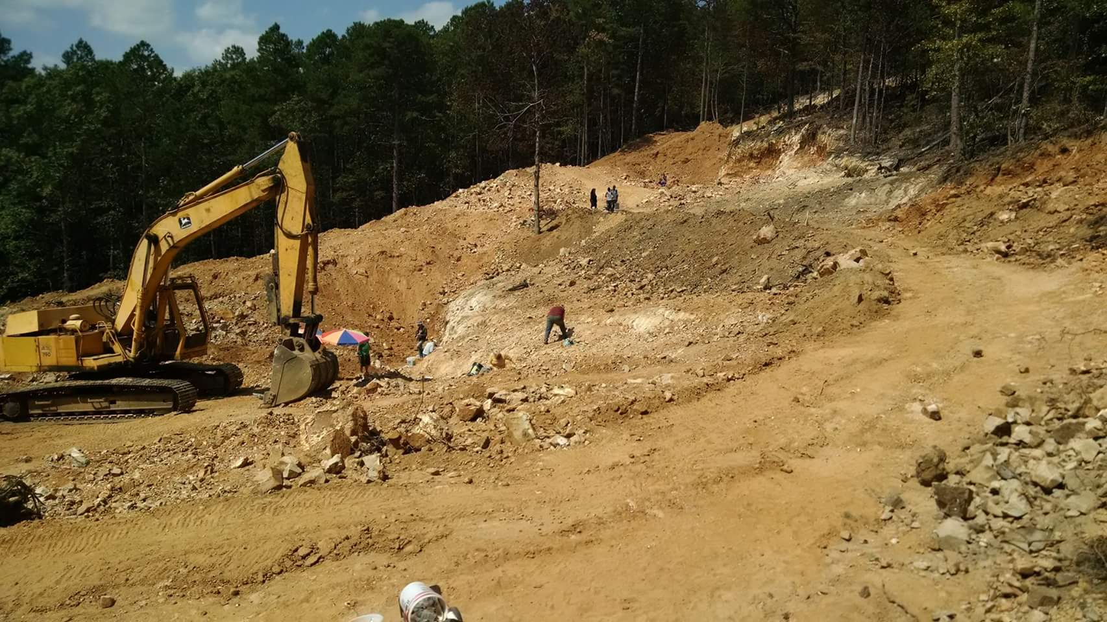

They actually used the backhoe to open up some new areas for us… which our group was checking out below.
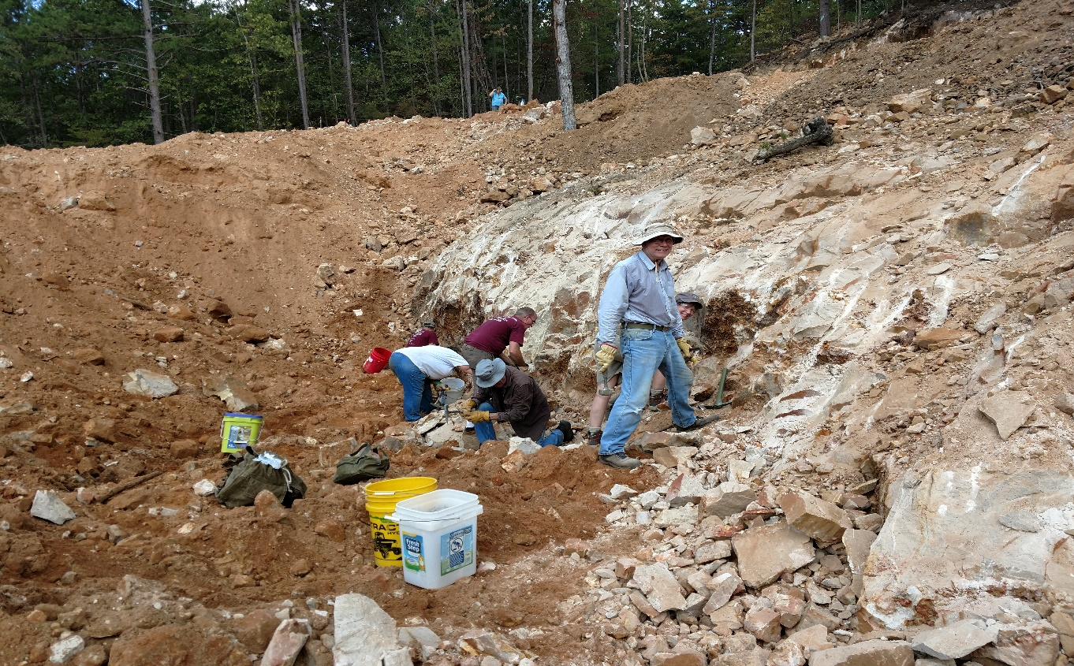

We also worked on some exposed veins along the tree line…
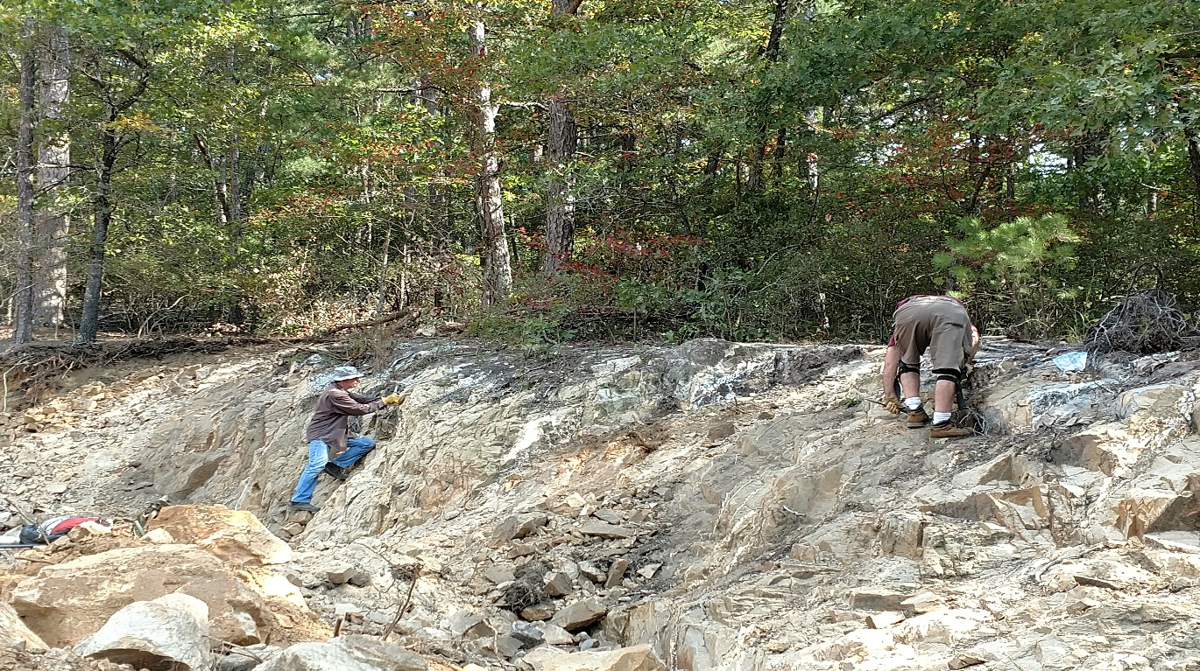

And in the top area… which after much work produced some nice specimens!
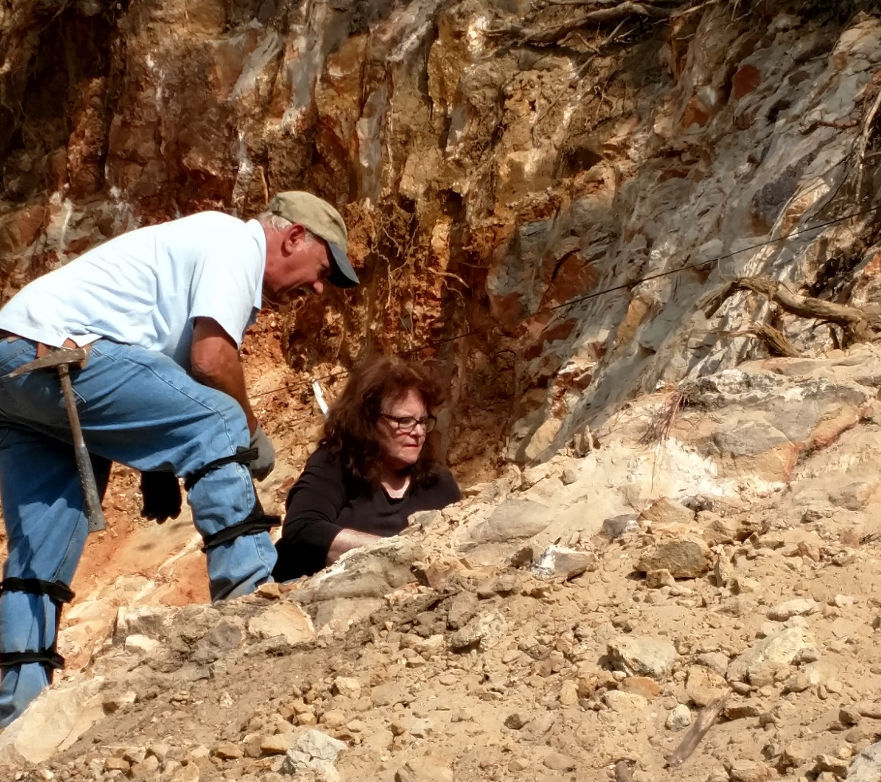

Overall, we found plenty of points and clusters in the rock, as well as in the tailings. Below are some examples found by Terry.

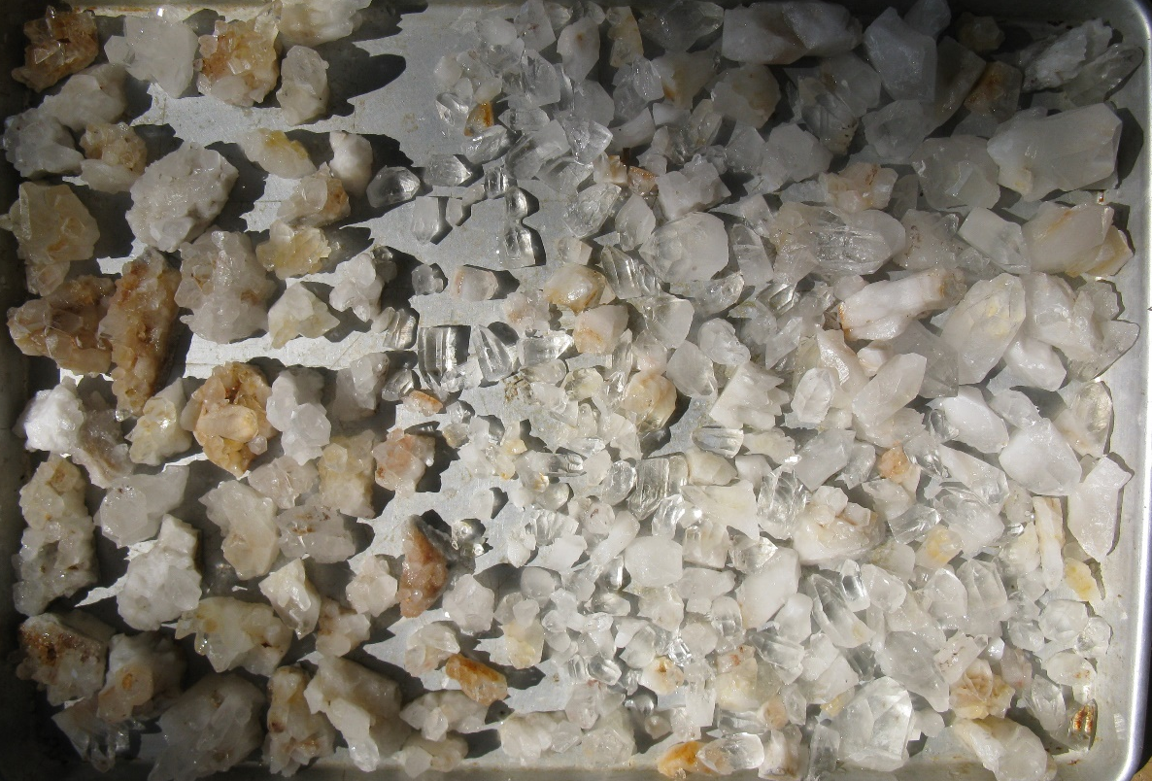
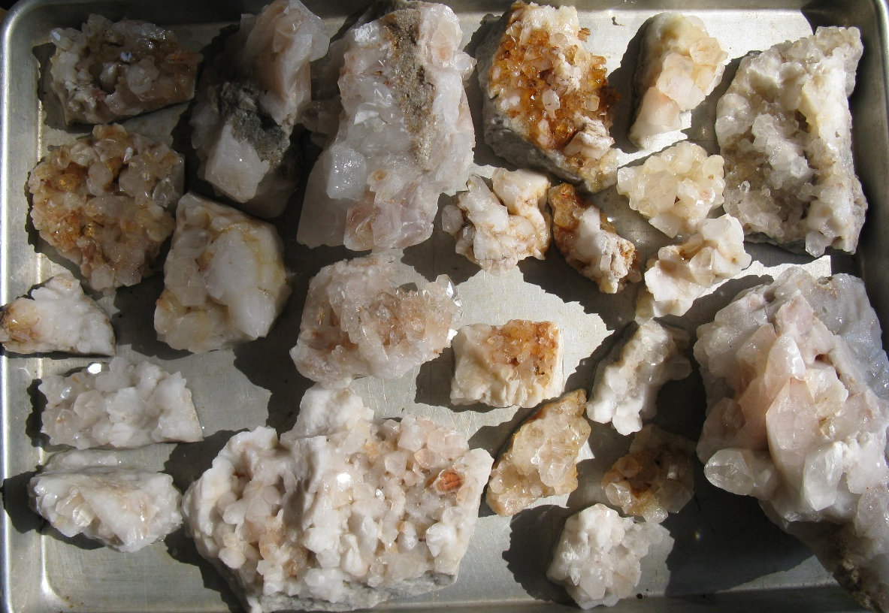

The consensus was it was certainly worth the trip… everyone found plenty of crystal, cluster and points. The mine was very accommodating! They had the cleanest Porta John I have ever seen! They also walked around to see if you needed anything and provided water and umbrellas! As I said… very accommodating! I will definitely be going back to this mine! Happy Rockhounding!
