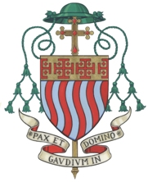 |  | Rt. Rev. Richard Moth  Bishop of Arundel & Brighton  High Oaks  Old Brighton Road North  Pease Pottage  West Sussex  RH11 9AJ  Tel: 01293 526428  e-mail: bishop@dabnet.org

To all in the Parish Prayer Group

On this 35th Anniversary of your foundation, may I take this opportunity to thank you all for your prayers for the Parish of St. Joan of Arc, for your local community, for the Diocese and for the wider world.

Your presence and service to the parish since your foundation by Fr. Michael Albon has borne much fruit in so many ways. The courses and programmes that have been arranged have added much to life of the parish, but much of the effects of prayer go unseen. There is so much for which to give thanks.

Please be assured of my prayers for you all,

With every Blessing,

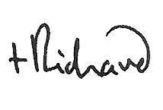
17th October 2015

