|  |  |  |
| --- | --- | --- |
| Brothers Logo | **B🞄R🞄O🞄T🞄H🞄E🞄R🞄S🞄 OF PATERSON INCORPORATED** ***Brothers 🞄 Reaching 🞄 Out 🞄 To 🞄 Help 🞄 Everyone 🞄 Rebuild 🞄 Self***  ***Mission… To create an environment that influences, enables, and empowers the men in our community towards the activities to succeed in life, through social, financial, and educational awareness.*** | |
|  |  | |
| **DONATION FORM** | **Enclosed is my gift to B.R.O.T.H.E.R.S. Of Paterson, Incorporated:** | |
|  |  |  |

|  |  |  |  |  |  |  |  |
| --- | --- | --- | --- | --- | --- | --- | --- |
| $10 | | $15 | | $25 | $50* | $100* | $200* |
| Other $ |  | |  | I’d prefer to give $ per month or per year | | | |

|  |  |  |  |  |  |  |  |  |  |  |
| --- | --- | --- | --- | --- | --- | --- | --- | --- | --- | --- |
| Name |  | | | | |  | |  | | |
| Address | |  | City |  | | State |  | | Zip |  |
| Cellular | |  | Home | |  | Work |  | | | |
| E-mail |  | | | | | Fax |  | | | |

My check is enclosed. (Make checks payable to BROTHERS OF PATERSON, INC.)

|  |  |  |  |
| --- | --- | --- | --- |
| Signature |  | Date |  |

|  |  |
| --- | --- |
| Mail completed form with your donation to: | *B.R.O.T.H.E.R.S. Supporter T-Shirt Gift |
| BROTHERS OF PATERSON, INC.  P.O. BOX 2154  PATERSON, NJ 07509 | Send a donation of $50 or more and receive a Supporter T-Shirt mailed to the address you provide above. Select size: |
| **Available Sizes: Medium, Large, XL, 2-XL, 3-XL, and 4-XL**  Please allow up to two weeks for delivery |

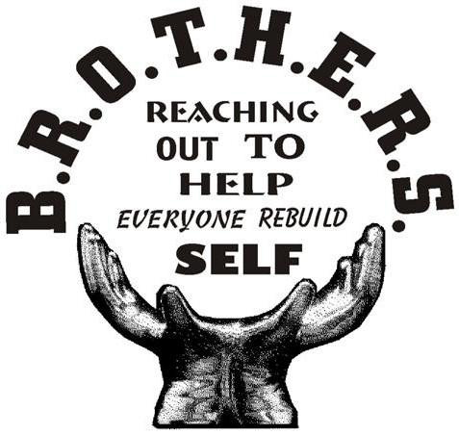

**Brothers or Paterson, Inc. Contact Information**

**Voice 973-910-0276 🞄 Fax 314-689-3328**

[**BrothersofPaterson@gmail.com**](mailto:Admin@BrothersofPaterson.com)

[**www.BrothersOfPaterson.com**](%20http://BrothersOfPaterson.com)

Thank you for your invaluable support!