General Information

Registration will be on a first come first serve basis. Limit of 18 foursomes.

Deadline for Registration is: May 13, 2017

Golfer Fee: $75.00 per person and includes 9 holes of golf, cart, 3 raffle tickets and Cookout.

Cookout Only: $10.00 per person

Soft spikes or sneakers only.

Contests and Prizes

Weston Allis
Caden Bell
Hudson Burkhardt
Daniel Burton
Kyle Currier
Dylan Devine
Sam Forrest
Michael Guerriero
Jake Guerriero
Dylan Kollar
Zachary Linderman
Brynn Maleryn
Ryan Maleryn
Gavyn Miller

Trophies for:
- Closest to the Pin
- Closest to the Line
- Longest Drive
Raffles Prizes
Schedule of Activities

1:00pm Registration
2:00pm Shotgun Start
4:30pm Cookout & Raffle
Tournament Committee

Scramble Tournament Format

Mike Guerriero / 973-477-5720
Jenn Paragone / 860-916-0995
Dana Plourde / 860-833-0979
Jill Currier / 860-989-1285

How Your Support Helps

RHAM Coyote Wrestling focuses on preparing our youth wrestler participants for the future because we feel that wrestling is one of the best ways to learn life skills. Your financial support allows the team to purchase much needed training equipment. Thank you for all of your support

Learn more about Coyotes Youth Wrestling
http://coyotes-wrestling.webstarts.com

Meet Our Wrestlers

Maxwell Miner
Aiden Muldoon
Trevin Nembhard
Vincenzo Paragone
Anthony Paragone
Frank Perry
Gavin Plourde
Chase Plourde
Nolan Plourde
Zach Pugliese
Aiden Sherman
Aiden Sulliman
Joey Tyler
Mitchell Weiss

In a scramble, each team member will hit a tee shot and the best drive is selected. The other team members will move their balls to the selected drive and all play the second shot from this location. The best second shot is selected and the procedure is repeated until the ball is holed out. On your honor, each person on the team must contribute at least one drive from the tee as the chosen shot.

Registration

Name______________________________________

Telephone__________________________________

Email______________________________________

*************************************

Name______________________________________

Telephone__________________________________

Email______________________________________

*************************************

Name______________________________________

Telephone__________________________________

Email______________________________________

*************************************

Name______________________________________

Telephone__________________________________

Email______________________________________

Please make checks out to:
“Coyotes Youth Wrestling”

Mail to: Coyotes Youth Wrestling
Attn:Jenn Paragone
176 Kinney Rd.
Amston, CT 06231

RHAM Coyotes Youth Wrestling
Sponsorship Opportunities

Blue & Gold ($100)
Coyotes Youth Wrestling is a non-profit, all volunteer organization. Our program offers an opportunity to learn and advance in the sport of wrestling within a positive environment. We aim to develop athletic skills while instilling good sportsmanship, courage, self-confidence, character and respect in our wrestlers so that they may grow up to be good, decent and healthy citizens.
These goals are achieved through the active participation and dedication of the children, parents, coaches, and volunteers.

- Link to your Website for one year from RHAM Coyotes Website
- Acknowledgement of your support for one year on the RHAM Coyotes Wrestling Website
- Large sponsorship sign on a hole
- Sponsorship sign on a cart (limited/first come)
- Dedicated QR code on your sign

Gold ($50)

- Acknowledgement of your support for one year on the RHAM Coyotes Wrestling Website
- Medium tee sponsorship sign on a hole
- Dedicated QR code on your sign

Blue ($25)

- Acknowledgement of your support for one year on the RHAM Coyotes Wrestling Website
- Small tee sponsorship sign on a hole

Please make checks payable to:
“Coyotes Youth Wrestling”

1st Annual
RHAM Coyotes
Fundraiser
Golf Tournament
&
Cookout

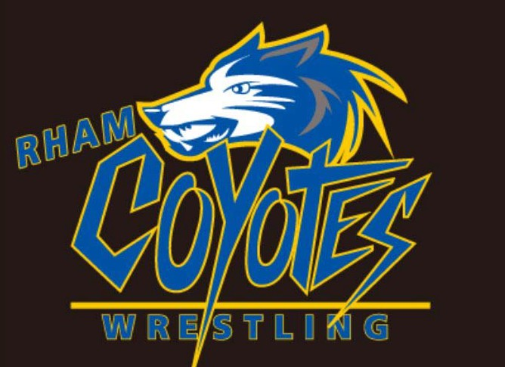

Chanticlair
Golf Course
288 Old Hebron Road
Colchester, Connecticut 06415
www.chanticlair.com

May 20, 2017
Saturday
2:00 pm Start
4:30 pm Cookout

