A Chance to Honor the Memory of a Fallen Mother, Daughter, and Sister

**Kendal Nicole Brown**

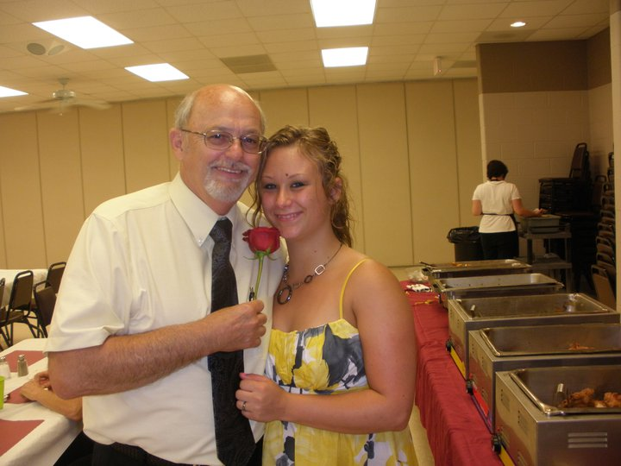

I’d like to start by saying thank you for time and consideration.

Thank you for listening to our story.

On the evening of September 29th, two detectives delivered the most devastating news to my family. My 23 year old little sister was found dead in a hotel room; leaving her 3 year old son Jaiden and 2 year old daughter Kahleia, motherless. The detectives were unable to give us any information about how she past. We have no answers. We don’t even know how to process this. What we do know, is that somehow we are supposed to bury our little girl and unfortunately don’t have funds to do so. She had such a beautiful spirit; such a light that seemed to radiate from her. We would like to give her the service that she deserves. We would also like to help her children in the most basic ways that she will no longer have the chance to.

**The Fundraiser will be held**

**Sunday, October 7th 2012**

**12pm - 8pm**

**Stone City VFW**

**124 Stone City Drive, Joliet**

**(On the Corner of Laraway and Rt. 53)**

* 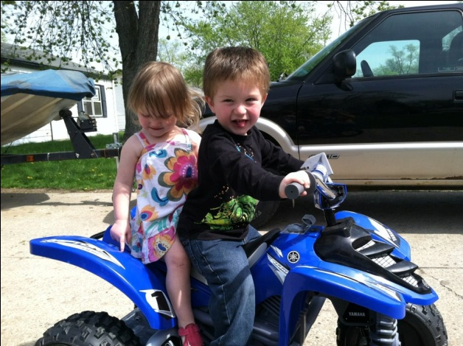**Door Prizes**
* **Raffles**
* **Gift Baskets**
* **50/50 Raffle every hour**
* **Mostaccioli Dinner**
* **DJ**
* **$10 entry**

Donations Greatly Appreciated

**Our Family Can Not Thank You Enough**

If you are unable to attend and would still like to donate, we have a paypal account set up **kash4kendalskids@gmail.com**

Please feel free to contact me if you have any questions.

I would like to thank you in advance for your time and generosity.

Kayla Brown 815-210-7964